COMMERCIAL pORTFOLIO

9712-108TH Street
Fort St. John, B.C
V1J 0A7

866-785-6409

sales@alpinewindows.ca

We are a retail store located in Fort St. John, BC that sells and installs everything to do with Glass, Windows and Doors. We have serviced the entire Peace Region since 1981.

Alpine Glass Mission: Clarity
Alpine Glass will be your clear choice for everything to do with glass, windows, and doors in the North Peace region and beyond.

Alpine Glass Vision: Value
The clear choice comes from the right product, price, people and process. With these combined, we will provide value for our customers on each and every job

Alpine Glass Values: People
We help each other. We believe in 1 + 1. Complete my tasks and do one more for someone else.
We believe in Team. We are stronger when we are united.
We believe in Partnership. We will partner with our suppliers and our customers and work together.

List of Commercial Services Offered
- Aluminum Entry Doors
- Aluminum Skylights
- Aluminum Storefronts
- Aluminum Strip Windows
- Structural Silicone Glazing
- Sliding Automatics Installation and Service
- Sloped Glazing
- Skylights
- Mirrors
- Standoff systems
- Security Shutters
- Partition Walls
- Commercial Steel Doors
- Glass Railings with or without rails
- Commercial Motorized and traditional Window Coverings
- Alpine Glass Picker and Glass Lifter for larger glass

Alpine Glass Windows & Doors is an experienced and knowledgeable provider and installer of overhead doors, whether its garage doors for residential homes, or larger commercial applications. We are your local experts when it comes to overhead doors, serving Fort St. John, Dawson Creek, Grande Prairie and the surrounding Peace Country regions.
Overhead Doors
Steel-Craft, Russel Wilcox, Garaga and Wayne Dalton Overhead doors
- Installation and service
- Full View aluminum to full sectional
- Full Vertical lift, Hi-Lift and Standard Lift

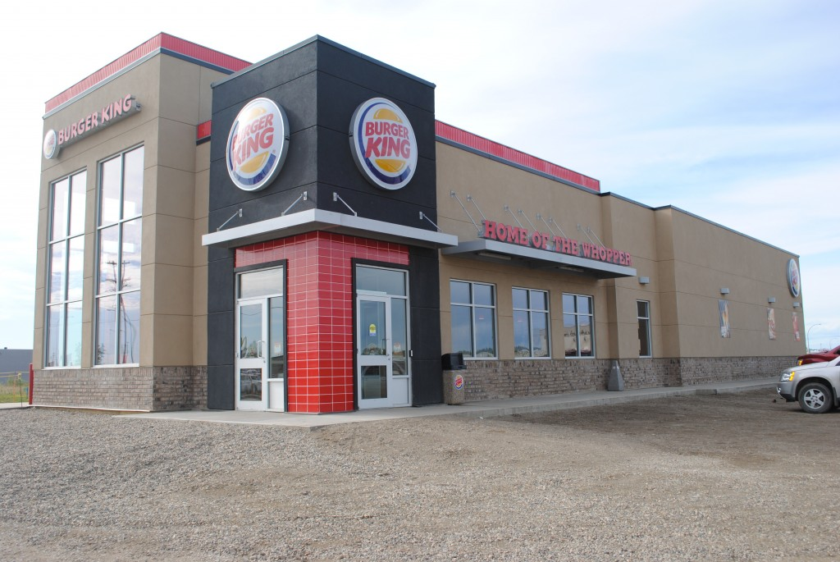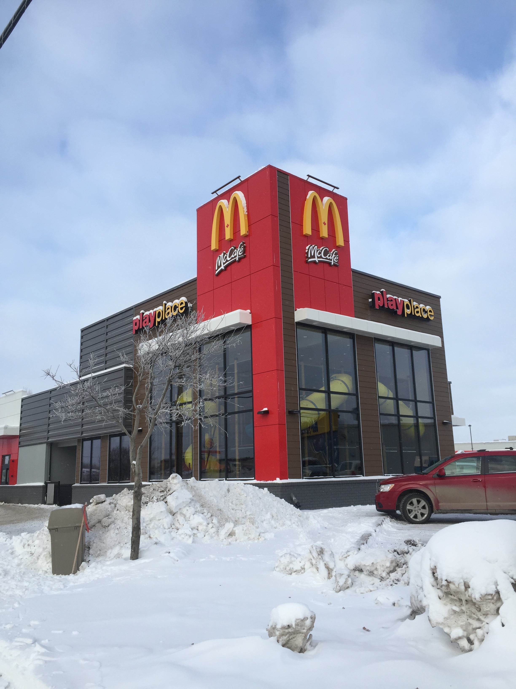

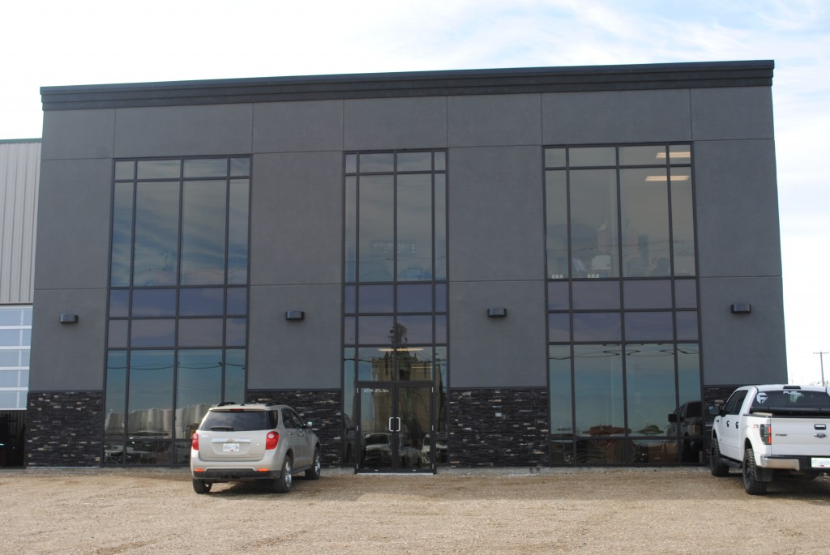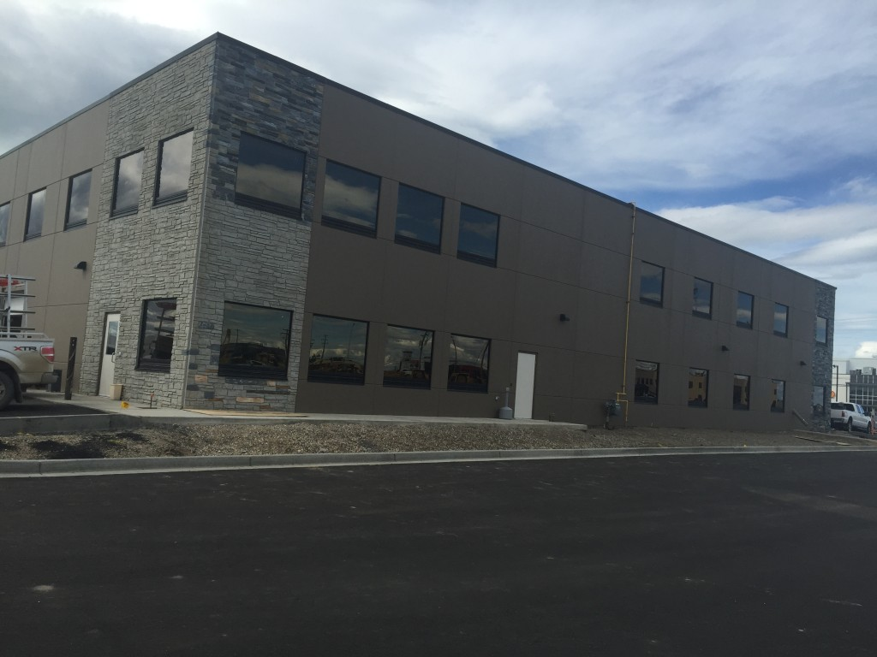

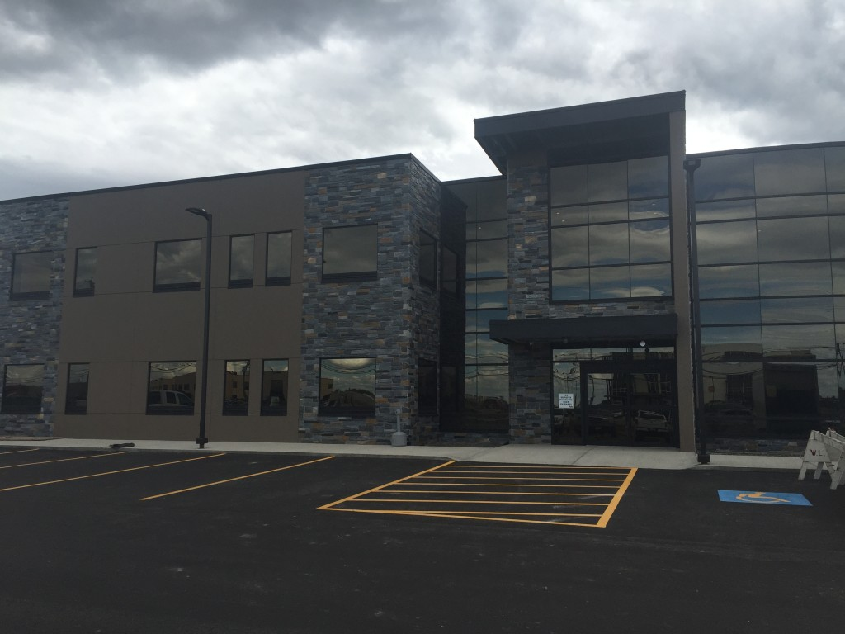

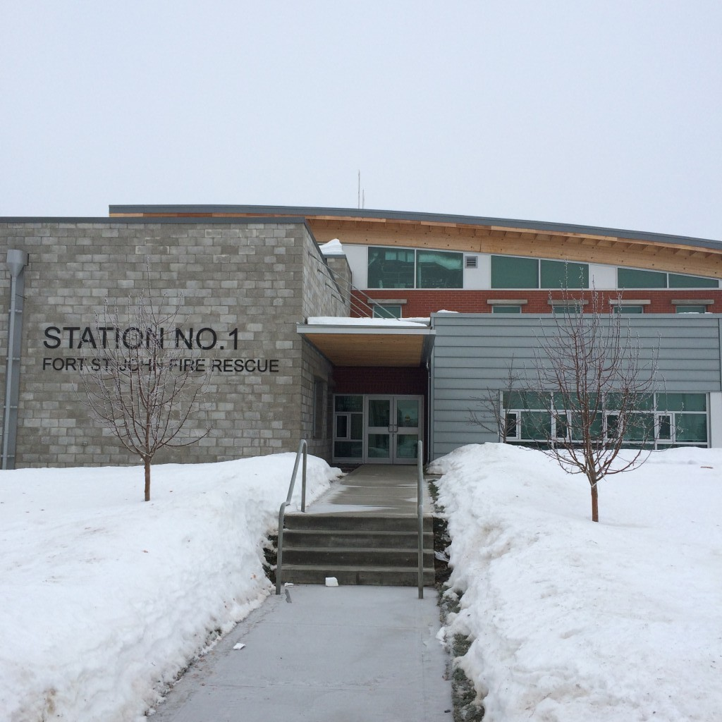

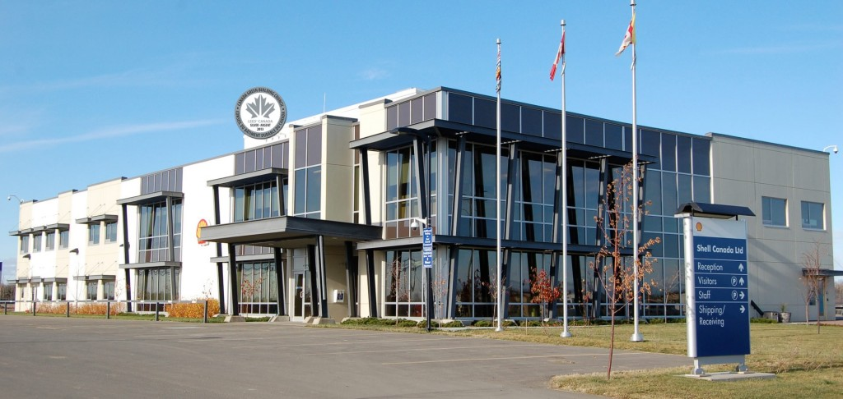

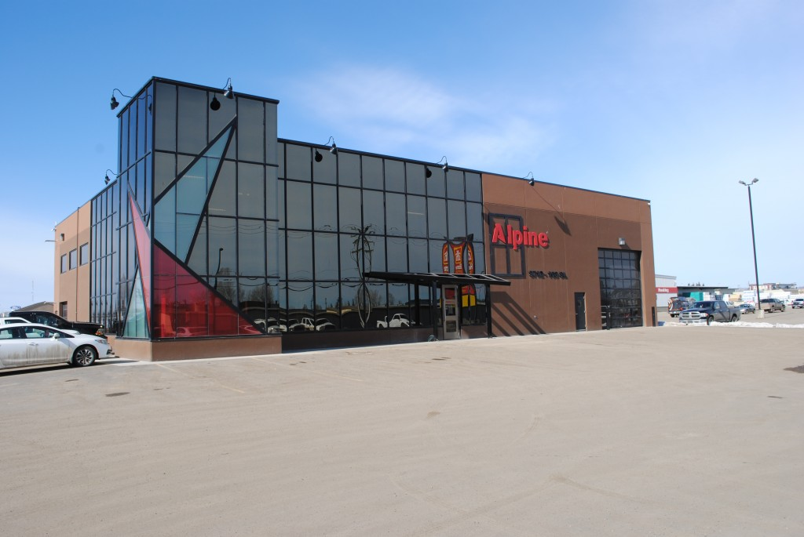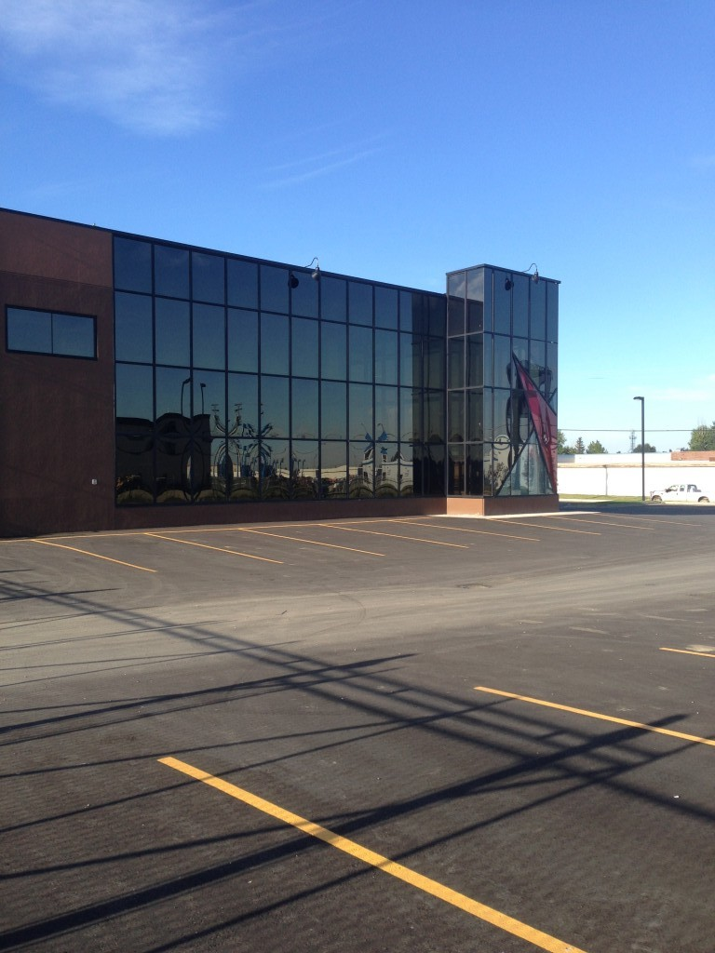

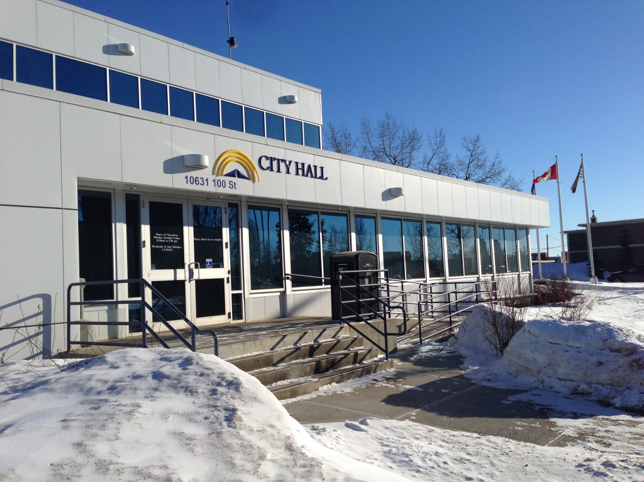
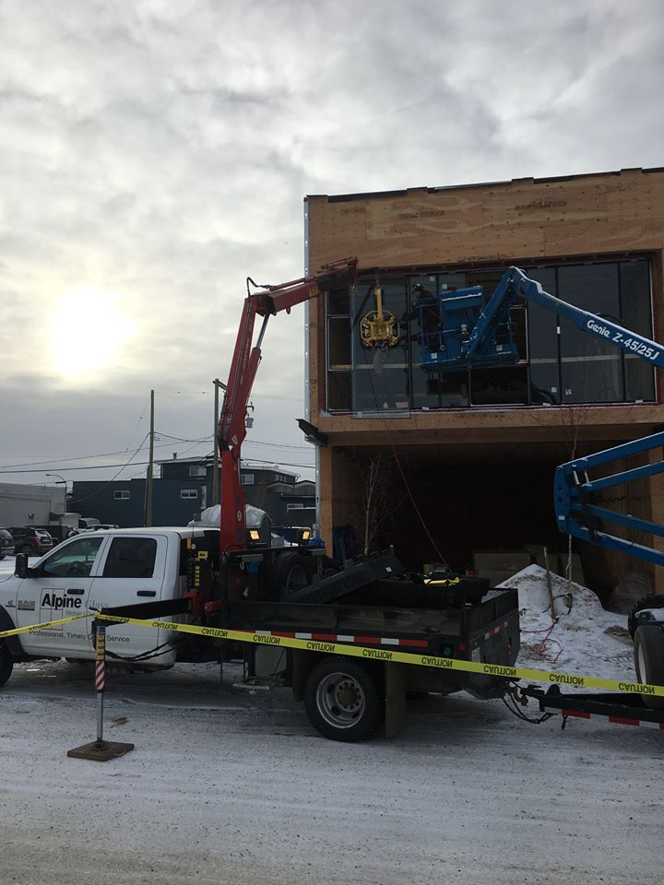
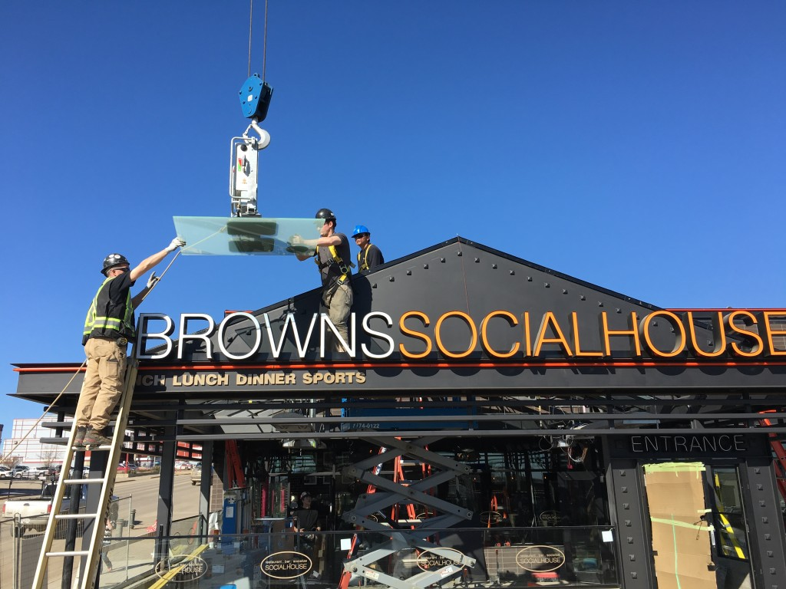

There is no project too big or too small, we would be happy to quote them all. We have 4 estimators that would be happy to assist you with any of your needs.

If you would be interested we would always be happy to sit down and discuss budgetary savings on projects if required.

From projects with very detailed specs to projects drawn on a napkin, we are able to have Shop Drawings produced timely as well as engineered if required.

Sales@alpinewindows.ca
Or
866-785-6409

Thank you,

866-785-6409

