Requirements for LFBA Logo
- Branding is used in various places
  - Website - for attracting new players and informing players’ parents
  - Uniforms, apparel, car magnets and other merchandise
  - Pennants, plaques, etc.
- Needs to conform to royal blue / gold color scheme
- Need a few different flavors
  - Circular logo used for car magnets, website, non-uniform merchandise, etc.
  - Ultra-simple version for hats (e.g. LF or LF with arrow joining)
  - Jerseys - across the chest - horizontal orientation
- Wish list
  - Modeled off of a visually appealing professional logo
  - Real estate shows the following
    - Words - “LFBA”, “Scouts”
    - Pictures
      - Baseball or baseball player
      - Element suggesting Indian Scout (I like the feather hanging down in current logo. Open to tomahawk or some other subtle representation, but not Indian face)
      - For a Minnesota Twins or Texas Rangers look, would want “Scouts” across the middle, “Lake Forest” at the top and “Baseball Association” at the bottom.

Current Branding items

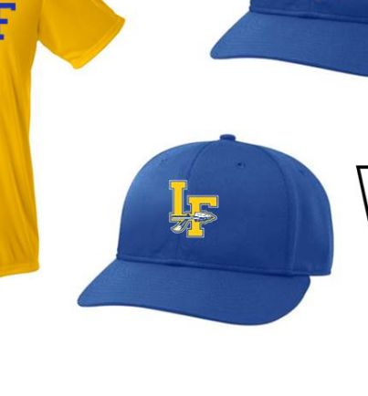
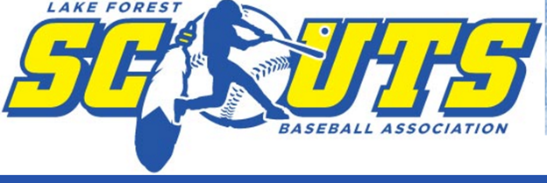

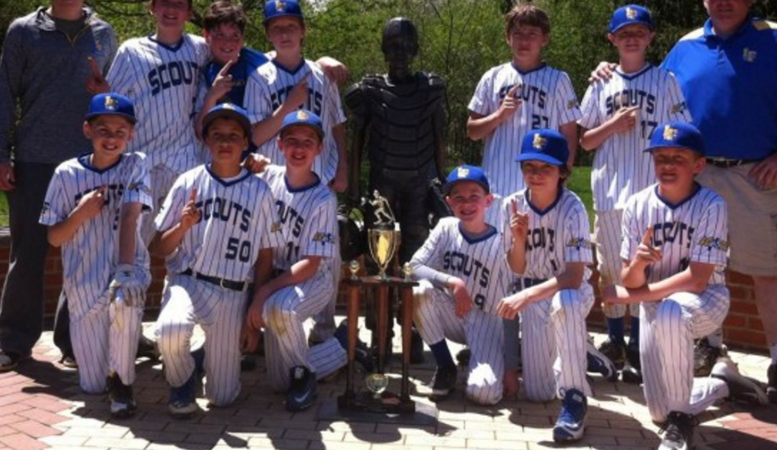

Appealing Logos to model off of
