

Contract Geoscientists Worldwide

WEBSITE DESIGN BRIEF

www.gngconnect.com

Summary
GNGConnect is an online platform for matching mining and oil and gas industry employers with short term needs to registered geoscience consultants. Not designed for work to be completed online, but rather as an online meeting place for companies and geoscientists to meet. Rather than going through an expensive contracting firm such as RISC, oil and gas companies and mining companies can search for the skill set they are looking for amongst the registered contractors.
Companies can either search through the contractors and contact them directly, or lodge a job and request contractors to register their interest.
Similar to Upworks or Expert360. Or RSVP for employees and contractors, rather than men and women. Also similar to Findababysitter.com.

There are 12 pages plus three sub pages to be prepared. For the competition, please provide the three pages and one sub page as highlighted below.

Pages
- Home Page
- How it Works
- Registration (Contractor and Employer)
- Contractor Profile Page
- Search page
  - Search Results lists
- Employer Favourites Page (displayed as either cards or list)
- Analytics Page
  - Map, Charts etc
- Articles
- Job Postings Page includes both contract and work for equity / deferred payment jobs
  - Detailed Job sheets
- Resources Page
- Payment Checkout Page
- Contact Us

Home Page

A simple, sleek, uncluttered, professional design with a call to action button. “Join Free Today” This takes the member to a filter of “Register as a Contractor” or “Register as an Employer”. The member is then shown the membership options with comparison pro’s and cons described to select before going forward and filling out details.

Also a login for existing members both contractor and employers.

The home page should have an RSS feed showing commodities prices (Brent Oil, WTI, Gold, Iron ore etc)

How it Works
A text description plus stylized graphics describing how the process works, with a “Join free today” button floating at the side. That button takes the member to the same process as described above.
This page also contains the FAQ section below the primary description

Contractor Registration
- Contractors will register with an industry (mining, oil&gas, geothermal, environmental)
- Contractors will also select a resident country for domestic projects.
- The Contractor then registers with the primary contractor type ie “Geologist, Geophysicist, Petrophysicist, Petroleum Engineer, Drilling Engineer, Procurements and Logistics, Commercial Analyst etc”.
- The Contractor will then be able to select up to 5 key skills from a selection panel of skills or add one of their own (which then gets added to the pool of skills for future contractors to choose from).
- The contractor must state their day rate in the local currency for domestic work and also international work. Dayrates should display for the person viewing the profile in both the domestic currency and an approx.USD equivalent based on the daily exchange rate.
- Optional photo upload. If the contractor does not upload a photo, use a generic silhouette.
- The contractor will indicate what contract timeframe they prefer (ie one week to one month or above one month etc), part time or full time
- The contractor nominates whether they will travel domestically and internationally and for what time periods (<1 week, 1-2 weeks, up to 1 month, >1 month).
- The contractor will indicate if they are available for immediate start, 1 -2 weeks notice, 2-4 weeks notice or >1 month notice or “contact me to find my current schedule”.
- The contractor will select their years of experience
- The contractor selects their highest level of education (technical college, bachelor degree, masters degree or PhD).
- The contractor can nominate if they have their own home office or not, and if they have access to any software. Software is selected from a list or can be added by the contractor. Any software added by a contractor is added to the list for future contractors to use.
- The contractor can choose a verification process and be tagged as “credentials verified”. This involves uploading a relevant degree and two industry referees from recent contracting positions. Once the administrator cross checks the references the contractor is “credentials verified”.
- There will be a short description section where the contractor can add a short paragraph describing their key skills and achievements
- The contractor can upload their resume or link to their Linkedin site or both, but this is only viewable by the employer in full subscription mode.
- Employers can rate contractors and leave a comment about the contractor attached to the contractors profile. The contractor can choose to share good reviews on either their Linkedin or Facebook pages
- Contractor subscriptions:
  - Basic free subscription – upload photo and basic details. Be visible in searches, can view contract and work for equity job postings but when they try to “register interest for this contract” they cannot, and get redirected to the paid subscription options. Limited access to analytical features.
  - Medium level subscription have access to the contract posting, one extra skill and all analysis tools, can view and apply for regular Contract Job Postings. Can view, but not apply for work for equity positions when they select “register interest” it re-directs them to the premium subscription options). Paid subscribers will receive a notification email when a new contract position is posted.
  - Premium subscription has access to all areas, notice emails for both contract and work for equity jobs, plus the contractors are highlighted and appear at the top of search results lists for their contractor type. As well as the notice email, Premium contractors can opt to receive an SMS when a new contract job is posted. Premium has extra 2 skills that can be added. Premium subscriptions ensures a “Featured Geoscientist” on the home page (Photo and name hidden for other contractors and non subscribed employers)
  - Subscriptions are valid for the year from the date the member joined. If the person upgraded from medium level to premium subscription, they pay the difference, pro rata for the time of year, and their new subscription is charged at the premium rate at the original joining date.

- Feature Geoscientist: From the premium members list, a different contractor is featured on the home page, rotated out each X hours.

- There should be an option to save the registration and continue later should they want to, if so an automated email is sent to them reminding them to continue their registration and a link to do so.

Employer Registration
Registered employers can either search for contractors directly or post a job online and request submissions.
Employers can register for a free access which will let them search contractors by skills but will not allow employers to see the contractor photo or contact details. When searching there will be a “register for full membership to access contractor contacts” button readily available.
Free registration employers can search the database but not see photos, names or contact details until the registration is paid. Similar to Findababysitter, potential employers who are not yet registered can search the database but when they hit contact, will get a “register” message similar.

The main difference is that names and photos will be withheld except for fully registered employers.

Contract Job postings
- The job postings is created by filling out a form with;
  - the country the work is required in
  - whether or not travel is required
  - if the contractors can work remotely or are required in-house,
  - Choose the advertisement period – 7 days, 14 days, 21days. When the posting has expired it remains on the site greyed out with the word EXPIRED stamped across it for a further 3 months.
  - the expected duration of the job
  - the expected start date
  - The type of project from a list which the employer can add to in other which then becomes part of the list (eg new business asset review, peer review, reserves estimation, technical study etc).
  - A short description of the project
  - What type of contractor(s) required and how many of each
  - Employers can also specify the exact day rate they are willing to offer for each contractor type in their job, or a maximum day rate they are willing to pay for any contractors.
- Job Postings appear as a job card on the Contract Job Postings page, with the newest posts at the top.
- The contractors can register their interest via a blind bidding where they may offer their services at full price or at a discount.
- When contractors register their interest, they can also add a short text (Up to 200 words?) on their recent relevant experience.
- All Job postings – employers need to be able to easily manage their jobs – delete, suspend, re-list etc.

Work for Equity/Deferred Payment Postings
Smaller companies and startups may wish to offer asset equity or shares in exchange for contract work.
- Only premium contractor can register as being interested in work for equity situations.

- Work for Equity postings are the same as Contract Job Postings, except that they include the following criteria:
  - Proposed equity sharing type: choose from list (deferred payment based on oil price, deferred payment based on contract award, deferred payment based on divestment, deferred payment based on other, asset equity, share issue, options rights)
  - Current value of proposition per day of contract work
  - Expected future value of proposition per day of contract work

- Work for Equity / Deferred Payment Jobs are displayed on the same page as the contract job postings but are differentiated visually. These jobs only visible to the appropriate level of contractor membership.

Contractor Search criteria
- Employers select an industry (mining, oil and gas, geothermal) and then will be able to search all contractor criteria including domestic country, contractor type, years of experience (1-5, 5-10, 10+, 15+, 20+) , skills, availability, domestic or international dayrate (ranked $, $$, or $$$), basically all of the criteria that the contractors input.
- The default search filter should be by recently active, and that should be a search criteria also.
- The search bar should be at the left hand side of the page.
- On the right are contractor photos like playing cards. Premium members (highlighted) in the centre. As the employer searches enters each criteria and the list is filtered, contractor cards fly off the screen (up, down and right) and are replaced by others that are a better fit with the search criteria. This way the employer can see if they are refining their search too much. The employer can click on the contractor card to go to that profile and click to go back to search results.
- If preferred, the employer can flip to a traditional list view.
- The search should return a list where the employer can click on several contractors to compare” side by side.
- Employer should be able to highlight certain contractors and come back to review and compare them at any time as a saved “favourites”.
- It should be as easy as unclicking a star to take the contractor out of their favourites.

- If the employer has a full subscription they will be able to see all the contractors names and photographs. If they have selected a limited “pay per contact” subscription or are not yet subscribed, they will be able to see all details except the name and photograph and contact details until they have paid a subscription (cards in this case will show the generic silhouette).

- Contractors can search other contractor lists, but do not see their photo, name or contact details.

- There will also be a jobs board, where employers can post an upcoming contract jobs and ask for submissions of interest according to criteria (critical and optional) contractors who do not meet the critical criteria cannot lodge their interest. When employer reviews the submissions, they will be ranked based on their fit to the job criteria. Again, the employer can select and compare before contacting the contractors.

Contractor Profiles
- The contractor details should be appear as a concise profile with icons across the top representing various criteria such as:
  - The contractors dayrate should display as an icon at the top of their profile, as well as the actual number in the more detailed list below. The dayrate icon should be $$$ if it is in the upper third of all contractors of that type and industry, if it is in the middle third $$ or if it is in the lower third $. If there are not enough contractors to be statistically valid, then $$ is the default.
  - There should be an icon for their domestic country (country flag),
  - an icon if they are willing to travel internationally,
  - an icon displaying availability and preferred contract length.
  - An icon for years experience.
- Similar to the layout of FindaBabysitter.com
- Contractors should have a short blurb about themselves

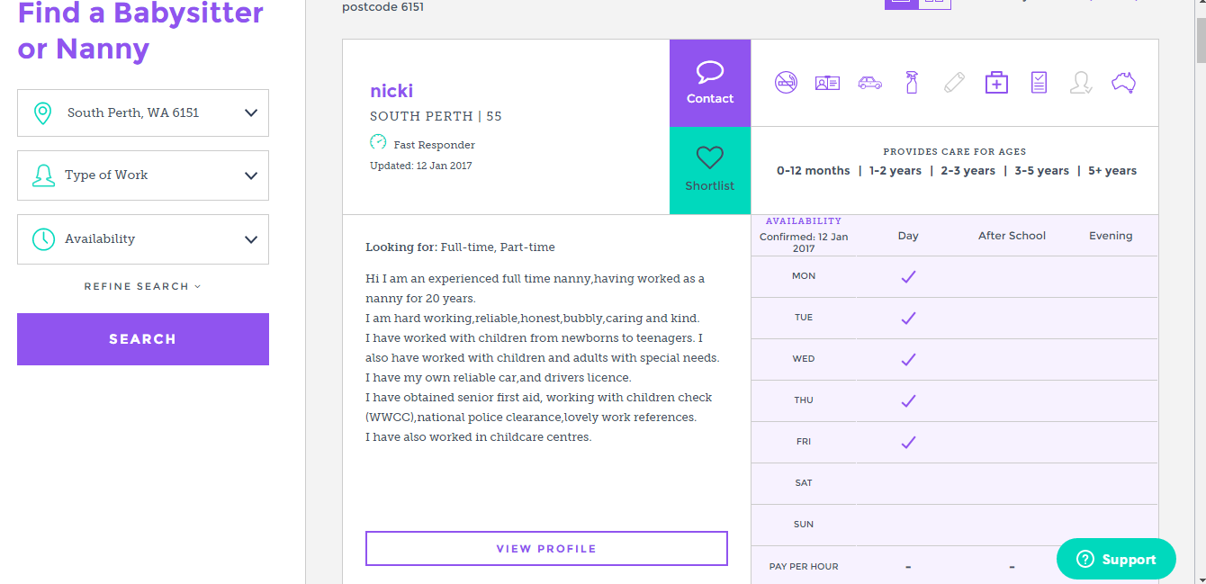

Analytical Features
A google map of the globe showing location pins of all the contractors home cities in one colour and all the registered companies in another. Zoomable but no further information on the map

For Contractors
“How do I compare” ranks a variety of numerical stats on a bell curve against all other registered contractors of that contractor type and displays on a chart as well as percentage.
Compare the individual contractor against his peers in dayrate, years of experience, a dayrate vs years of experience scatter plot etc.
Also compare all of the above against similar contractor types listing a specific skill

Free basic members can see the charts but figures are missing from the charts. For these members there should be a large call to action button “upgrade to view full analytics”.

For Employers
Employers can also compare criteria of all contractors of a particular job type, for example they can see the bell curve of contractor day rates to see what they should be expecting to pay for example, for a geologist in the mining industry.

Short term contract and Confidentiality agreement documents can be customized on the website by the employer by answering a few questions and sent directly from the employer to the contractor for signing.

Advertising
The website should have space for paid advertising on all pages

Employer Reviews
Contractors can request a review form an employer that has made contact via the website.(1-5 stars, short comment).
Once an employer has made contact with a contractor through the website, they are able to give a review (1-5 star rating) and make a short comment endorsing the contractor.

Articles
The articles page will have articles written for Linkedin and Rigzone about contractor workforce in the new, lean oil industry, featuring links to GNGConnect.
A simple image and first few paragraphs of each article summarized on the page with “read more”. Click through to go to the entire article.

Resources
Resources page will have links to helpful resources such as Public Liability insurance, editable Service Contracts and editable Confidentiality Agreements that can be edited online and downloaded as a pdf document, or have an affliliate link to a third party website.

Contact Us
Contact Us page should be a simple internet form that the person fills out online which converts and sends an email to the administrator and then sends an automated email to the person thanking them for their contact and we will be back to you shortly response.

Style Inspirations
The style should be modern and professional. Streamlined and functional but also understated style.
Although the logo is red, please use red as an accent colour, not to be too dominant in the theme.

Website Styles
Expert 360
https://expert360.com/
I like the simple, clean, professional, but bold style of this site. The landing page directs you straight to a call to action. The orange colour is used sparingly as a strong contrast.



Standard Chartered Bank
https://www.sc.com/en/
Approachable but professional design. This may be a little busy for the landing page I envisaged.


WoodMackenzie
https://www.woodmac.com
I like the geometric feel, clean lines and professional but interesting.



