Logo Questionnaire

Creative Brief for Logo Design

YOUR STYLE
Select all the logos that represent your style. Which styles communicate the personality of your company?

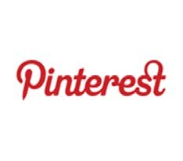 | 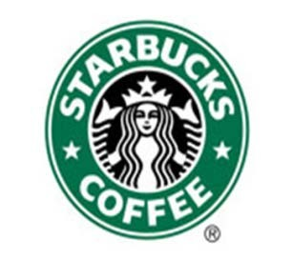 | 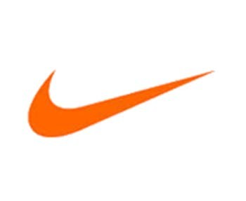
Text Only | Emblem | Simple

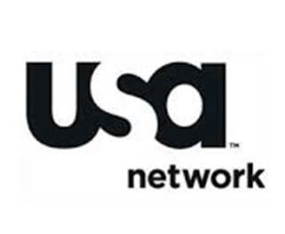 | 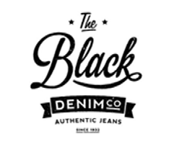 | 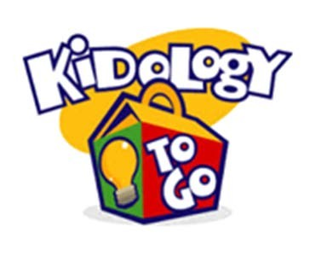
Negative Space | Vintage | Fun

 | 
Modern | Other

Which Style you like:

- If you selected Other, please describe:

Please see concept examples that I sent

COLORS
Please select all the colors that you like. It provides us a starting point.

- I have colors I like Maroon and Silver, with blue medical emblem

- I have specific colors I need to adhere to. (Specify with your designer later) Maroon and Silver, with blue medical emblem

- Don't have any specific color preference (Select from below)

 |  | 
Cool | Warm | Modern

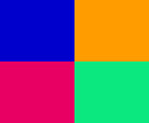 |  | 
Bold Colors | Monochrome | Earthy

Color Scheme you like:

VISUAL REPRESENTATIONS OF YOUR BUSINESS

There might be some established imagery that are used today in your area of business. Please indicate images that you like and dislike.

Describe images that you LIKE to represent your business
Example (You are a painter): I want a paintbrush in my logo

Blue medical emblem

Describe images that you DON'T LIKE to represent your business
Example (You are a painter): I don't want a paint bucket in my logo

Your Information

First Name: Laura

Last Name Kamrath

Email: Laura@zebramarketingsolutions.com

Phone: 713-502-3612

Logo Usage

Check all the places where you want to use the logo.

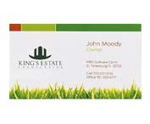 | 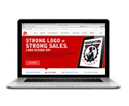 | 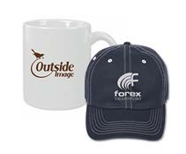 | 
Business Card | Website | Promotional Merchandise | Social Media

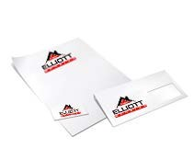 | 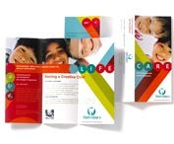 | 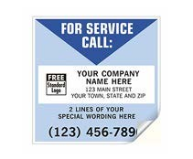 | 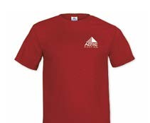
Stationery | Printed Marketing Material | Labels | Uniforms

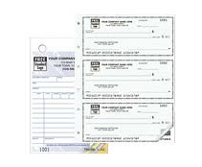 | 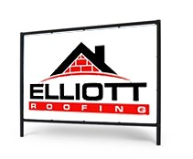 | 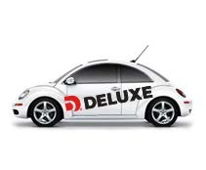 | 
Checks & Forms | Banners & Signage | Company Vehicles | Retail Packaging

If Other, Please describe below:

The logo will be placed on the company’s ambulances

YOUR COMPANY OR ORGANIZATION INFORMATION

Please fill out information about your business. We want to learn about your business. The more we know, the better your match will be.

Business Name:

Dignity Best EMS

(EMS stands for Emergency Medical Services, or Emergency Services – either of these 3 terms could be included in the logo depending on design)

Describe these products
(I sell products)

Describe these services
(I sell services)

Provides ambulance services

Describe what makes you different from your competition
(Describe your key differentiators)

A smaller company, they give more personal customer service attention and better prices to their customers than a bigger company would.

Describe your brand
(Try to use adjectives like: modern, fun, trustworthy, luxury, hip, cool, etc.)

Combination of traditional and modern, trustworthy, honest, responsible, loyal, experienced, dependable, state of the art, expert, there when you need them most.

Anything you would like to add?

This is an ambulance company – so logo should have attributes that you would associate with needing an ambulance or emergency medicine when you’re in a crisis situation - dependable, reliable, and offers top level care. The customers will be doctors, homes for the elderly, end of life care centers (hospice), hospitals, etc.

