Real Estate Agent ∨ | LOGIN
Building Reports 4 Sale
www.buildingreport4sale.com.au
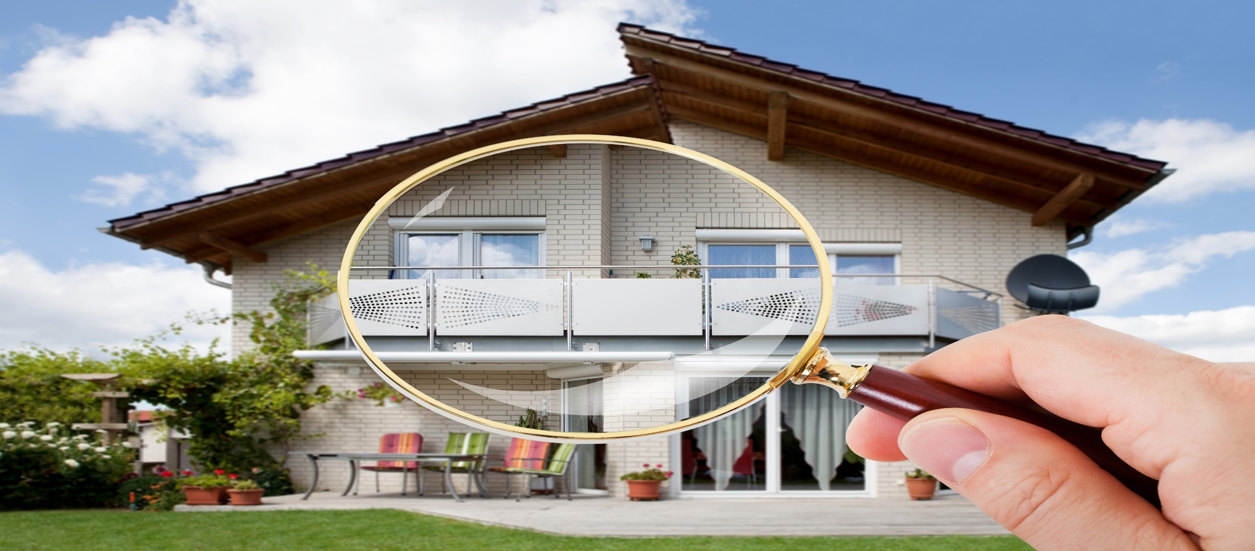 | HOME | BUILDING INSPECTION TYPES | INSPECTORS REGISTER TO LIST COMPLETED REPORTS | ABOUT US | CONTACT
Don’t pay for a building inspection when an existing inspection report is available.
Building Inspection reports for sale online for $200.00 plus GST in PDF format.
Simply enter the address of the property and click search.
Pay with PAYPAL, VISA, AMEX or MASTERCARD

SEARCH FOR A BUILDING INSPECTION REPORT 4 SALE RRRREPORREFFINSPECTIONINSPECTION NOW

INSPECTION TYPE ∨ |  | Search by suburb, region, postcode or address
SEARCH

