I would some logo representing the name Alders and a reference to software development or consultancy. My brother has a real a state agency using this logo:

http://www.alders.nl/

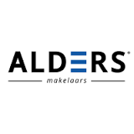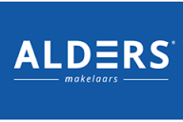

I would also like to have the name alders in the logo but it would also be nice to have some kind of abstract logo in there. And i would realy to use some other colours than dit hard blue.

Other logo I like are:

