

the property is marketed exclusively b y

LAURENTIAN MOUNTAIN PROPERTIES AND ANTIGUA INVESTMENT PARTNERS

CONTACT: GEORGE LATHOURAS
George@laurentianmountain.ca

819-681-9703
Sugar Ridge is a 43-acre mixed use hotel, residential and commercial development overlooking Jolly Harbour Marina and Antigua's best beaches on the stunning West Coast.

The 60-room boutique hotel opened for Christmas 2009 with a new concept and style. It is 4.5* with 5* facilities, including an Aveda Concept Spa, Cybex gym, Sugar Club restaurant and piano bar and Carmichael's fine dining restaurant. It has become Antigua's sweet spot with excellent local trade and tourist Trip Advisor reviews.

There are currently 9 luxury Villas built or under construction of value between USD1.5M-USD2.5M.

There are approximately 25 acres of fully serviced land that has yet to be built out.

Sugar Ridge is the best-positioned property in Antigua to benefit from the return of both the tourism and luxury second home markets. With the advent of the Citizenship by Investment Programme (CIP) in Antigua,

- Sugar Ridge is situated in an approved CIP area.
- Sugar Ridge has 60 existing hotel units that can be sold in the CIP immediately.
- Sugar Ridge is a ready made, turnkey CIP project with management in place.
- Potential to subdivide and reclassify land to create in excess of 300 CIP "units"

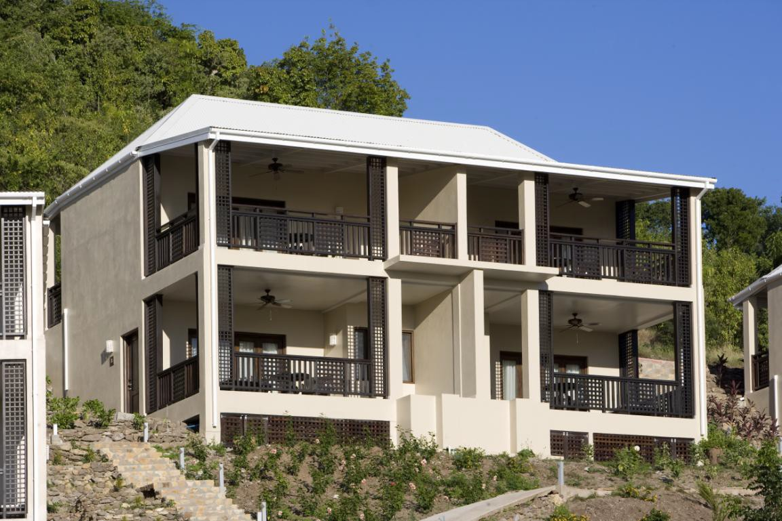
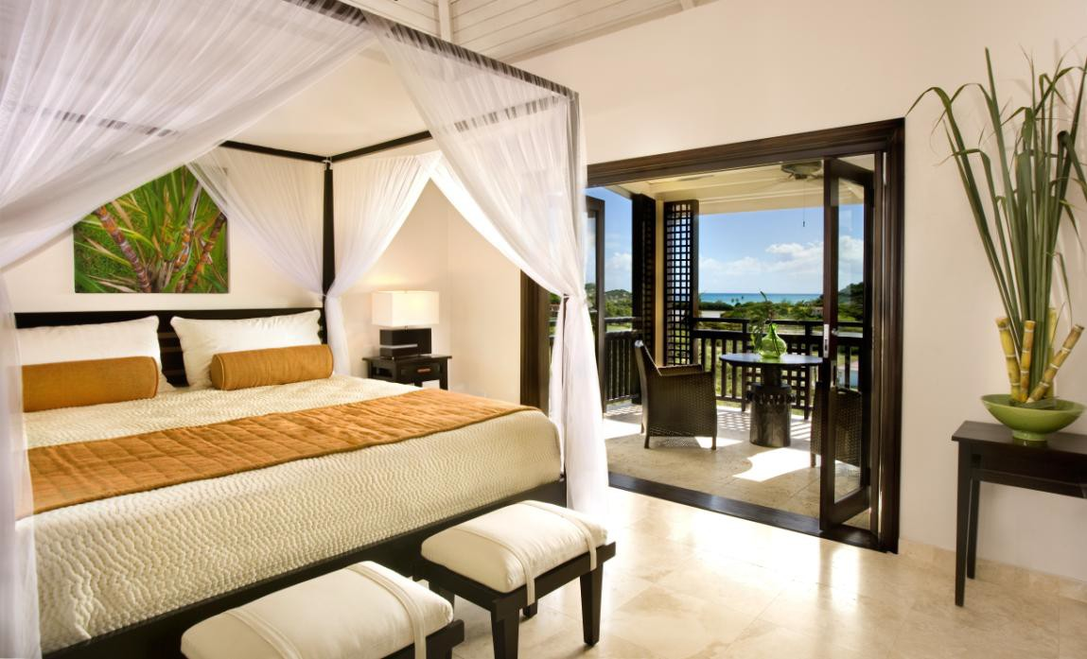

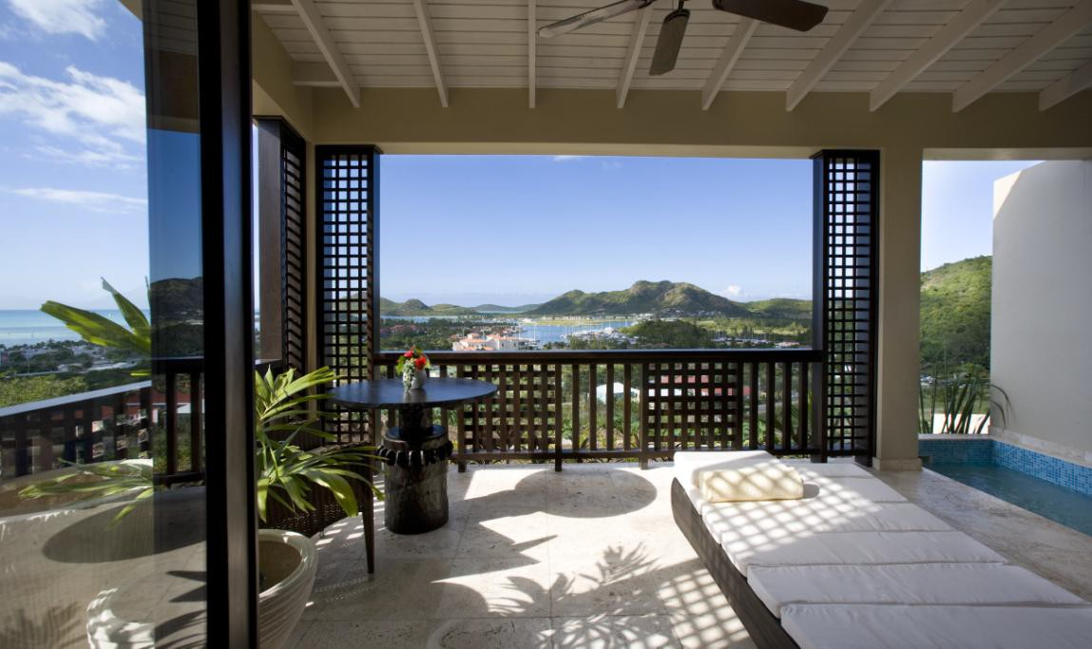
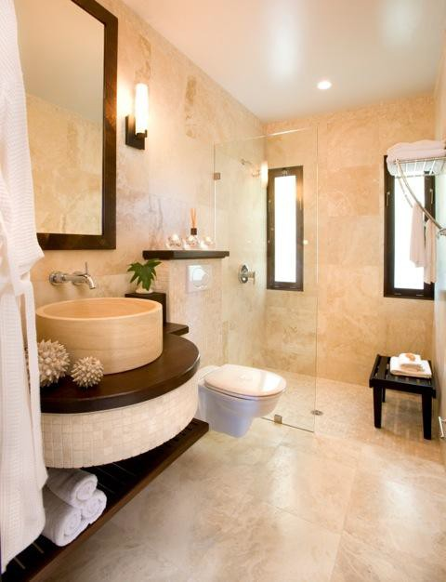

SUGAR CLUB inc. Restaurant, 2 Bars, Spa, Gym, Yoga Room, 2 Pools, Pool Deck and Pavilion.

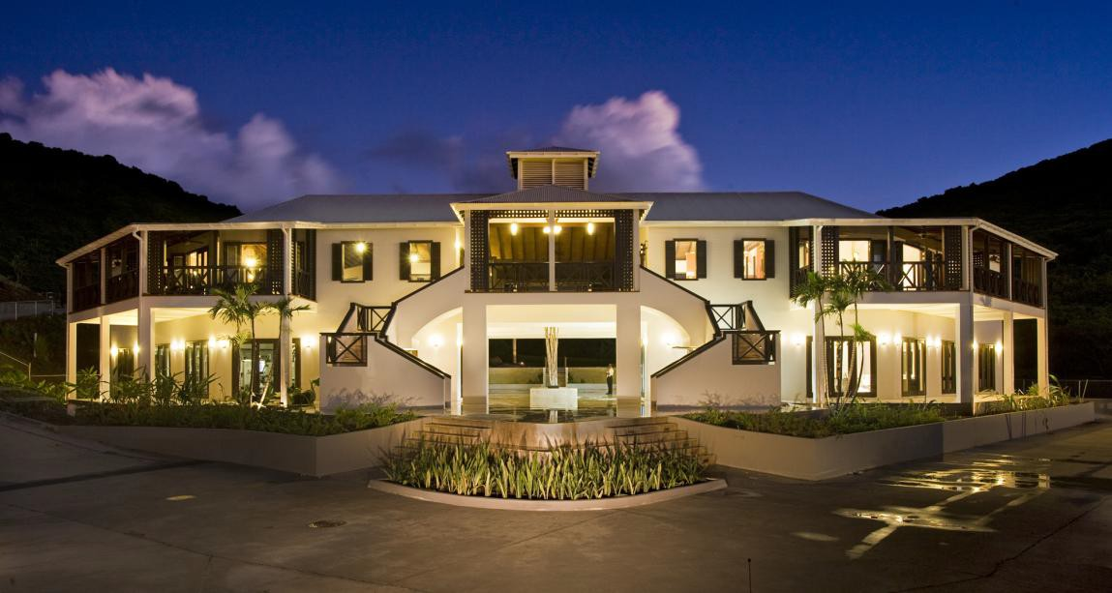
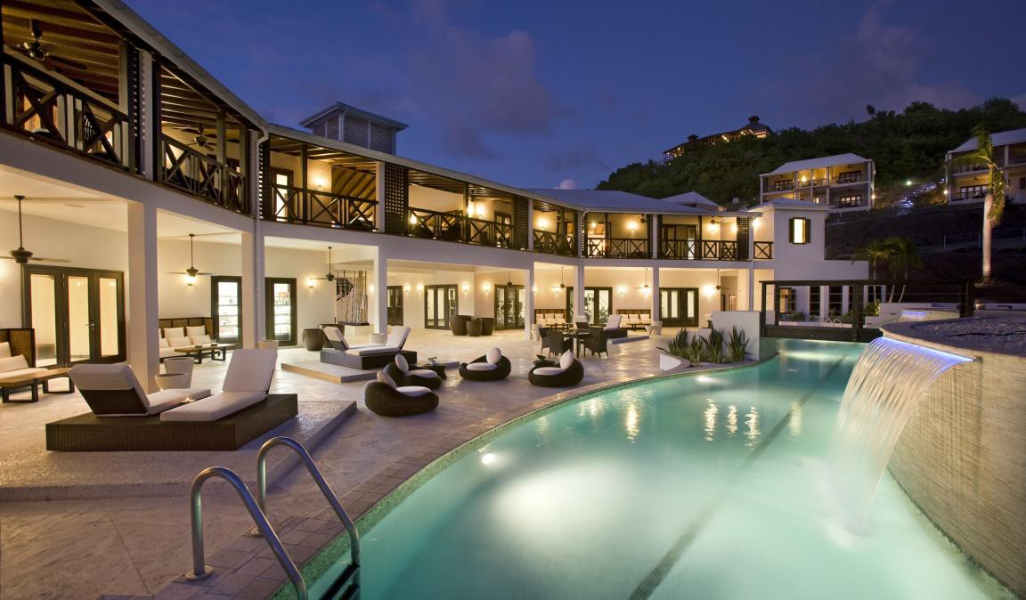

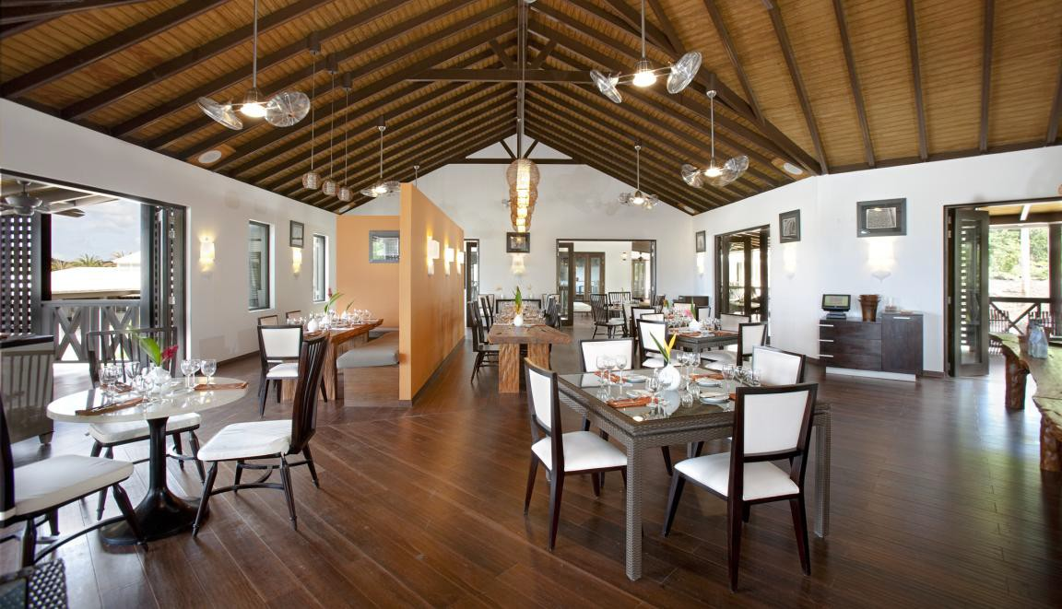
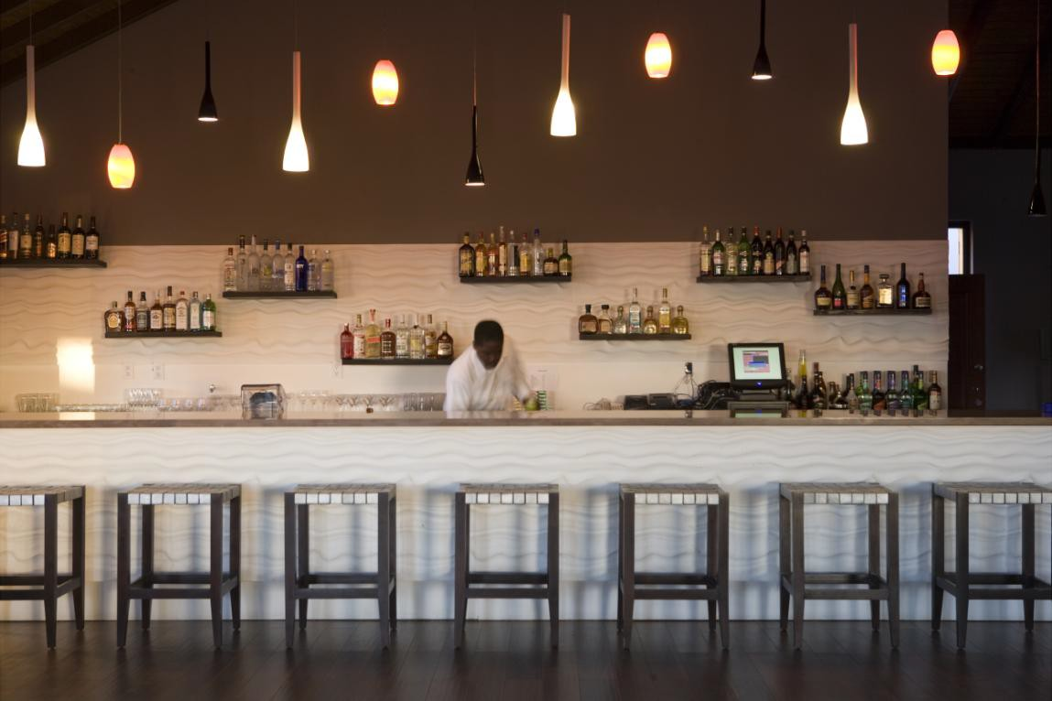

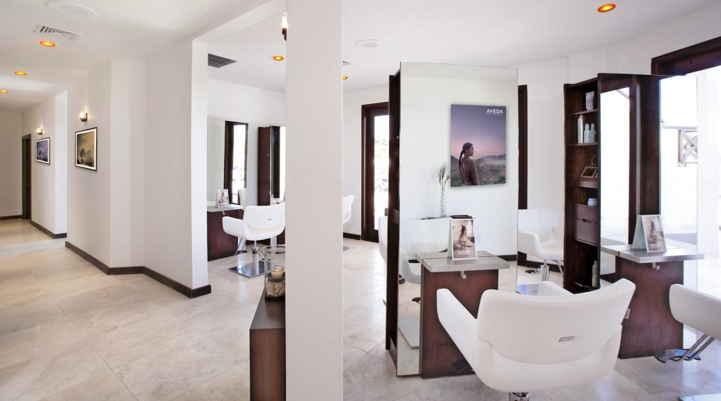
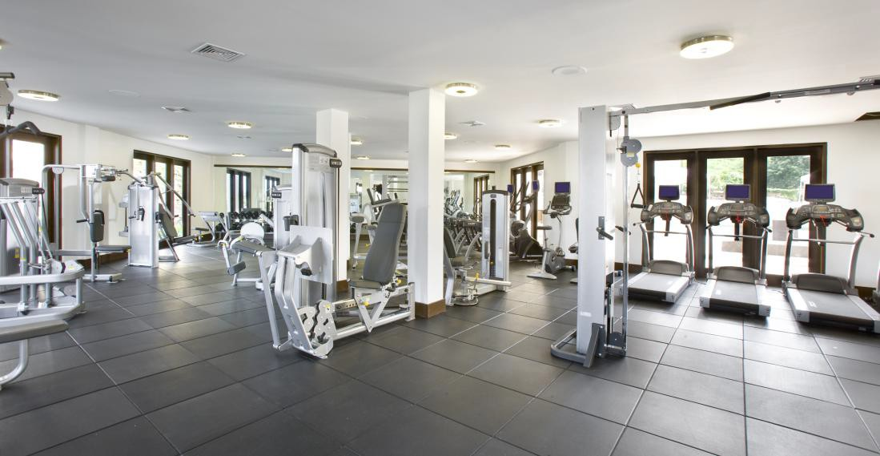

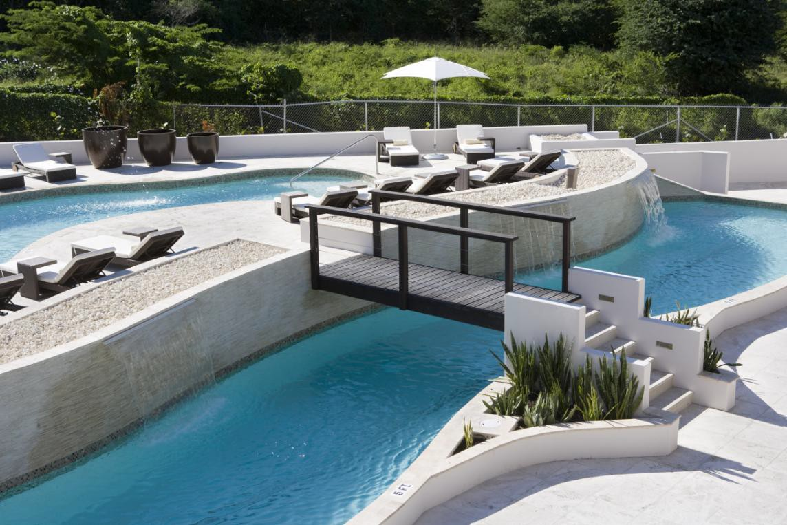

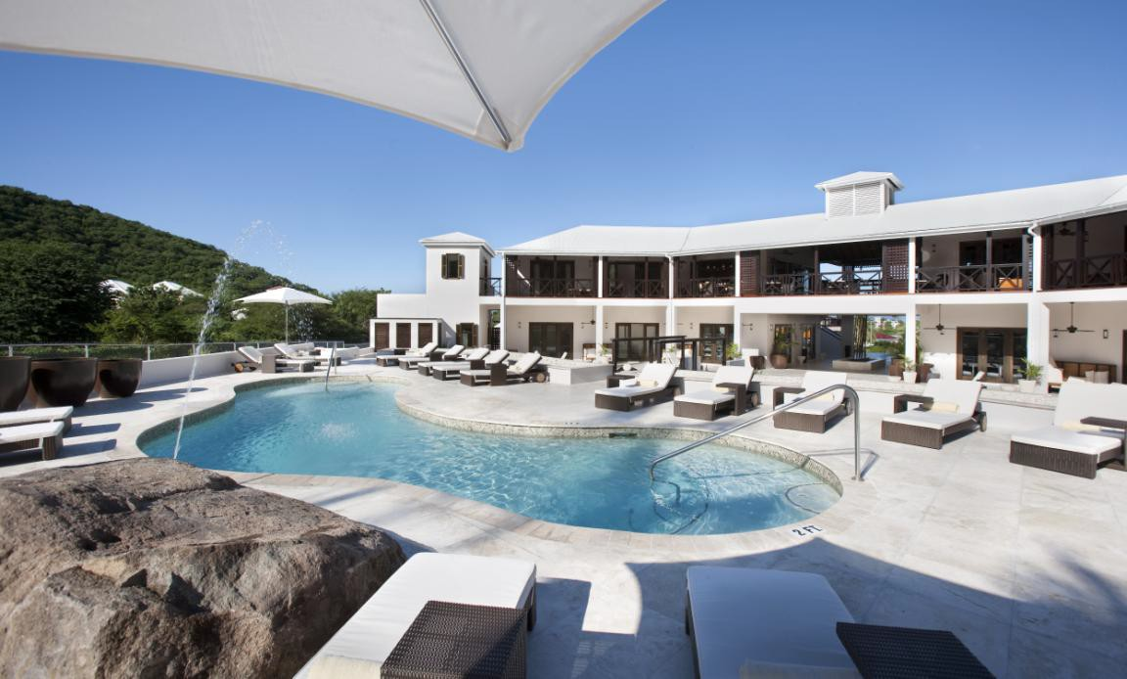

CARMICHAEL’S FINE DINING
RESTAURANT
Inc. Bar, Infinity pool, Wedding gazebos

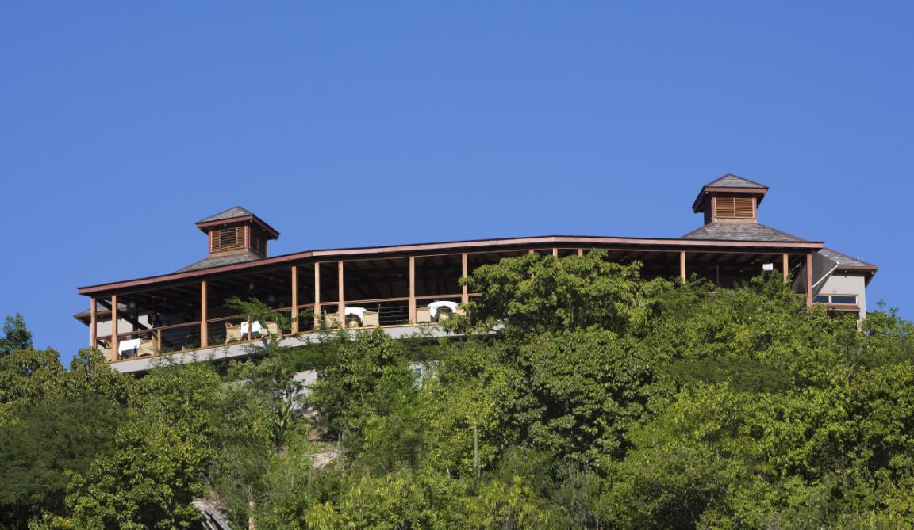

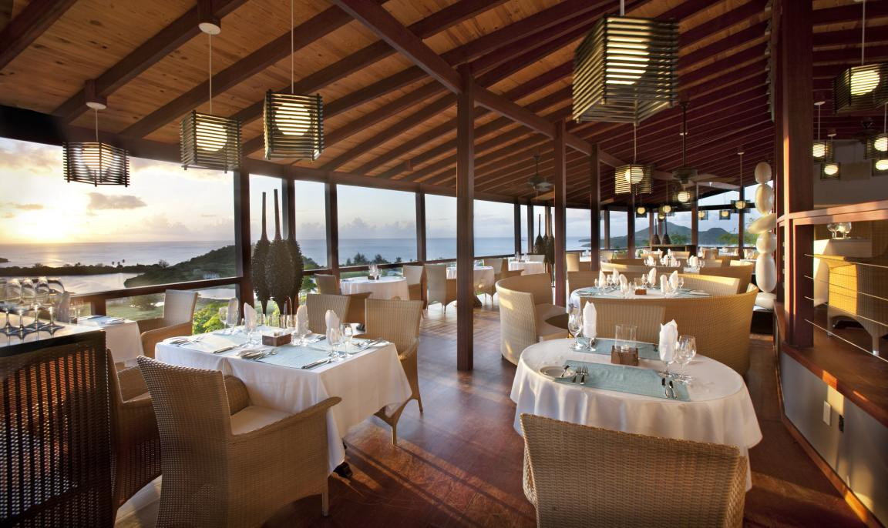

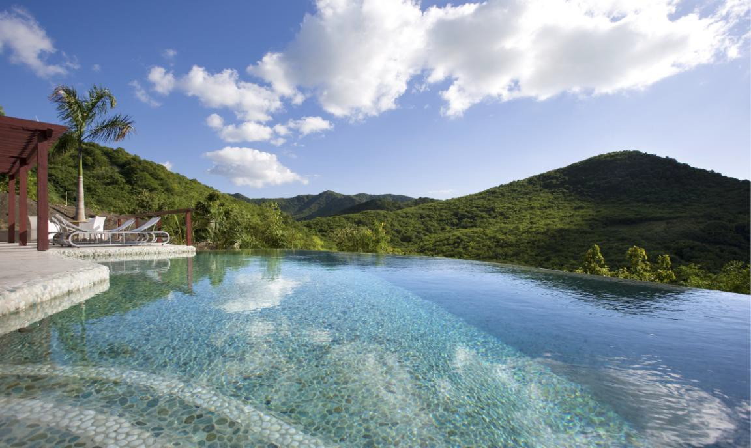

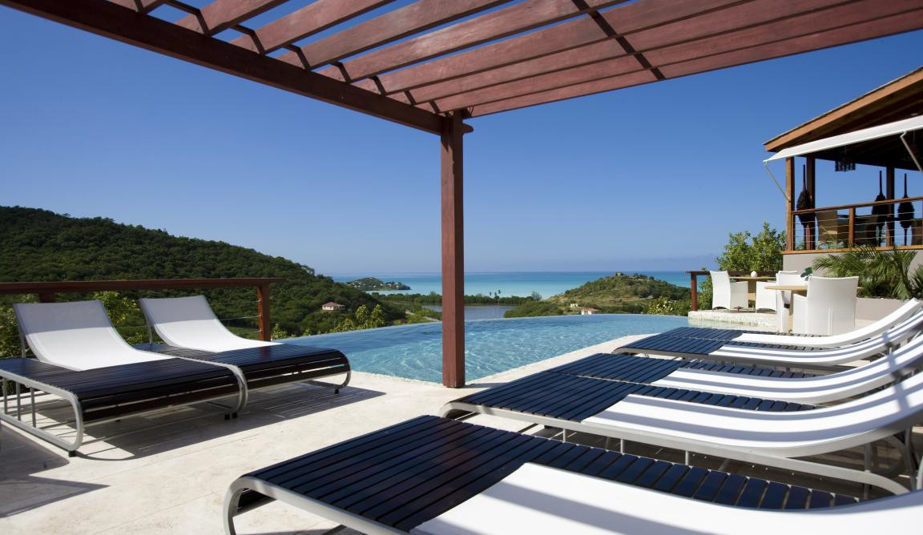

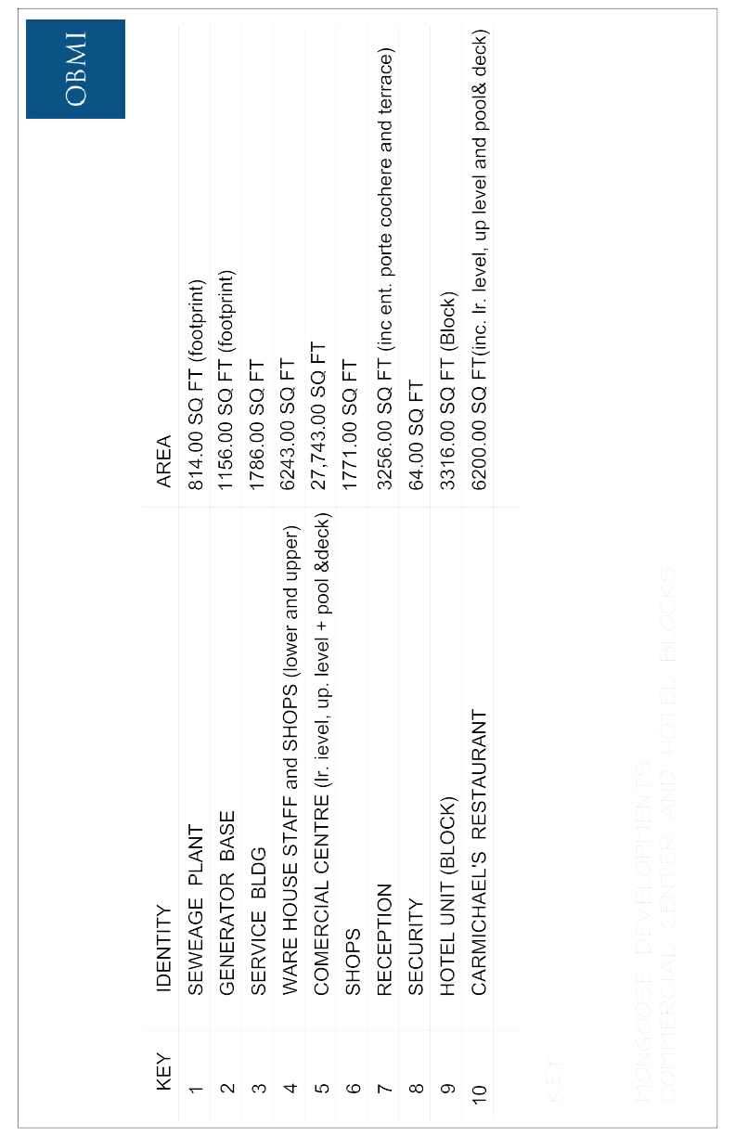

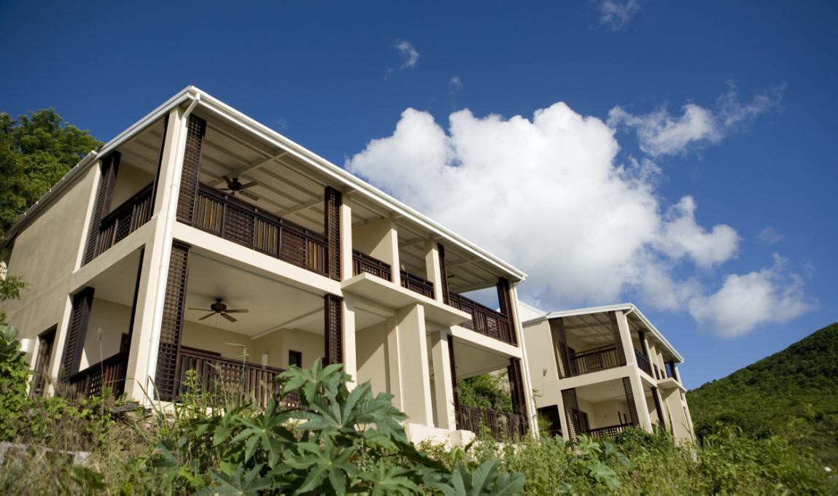

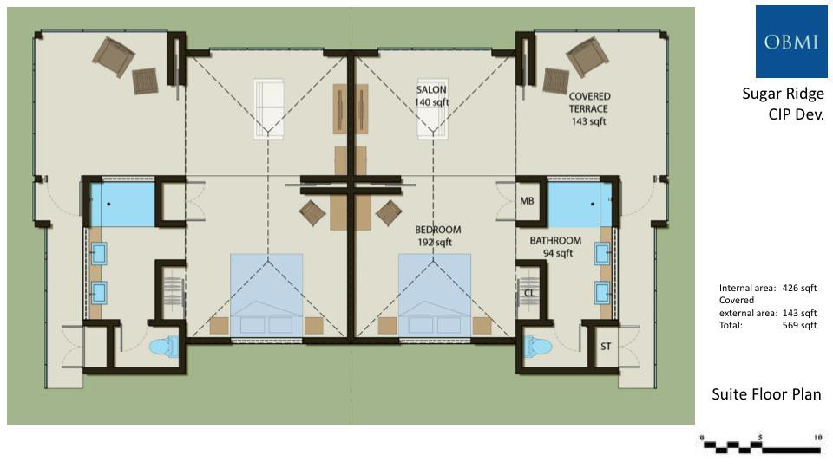

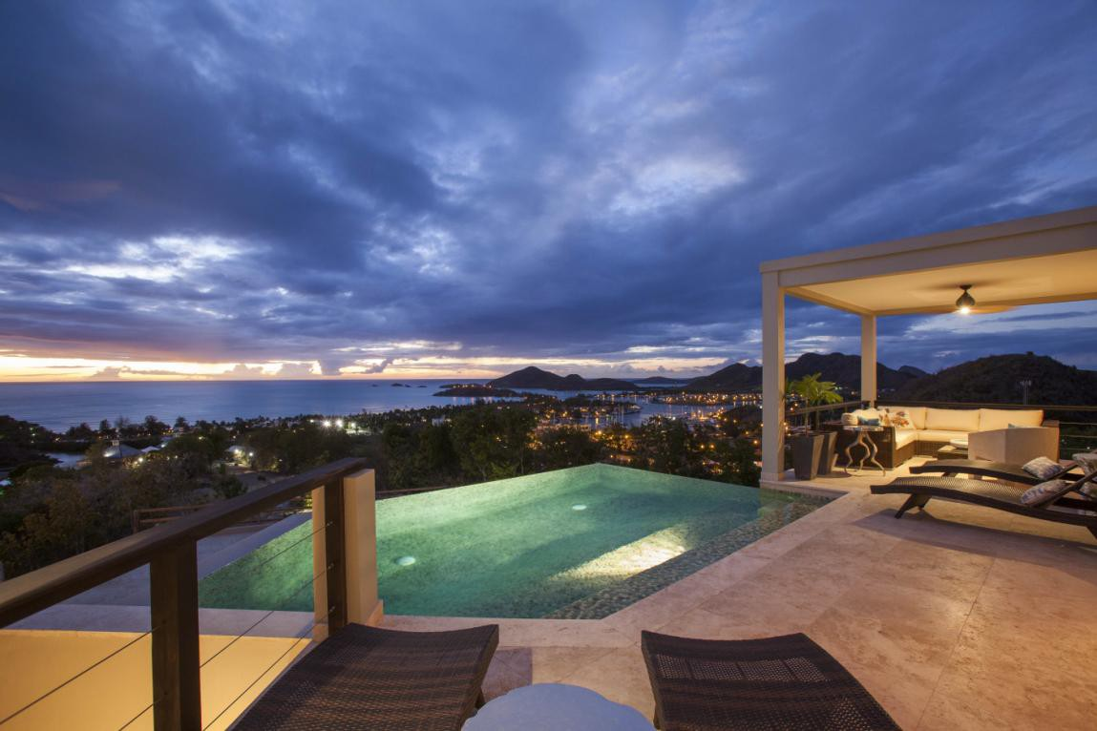

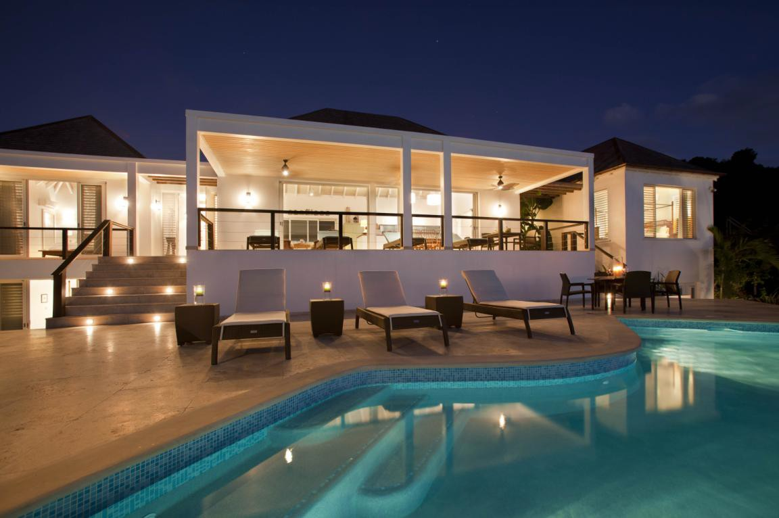

3 Homes Under Construction
PLOT 8
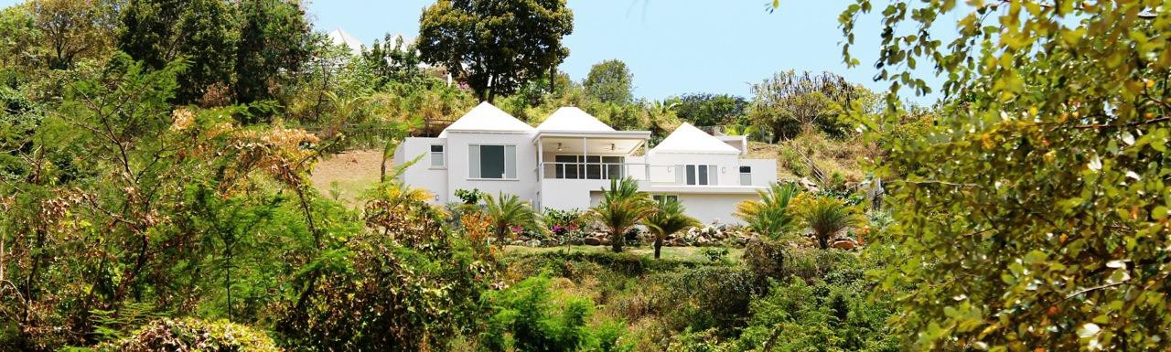

PLOT 6
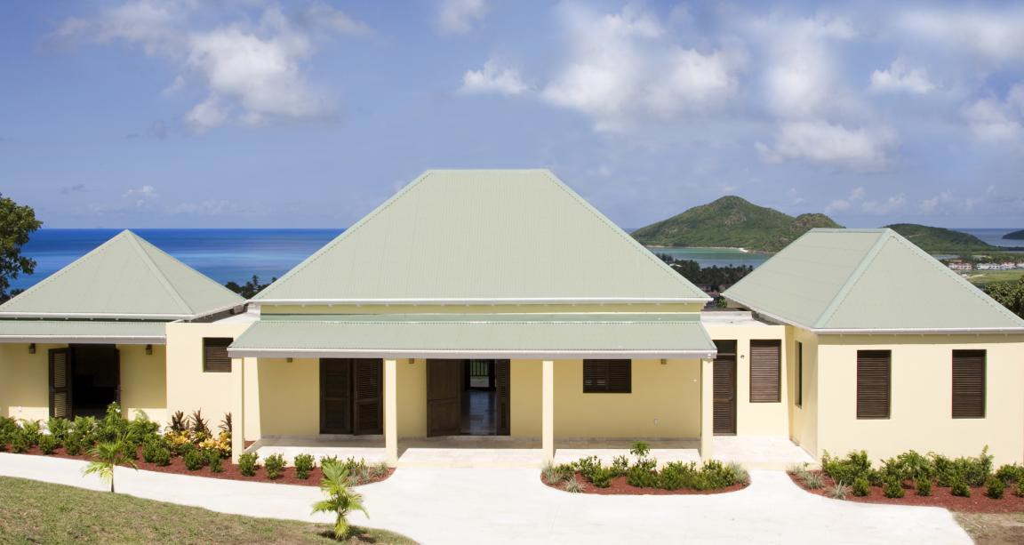

PLOT 33
