PAGE: Home Page

MARTIAL ARTS FOR EVERYONE
Kick, punch, and block yourself to a fitter healthier mind, body and spirit.

BOOK YOUR FREE TRIAL NOW (button that needs to link to contact form)

At Twin Tigers we teach the Northstar Ju Jitsu system of martial arts which is a powerful, easy to learn self-defence system suitable for men & women of all ages and children from 3 years of age.
Northstar Ju jitsu combines elements from various martial arts including Taekwondo, Jujitsu, kickboxing, Judo and Aikido into a blended system that gives students the advantage they need to protect themselves in virtually any situation.
Martial Arts is one of the best fitness classes. As you feel good about your weight loss, increased flexibility and new levels of stamina and energy, your confidence will shine.
We welcome and encourage all people from every walk of life to come and join in the experience.

PAGE: About Us

Sub-page: The Twin Tigers Team
[Photo to be provided]
James Storey
Head Instructor
Twin Tigers Martial Arts was founded by James Storey a qualified Northstar Ju Jitsu Black Belt and trainer. James is a 1st Dan Black belt in Northstar Ju Jitsu and has a competition experience in boxing, kickboxing and sports ju jitsu along with teaching children and adults at Northstar before founding Twin Tigers Martial Arts.

[Photo to be provided]
Rhiannon Storey
Operations
Rhiannon divides her time between managing the operations of Twin Tigers and looking after their young son and future tiger cub, William.
NOTE: I need the ability to add trainers

Sub-page: Northstar Jujitsu
What to expect in your first class
A typical Northstar Jujitsu class starts with a stretch and warm-up designed to get you moving.
This includes punches, blocks, kicks and a variety of calisthenics exercises like push-ups and sit-ups. More than likely you haven’t done some of these movements before, that’s okay, we will partner you with a buddy and you can go at your own pace.
Following the warm-up, we usually do a variety of pad-work which might be boxing or kickboxing combinations or practicing our kicks on the strike shield. We try to partner new students with more experienced students and the instructor always comes around to help.
We then break into our belt levels and go through our multiple defence (kata) and self-defence which includes various Ju Jitsu techniques like wrist locks, throws and escapes
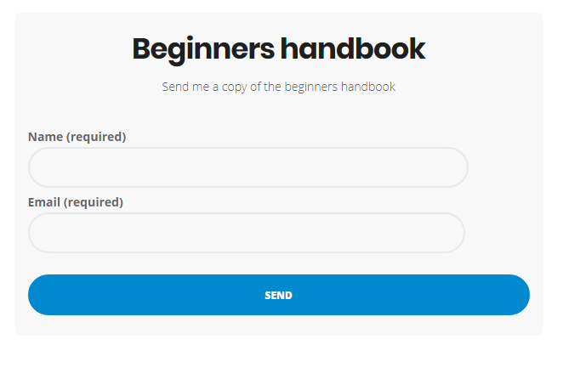
Download our beginner’s handbook
NOE: Have form that people complete so I can send an email and the beginners handbook.
PAGE: Children’s Martial Arts
HAVE FUN, GET FIT, STAY FOCUSED!
[insert children’s logo]
We teach the Northstar Ju Jitsu system, which is designed to be a practical, fun, easy to learn system that develops your child’s motor skills and boosts your child’s self-esteem.
The Northstar Jujitsu System combines self -defence moves from Taekwondo, Judo and Jiu Jitsu and is a great non-contact way to keep your child active and focused in a fun and friendly atmosphere.
Classes are broken into Bright Stars (5-8 years) and Super Stars (9-14 years)

Adults’s Martial Arts

HAVE FUN, GET FIT, STAY FOCUSED!
[insert NSJJ Logo]
Northstar Ju Jitsu immortalises the spirit of the ancient samurai in modern society. The program is a newer, evolved approach to martial arts and life relevant to our society and culture.
Developed by Sensei Andy Dickinson, Northstar Ju Jitsu integrates traditional elements of ju jitsu, Taekwondo, Judo and Kickboxing into a holistic practice or self-defence and fitness, and also as a space for personal growth within our hectic modern lives.
We guarantee that even after your first class you will have usable skills that will stay with you for life.
You will learn to kick, punch and defend yourself in many different situations. No matter what size or fitness level, you will be taught to generate explosive power by using your entire body weight to strike weak points.
Women will have usable and practical moves that can be used on a larger, stronger opponents even after training for a short time.
You can join the sparring class and test your skills against others in a robust and safe training environment.
There is plenty of kicking and punching, plenty of pad work and our classes are really safe so don’t worry about getting hit or getting hurt.
The classes mix in plenty of strength and conditioning work and they are excellent for fitness and endurance.

PAGE: Timetable

Mon | Tue | Wed | Thur | Fri | Sat | Sun
 |  |  |  |  |  | Adults 11.15am to 12.15pm
 |  | Adults -7:00pm to 8.00pm |  |  |  | Children 12.15pm to 13.00pm

Location Details

Classes are located at Level 1, Paddo RSL Club, 220 Oxford Street, Paddington

PAGE Contact Us
T: +61 490 732 882
E: info@twintigers.com.au
Location Map
Level 1, Paddo RSL Club, 220 Oxford Street, Paddington

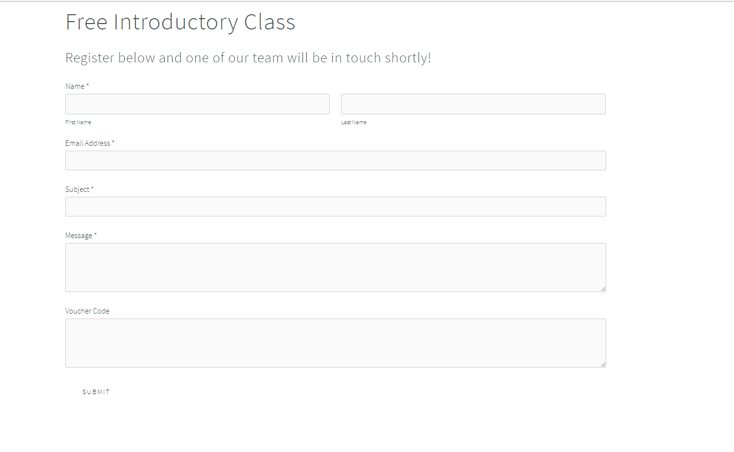

PAGE: This week at TTMA

This needs to be my editable blog.
+++++++++++++++++NOTES++++++++++++++
Footer needs to be Copyright 2017 Eastside Martial Arts ACN 616 394 291
I need lots of fun and friendly stock photos that I can update later with real photos once the school is up and running.
This is a family friendly atmosphere please see the following websites which are within the broader northstar community.
www.northstarmartialarts.com.au
http://www.keystonemartialarts.com.au/
https://quantummartialarts.com.au/
http://www.weststarmartialarts.com.au/
www.eurekamartialarts.com.au
http://espritmartialarts.com.au

