NOMAD Human-Advertising
Zipcar Case Study

Learn how Zipcar used the NOMAD billboard network to get their message inside Stanford and other universities to drive more users for their car sharing service.

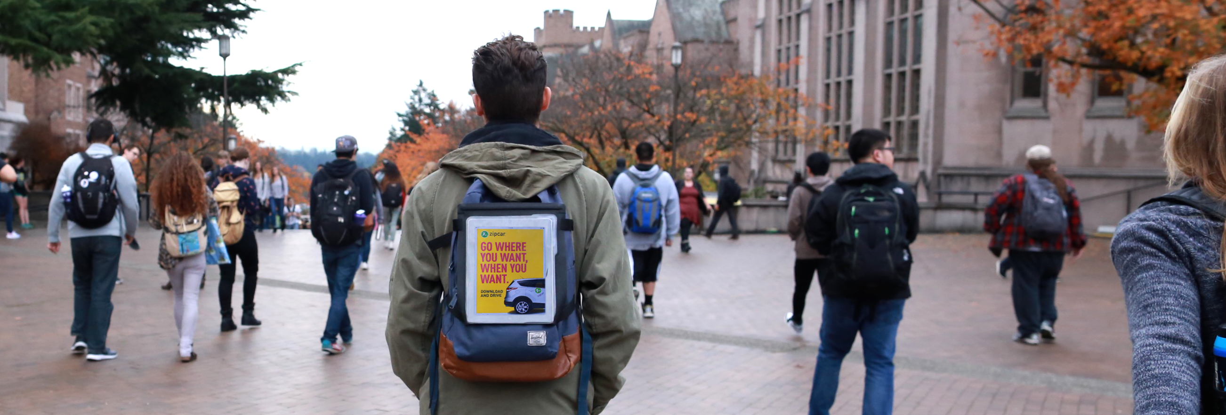

About Zipcar
Zipcar is the world’s leading car sharing network, driven by a mission to enable simple and responsible urban living. With its wide variety of self-service vehicles available by the hour or day, Zipcar operates in urban areas and university campuses in over 500 cities and towns where they offer immediate access to cars on campus parking lots. Zipcar is a subsidiary of Avis Budget Group, Inc.

About NOMAD
NOMAD is the world’s only network of human-powered advertising where highly visible college students carry digital billboards on backpacks on campuses and major metropolitan areas. NOMAD’s network provides something no other billboard can offer – interaction with a real person and the ability for companies get their message anywhere.

Why Zipcar Picked NOMAD
Zipcar has always approached college students with innovative marketing efforts, from student ambassadors, to pop-up booths, to social media promotions.

Margaret Lapp, who oversees Zipcar’s campus marketing, saw in NOMAD an opportunity to offer a completely new way to get students’ attention that combined the agility of digital marketing with a human touch: “NOMAD gave Zipcar a brand new and unique way to engage with students by literally being in front of them as they walk to classes, dorms and events,” said Margaret. “There’s also a powerful new social factor since it’s the students’ peers carrying the ads.”

NOMAD’s digital billboards also allowed Zipcar to change messages at the click of a mouse, allowing Margaret to create different messages to drive students to web pages about Zipcar locations on their specific campus. “I also liked using NOMAD’s real-time trail maps that showed me where the students were walking and where on campus Zipcar’s message had been seen.”

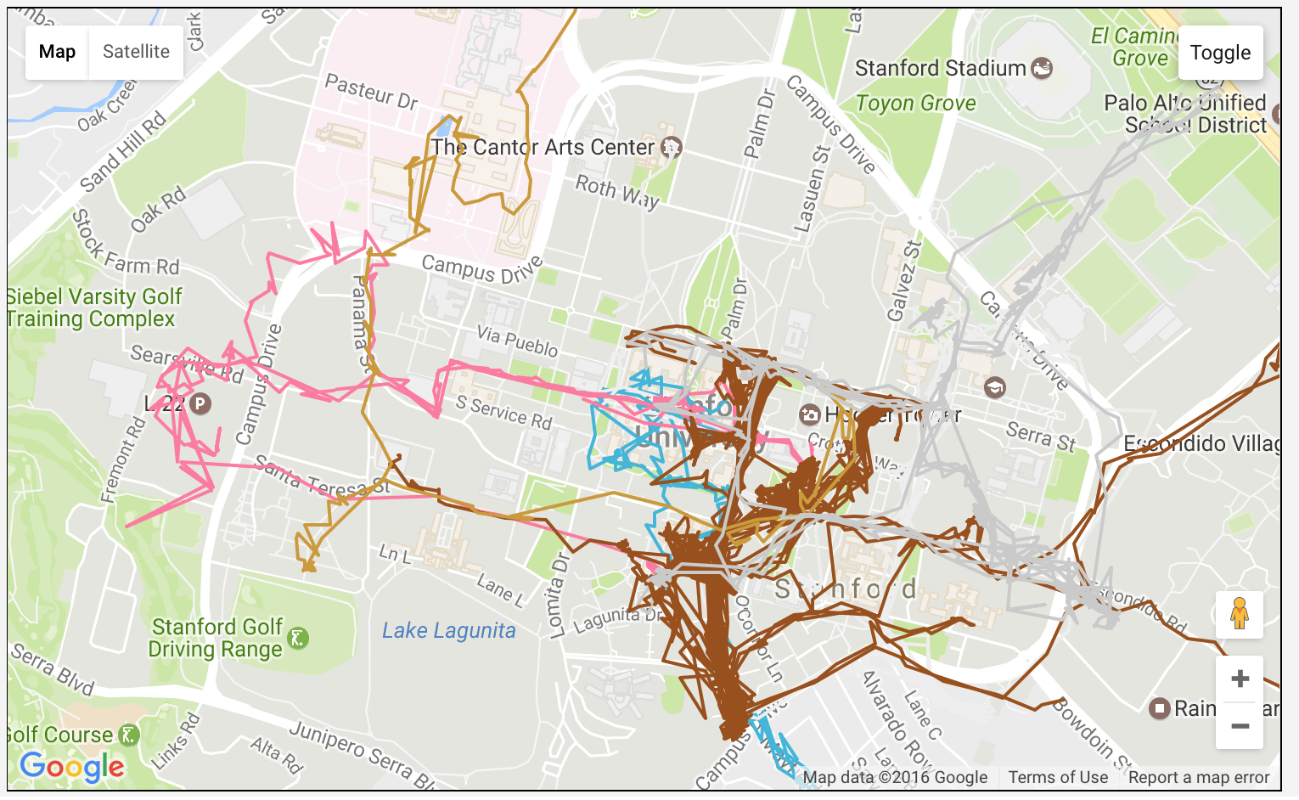
NOMAD trail map showing where each student walked on Stanford’s campus with Zipcar’s ads during a 1-day period.

Tangible Results
During the fall of 2016, Zipcar first began using NOMAD on one campus, and quickly expanded to three where they have significant presence (multiple parking lots with Zipcars), including Stanford University, University of Washington and San Diego State University.

At the end of the fall semester, Zipcar’s evaluation of NOMAD’s effectiveness led them to not only continue using the service on the original three campuses, but also expand to three additional universities, including UC Santa Barbara, US Santa Cruz and the University of Oregon. This decision was based on NOMAD’s ability to provide:

1) Measurable results provided by trail maps and data analytics, that showed the time and location of Zipcar’s ads across three campuses, as well as large-scale exposure of over a quarter million student impressions.

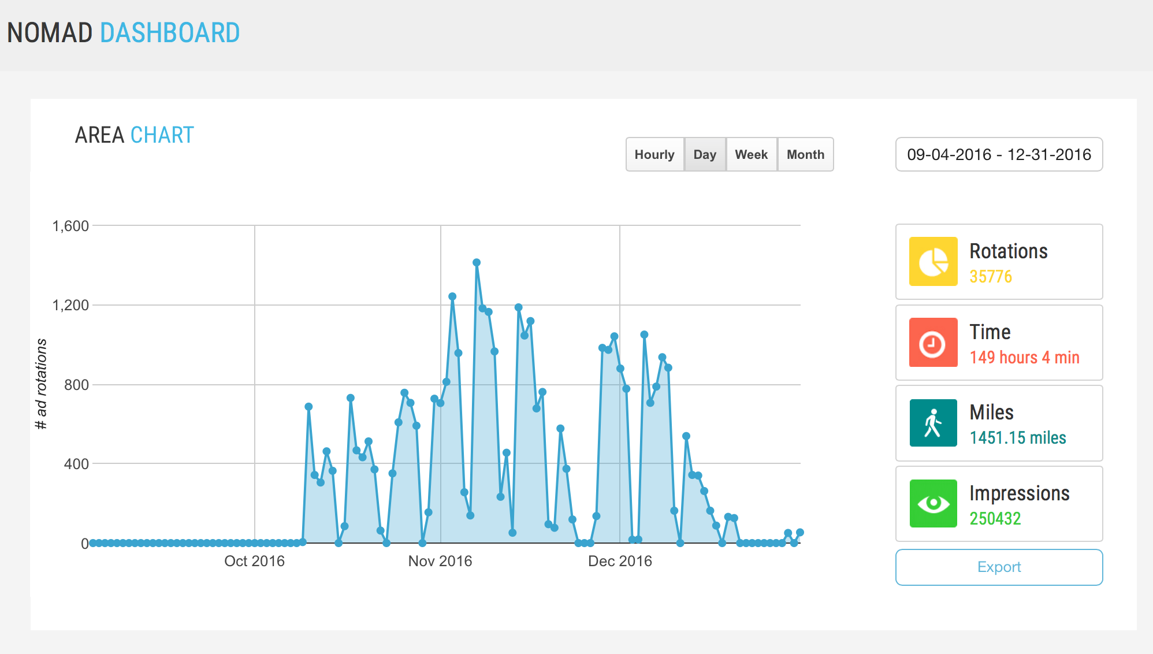

2) Greater campus intelligence & insights: One of the surprising results came from NOMAD’s heat map analytics, which shows where the greatest concentration of student messages were displayed. Zipcar is now using these maps and data to help them determine the best locations for future Zipcar locations on campus.
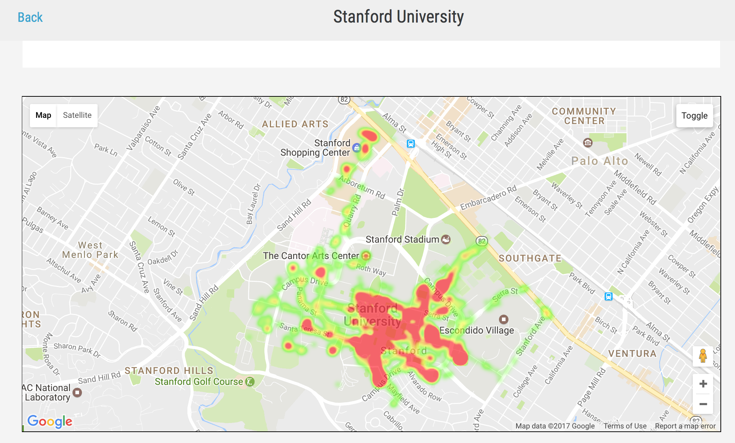

NOMAD heat map showing concentration of messages over time.

3) Increased traffic to Zipcar’s specific campus sites, such as www.zipcar.com/sdsu

4) Ability to have a presence at campus special events. For example, NOMAD deployed student billboards with Zipcar ads at ESPN’s Game Day event at the University of Washington.

“A lot of on campus advertising can be a black box – you don’t really know how effective it was,” said Margaret, “With NOMAD, Zipcar can now measure exactly where and when our message is displayed on campus – and see the results immediately.”

