The Art of
Stress: THE BOARD HAS TOO MUCH WORK TO DO
Relax…and let us do the work.
Stress: YOUR COMMUNITY HAS “ISSUES.”
Relax…and let us give you a Fresh Start.
Stress: YOUR MEMBERS CANNOT PAY ONLINE.
Relax…we’ll give your members multiple ways
to pay.
Stress: COMMUNICATION IS POOR OR INCONSISTENT.
Relax…we’ll keep you informed with a robust online portal, chock full of information.
Stress: YOUR DELINQUENCIES ARE HIGH.
Relax…as a licensed collection agency, we have developed an effective collections program that works in tandem with your collections attorney. Plus, we can report to the credit bureau!
COME IN TO TALK AND START RELAXING TODAY!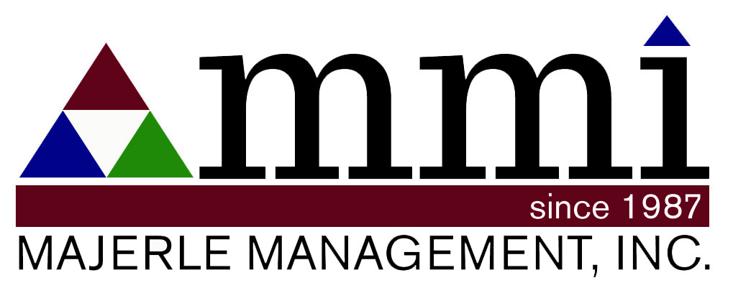
Relaxology
for Board Members

