Step One: Blood Draw
First step in a PRP Therapy injection is to draw the patient’s blood sample to prepare the platelets.

2
Step Two: Spin To Separate PRP
The blood sample is then loaded into a centrifuge and is spun for a certain amount of time to separate the components, mainly Red Blood Cells, Poor Platelet Plasma and Platelet Rich Plasma.

3
Step Three: Load the PRP and Inject
Once you’ve successfully separated the PRP (buffy coat), it can directly be loaded into a syringe for application onto the patient.

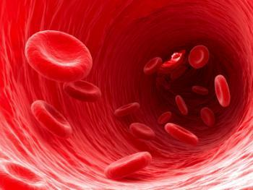

PRP IS 100% SAFE
PRP Therapy uses Platelets harvested from your own blood
Therefore there is no risk of rejection, disease or allergic reaction

PRP is very Convenient
PRP can be performed in a lunchtime
No need for any complex surgical procedures or hospital stays
It’s easy and quick in skilled hands
Performed in our day Clinic

PRP is 100% Natural
Regrow your hair using the Stem-cell regrowth factors
Contained in your own natural occurring Platelets

