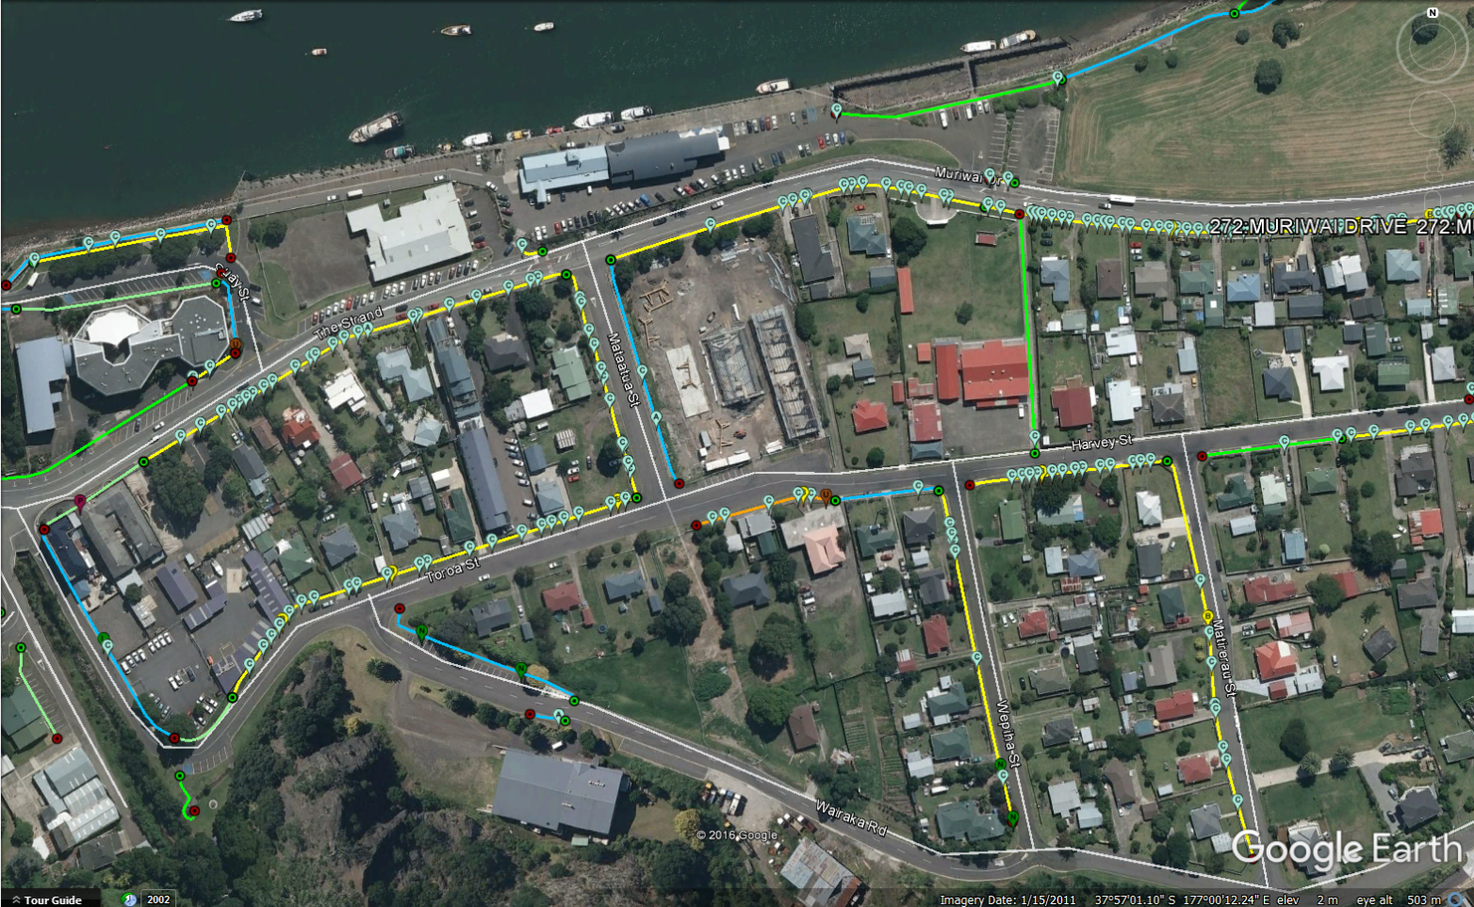
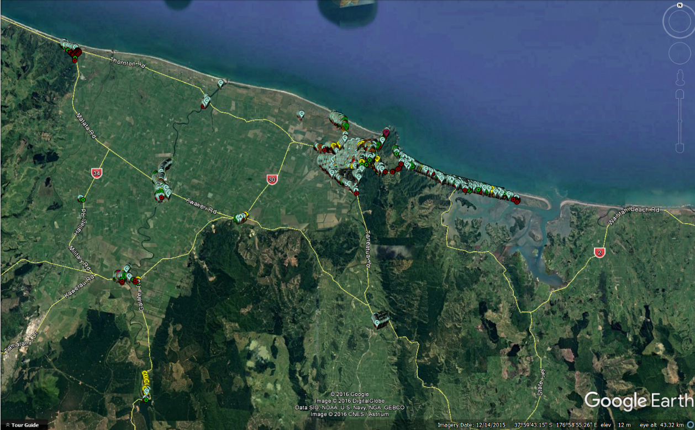
Whakatane District- 15,700 footpath faults. Individually located and prioritised.

