ccRobot/Home page
To get you going, here are some ideas we are thinking of including on the home page. Not all of the points have to or should be included on the home page. We are looking for your design expertise to make the homepage attractive while getting the point across.

Digital customer experience is the new battleground.
Your customers are looking for:
On-demand
Low friction
Intuitive

Potential customers are already on your website.
Start the conversation with ccRobot.
Help your visitors get instant answers.

ccRobot
Intelligent customer service automation
A cutting-edge enterprise chatbot platform
Achieving customer experience success has just become a lot easier
Improve customer experience while reducing costs

Web: chat with visitors on your website
Mobile: talk to your customers on-the-go
In-app: help users as they are using your apps

ccRobot makes it possible to transform the way you provide customer service.
ccRobot is not like other A.I. It isn’t programmed and it isn’t riddled with complex algorithms and linguistic models. ccRobot learns by doing.
ccRobot learns to interact with your customers, by learning the way you interact with your customers.

ccRobot is suitable for both large and small organizations. Popular industry applications include:
- Telecommunications
- Finance & Banking
- Government
- Transportation & Travel
- Health & Pharmaceutical, and Retail

Benefits

Why automate chat-based customer service?
- 80/20 Automation: Automate repetitive inquiries and free up valuable time for your employees to focus on critical tasks

- 24/7: Offer 24/7 customer service to your clients. Calls are answered immediately with zero wait time

- Reduce Costs: Lower the cost of servicing your customers by automating the handling of repetitive inquiries

- Customer experience: Improve service quality by standardizing dialog flow and minimizing staff turnover and emotional agents. Provide your customers a natural user interface which they can use to access your services.

- Call volume agnostic: ccRobot has the capacity to scale to handle spikes in call volume, able to handle virtually unlimited number of clients simultaneously

What sets ccRobot apart:
- Omni-language support: ccRobot supports all written languages (as long as they can be typed on a computer). While traditional AI chatbots require a “base language” or working in one language at a time, ccRobot works seamlessly in multilingual and mixed language environments.
- Real world natural language interaction: ccRobot is trained on-the-job (like an apprentice by his master), rather than by programmers and technicians in isolation. By training your chatbot in your live operating environment, your bot learns to interact with the same language that your actual customers use. The result is far more natural, seamless and intuitive style of conversation that customers love.
- Enterprise modules: ccRobot includes a number of modular “add-ons” to make integrating the platform into current operations a breeze (including back-office integration). Popular modules include Email Ticket Creation, Mixed-Media Responses (not just text) and Password Reset.
- Accelerated speed to impact: ccRobot uses the most cutting edge machine learning in the industry, which means it learns very fast. As ccRobot becomes smarter and smarter, you can automate batches of inquiries as ccRobot meets your confidence threshold.
- Data/IP ownership and privacy: Your data is important to you. With ccRobot, your collected data is owned 100% by you – that means full data privacy and no need to share your data with outside parties.
- Low cost independent operations: As the language training occurs on-the-job, there is no need for expensive programmers, computational linguistics or technician support. Organizations can choose when to continue training at will, and on demand, without the need for external development.
If possible, use some dynamic layout/formatting to make these more interesting as well as some graphic next to each. If you have some good fitting icons we would like to see them, otherwise we used the following icons in our PowerPoint (from slide 8):
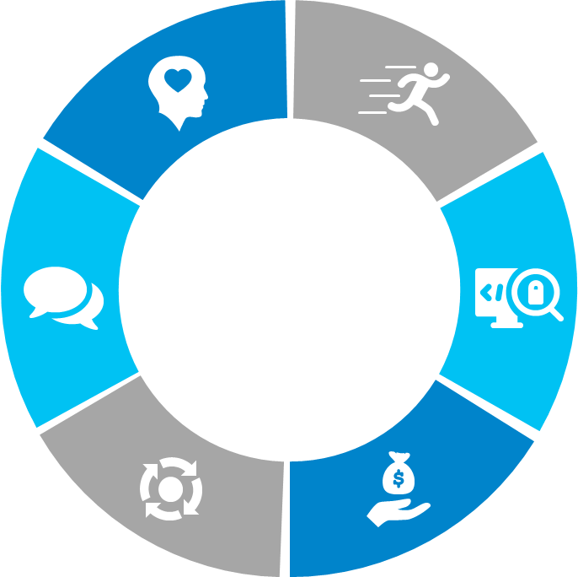

Here are some examples of website designs we like when showing a list of information:
http://nextit.com/platform
http://www.virtualspirits.com/benefits.aspx
https://www.intercom.com/live-chat/olark-alternative
http://ap1.io/platform/apengage/ (clickable buttons which change the content on screen)

How It Works

What is required to get started?
In short, not much! We designed ccRobot to be easy and painless to setup, so that you can get the ball rolling much faster than traditional A.I. products. Implementing is done in five easy steps:
- You provide your existing training materials (such as product FAQs or customer service training manuals)
- We get ccRobot ready for initial deployment (and make tweaks to dialogue flow together)
- We deploy ccRobot on your preferred platform
- ccRobot operates in “learn mode” and gest trained on-the-job, learning from your existing customer service representatives
- When performance meets your requirements, you switch ccRobot to “lead mode” and it handles customers on its own
Put this into a visually appealing timeline layout with graphics to represent each step.
Below is an example taken from our PowerPoint presentation (slide 19):

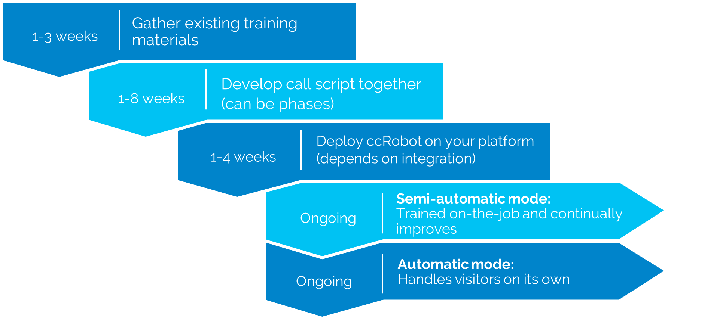

About Us
ccRobot is an enterprise chatbot platform, designed to automate frequent customer dialogues in chat environments – ranging from SMS to mobile web. ccRobot uses the latest in natural language processing (NLP) and machine learning technology to enable excellent customer experience, smooth operator experience and meaningful bottom line impact.
ccRobot is technology owned by Korah Limited. Founded in 2011, Korah Limited is a leader in artificial intelligence for customer service. The company is specialized in automation and business intelligence and has a 25 year history serving leading organizations including Bell Canada, Moneris and CAA. Most recently, Korah launched ccRobot – a cutting-edge enterprise chatbot platform designed to meet the next-generation customer service needs of top organizations.
For more information about us, please visit www.korahlimited.com

Get in touch
Drop us a message
[Your name] (this should be text input field)
[Email Address] (this should be email input)
[Write message here] (this should be text input field)
[SEND] (button should send the above details via email to info@korahlimited.com)

Bottom bar found on all pages (not a separate webpage)

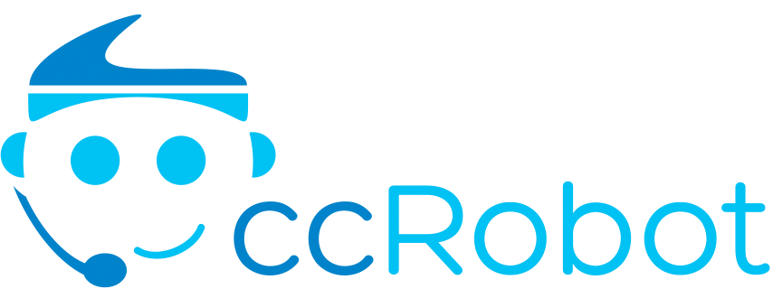 | Benefits | About us
 | How it works | Contact us

© 2017 Korah Limited

