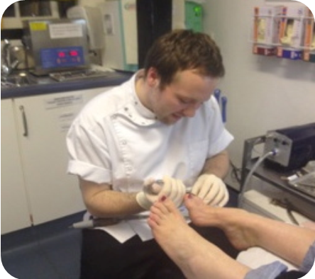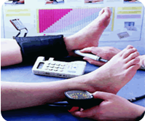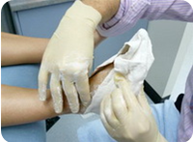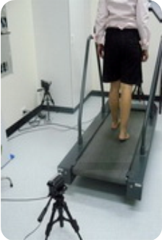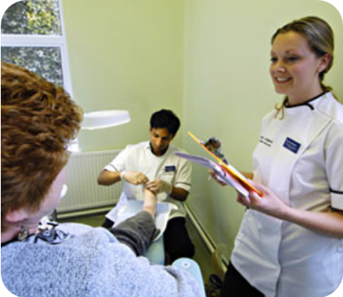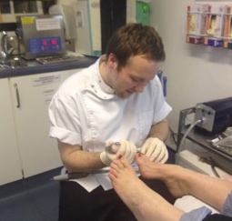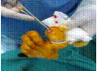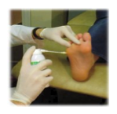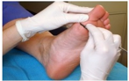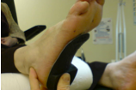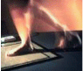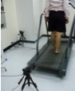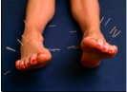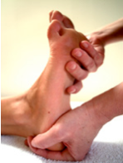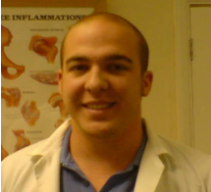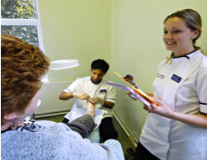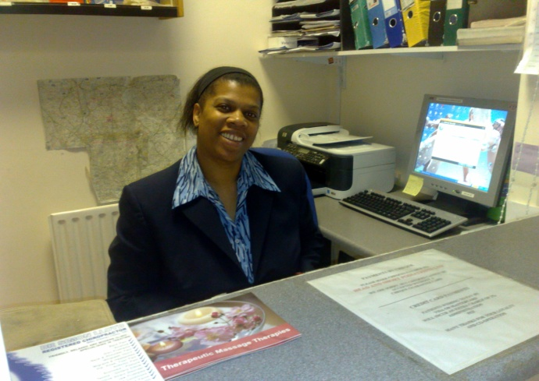
- Athletes foot
- Balance & co-ordination exercises
- Benign joint hyper mobility syndrome
- Bowlegs
- Developmental problems
- How to dress your wound
- Flat feet
- Foot and ankle strengthening with a rubber band
- Footwear advice
- Heel raises
- How to wear your foot orthoses
- In-toeing
- Knock knees
- Strengthening exercises
- Stretching exercises
- Stretching (back & legs)
- Toe deformities
- Toe walking
- Verrucae treatment
- Choosing the right footwear
- Diabetes – do’s and don’ts
- Electro-surgery
- Gait analysis & Biomechanics
- General foot-care advice
- Laser for fungal nails
- Nail surgery
- Patient confidentiality
- Podiatric Acupuncture
- Practice Accreditation
- Verrucae Needling
Our other leaflets…
Free advice leaflets & sheets…
  - Integer egestas orci quis lorem feugiat adipiscing.
About Our
Services
Please telephone us to make an appointment or book online:

Harpenden 01582 467667
Hertford 01992 505105
St. Albans 01727 865343
Stoke Newington 0207 275 0382

www.headandshort.co.uk/podiatry
Head & Short Footwear & Podiatry
14 High Street, St. Albans, Hertfordshire. AL3 4EL
Company Reg. 6741445 VAT No. 975 7625
Head Office:
All of our Podiatrists (Chiropodists) are educated to degree standard (or equivalent), are registered with the Health & Care Professions Council and are full members of the Society of Chiropodists and Podiatrists

Praesent
congue sapien
sit amet justo.
- General foot-care (including nail care, corns, callus, infections, etc.)
- Verrucae treatments, including chemical therapies, cryotherapy and minor surgery (e.g. electro-surgery, excision & needling)
- Minor surgery, including nail surgery for painful in-growing and involuted nails, verruca needling, etc.
- Diabetic foot-care assessment, treatment and advice
- Podiatric wound care and advice
- Assessment and treatment of children’s walking problems
- Musculoskeletal assessment and treatment (Gait analysis and biomechanics), for foot, leg and gait-related back pain, lower limb mechanical dysfunction, soft tissue injuries, massage, trigger point therapy , etc.
- Sports injuries assessment and treatment
- Prescription and supply of off-the-shelf insoles and casted and non-casted orthoses (orthotics)
- Foot-scans, including walk-on pressure measurement, Doppler ultrasound, etc.
- Fitting and supply of specialist footwear and socks
- Podiatric acupuncture
- Supply and administration of medication including antibiotics,
anti-fungals, anti-virals, topical steroids, steroid injections,
foot creams/balms and other
Podiatry related products
- laser for fungal nails

- everything a great Podiatry
practice should do!

We are qualified to offer a wide range of podiatry/chiropody care and treatments including:

How can we help you?

Appointments…
Our surgeries are open full-time in Hertford St. Albans and Stoke Newington and 3 days a week in Harpenden. We will endeavor to see you at a time, which is most convenient to you.
If you are house-bound, and require a home visit, please telephone your nearest surgery and our friendly reception staff will be happy to be of assistance.
Full details of all our services, including opening times, prices, terms & conditions, etc. can be found on our website:
www.headandshort.co.uk/podiatry
Whether you are a new or existing patient we would like to take this opportunity to welcome you. Thank-you, for choosing our practice.

Welcome…

