1. Tribal + Arrows

Concept 1 – Prefer this colour scheme for the logo. Arrows are great. Perhaps incorporating a toy or two might work if we remove the target? Probably best not to mix arrows and animals?

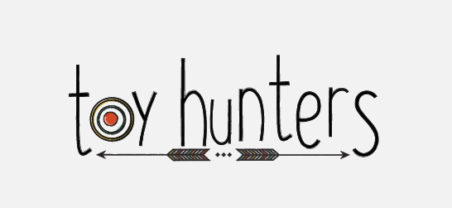

Concept 2 and 3 – Prefer this colour palette



2. Modern - Mascot / Animals / Safari e.g. woodland fox, deer, bear, zebra, giraffe, elephant, etc

https://au.pinterest.com/pin/376895062537592848/
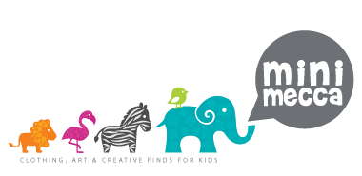

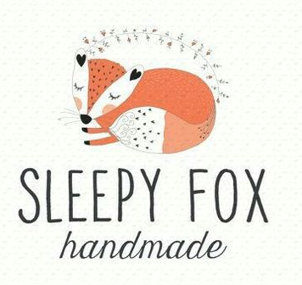

https://au.pinterest.com/explore/woodland-logo/

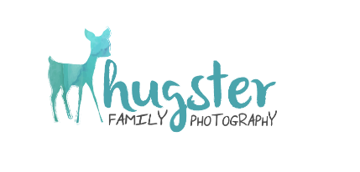
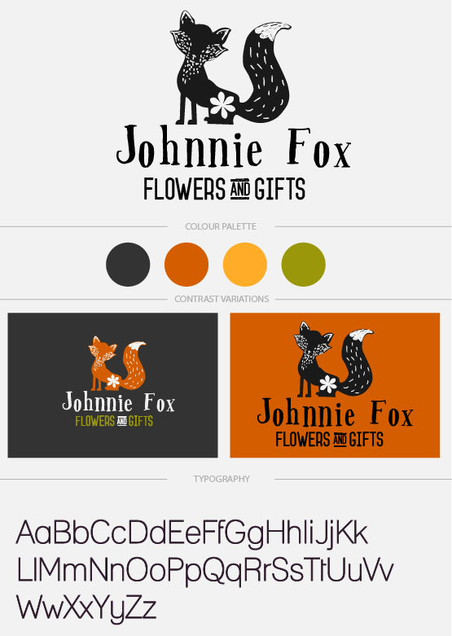

3. Soft watercolours

https://au.pinterest.com/pin/286119382555399329/

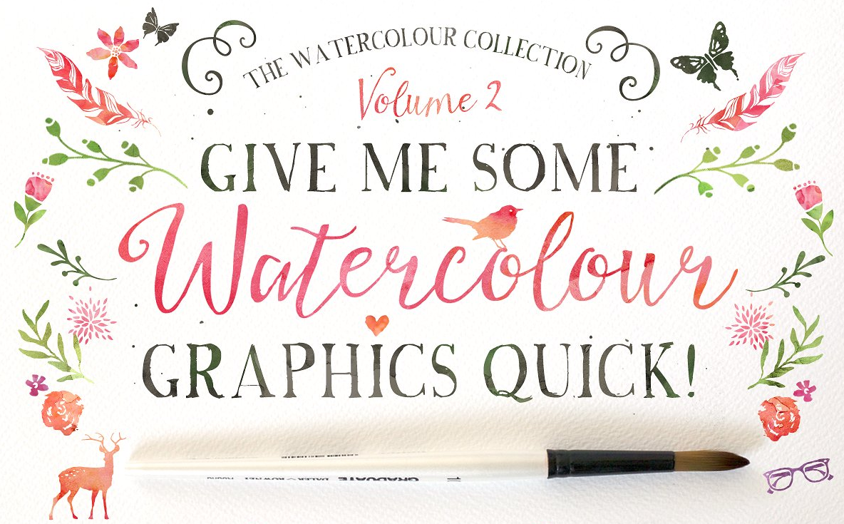

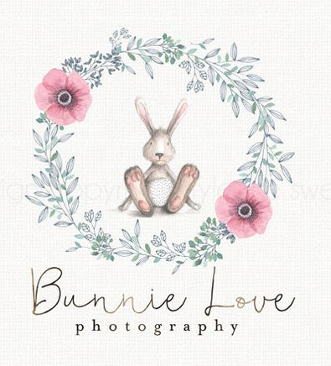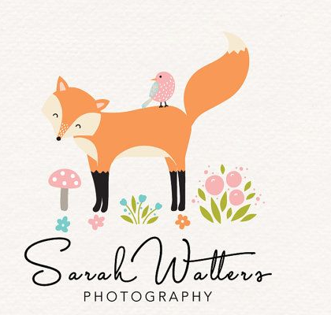

4. Fun / Hip / Bright

