1)First one

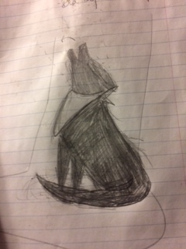

I drew this and it’s pretty much what I want. Maybe just a better drawing and fix the head. This is what a blue healer looks like.
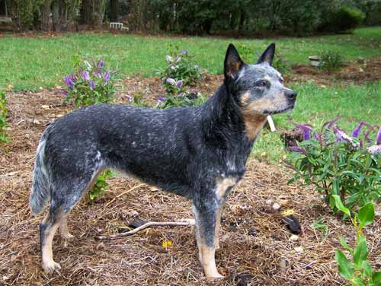

This is the bandana inspiration

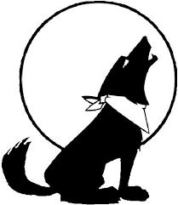
I like the tail on the tribal one and the rough edges, handrawn feel of the moon one. 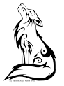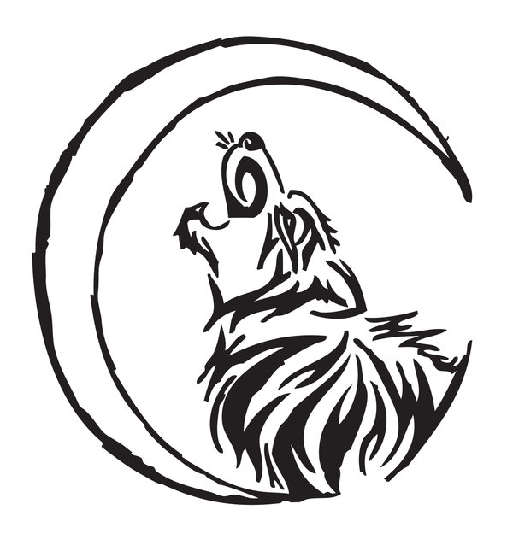

2) Second one. My working sketch is drawn below. planet should be smaller. Thinking classic atlas drawing as seen below with some big changes. I’d like the kid to be barefoot. I like the profile on the left picture but much less cartoonish and slightly higher stance. I like the half toga, skirt thing on the right.

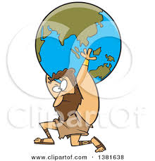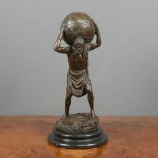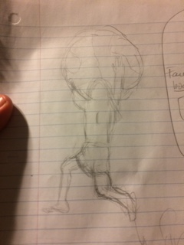

Would like a boy like mowgli below or inspired by one of the kids below. 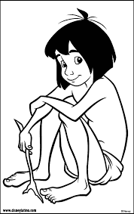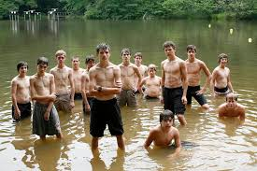

Face is most important. War album har seriousness. But I don’t want anger that he has. I want purpose and vigilance for holding up planet but also just worn out, beaten up, tired can’t take anymore on the face. Same intensity as below but not anger.
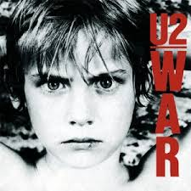

For planet, I think something cool would be video game world inspired reliefed planet. I don’t need it to look like earth.
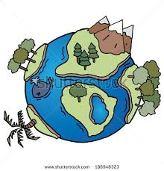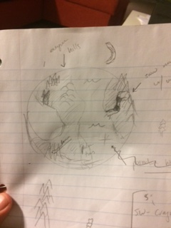

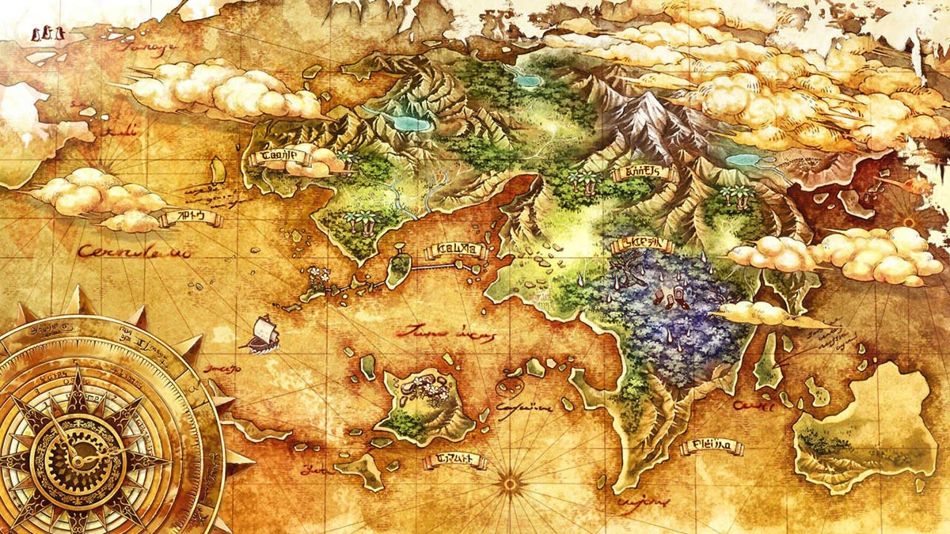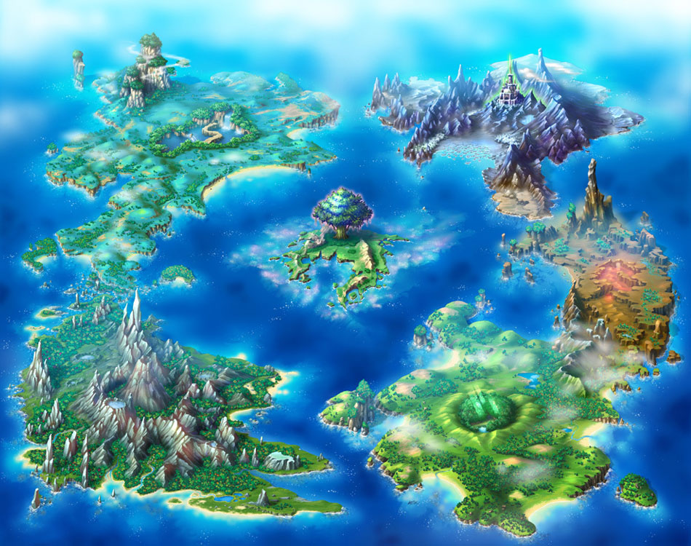

Contact with me any more details. Thanks so much-

Matt

