Looking For | Requirements
- Original  - Clean, fresh  - Stand out  - Professional | - Use green, blue and orange  - Shows what Mowdown does
I like how simple this design is.
I really like this logo. It looks original. I like that the logo is incorporated in the company name.
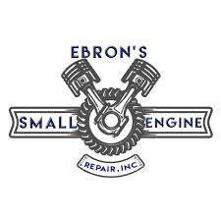
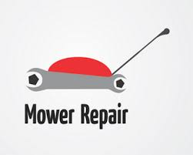
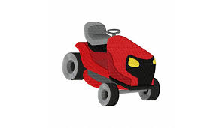
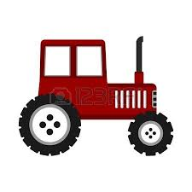
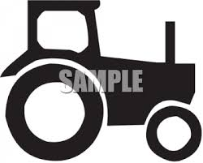
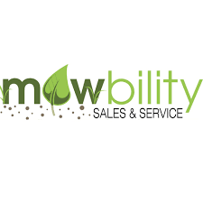
I looove this. I like the old-school look of it. Needs to be more agricultural.

