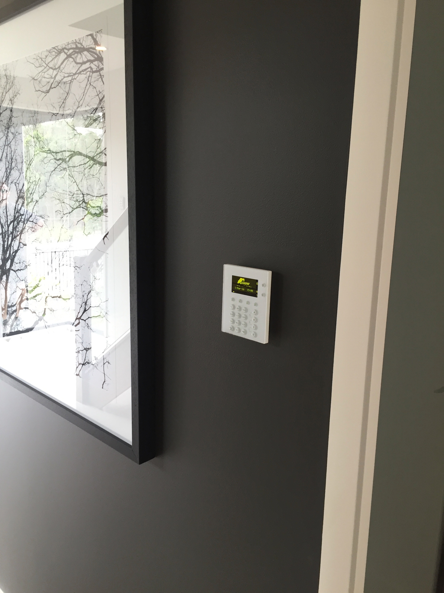
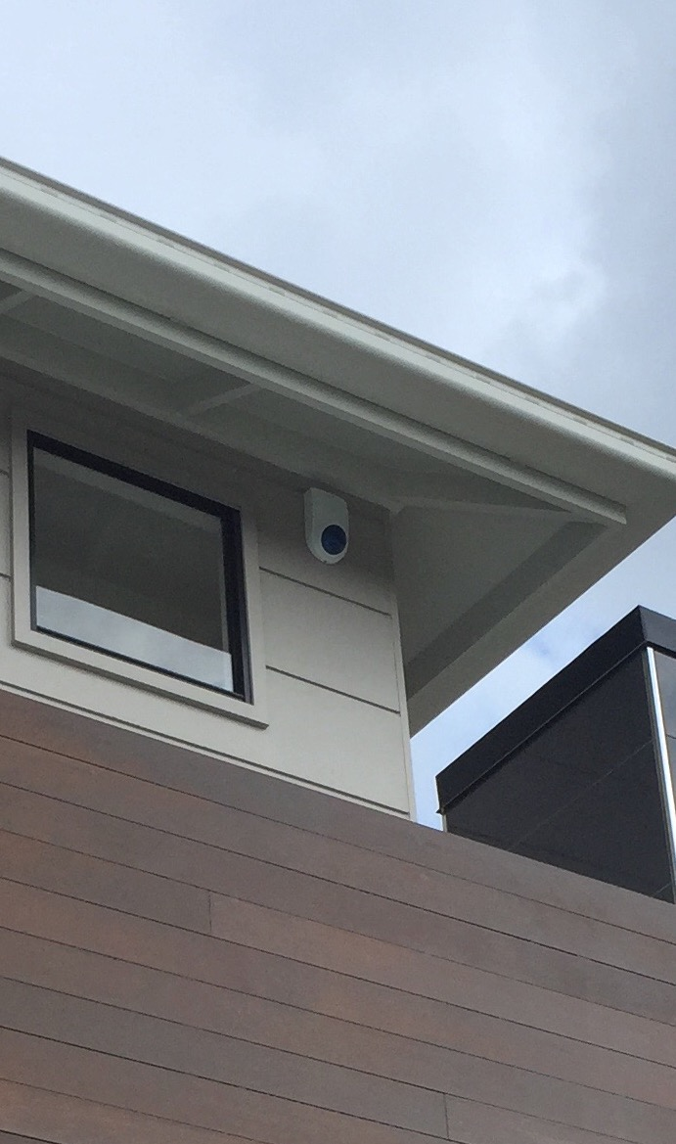
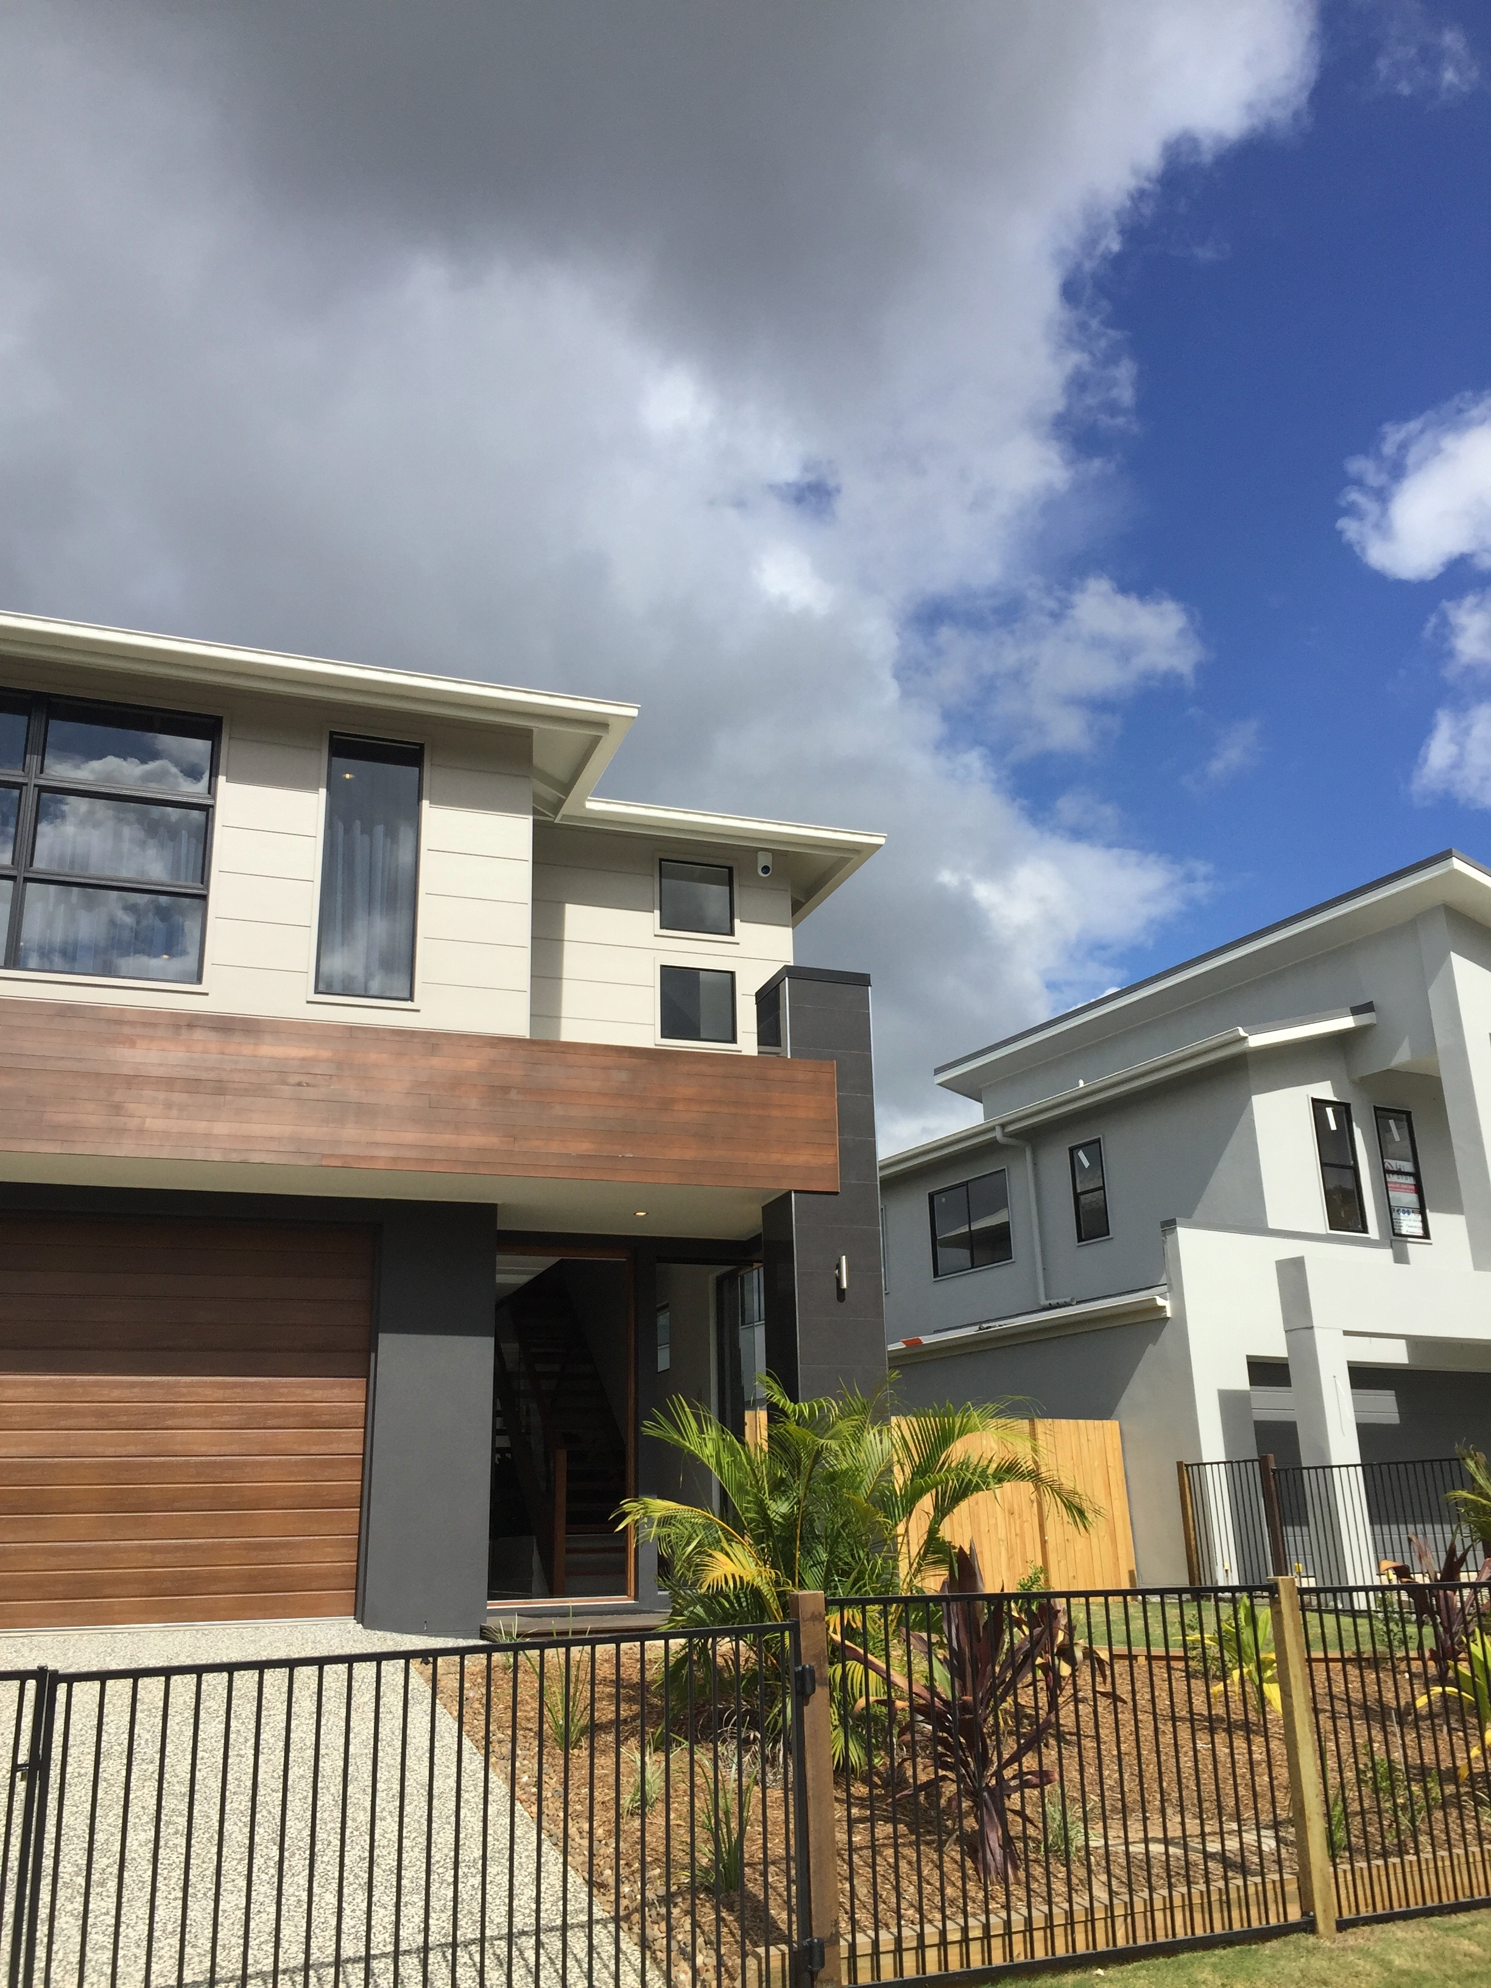
Back Cover
Front Cover
Alarm Systems
Bespoke Security is an Australian owned and operated company, with security applications at our core we strive to keep our clients safe with the most up to date security in an ever changing security technology world.

For expert advise give us a call to arrange a consultation from one of our Queensland Government licensed security advisors
This document is ©Copyright of Bespoke Security & Screens Pty Ltd.
For all inquiries

E-mail: info@bespokesecurity.com.au
Phone: 0451 960 867

www.bespokesecurity.com.au

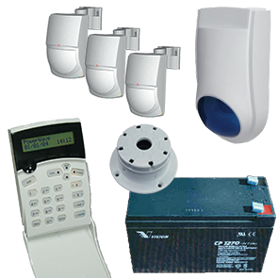
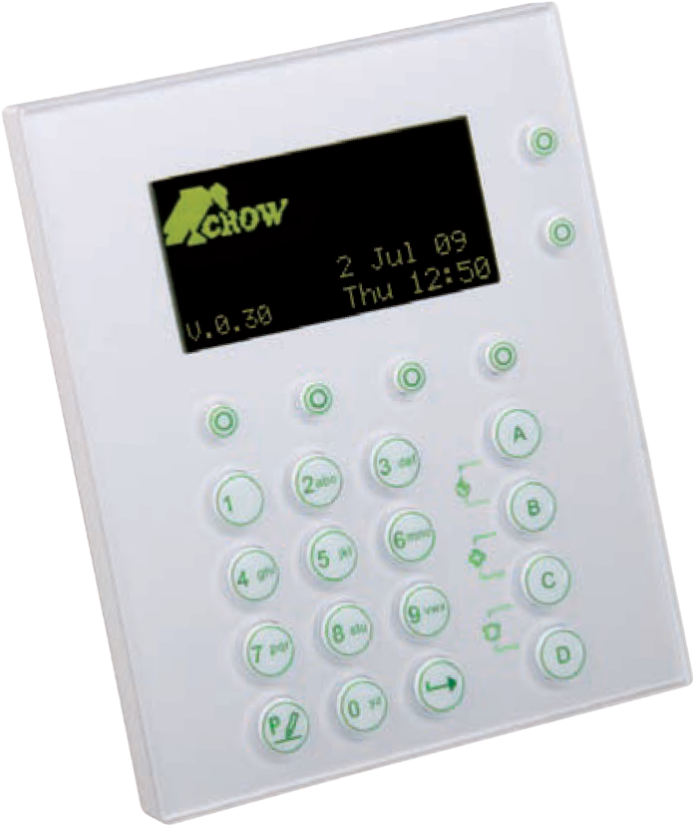
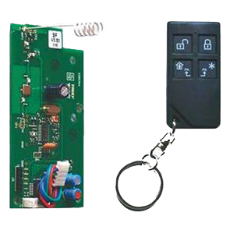
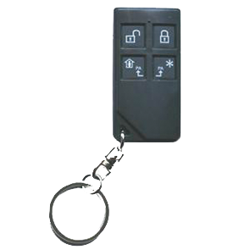
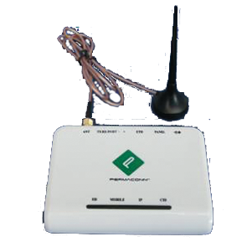
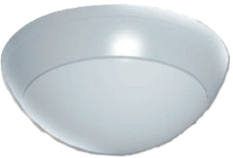
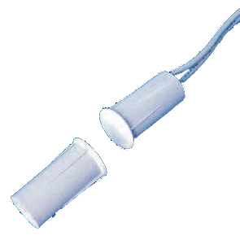
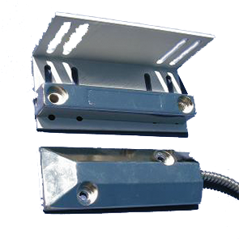
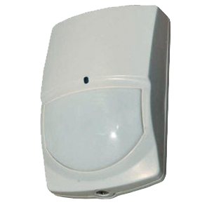
Popular Upgrades
OLED Keypad upgrade
Remote Arm and Disarm
Professional Alarm Monitoring

360 degree motion detectors
Door and window magnetic switches

Roller door magnetic switch

Motion Detectors in additional rooms

A Bespoke Security alarm system with its state of the art equipment is the perfect defense for your family and home. With detection devices such as motion detectors, magnetic door sensors and warning devices like siren + strobe combos to alert others of a break in to name a few, it will be everything you need to feel secure.

With the added option of having your security system monitored, you will always have someone watching over your home, even when even when the house is vacant..

Did you know, industry leaders say that burglars are 3 times more likely to to target a home without a security system. This means that simply having a home security system always keeps you safer, even if an alarm is never triggered.

Home Kits
Standard kits consisting of everything you need to get an alarm up and running. Components such as an Alarm Control Panel, Keypad, 3 motion detectors, and internal siren, an external siren+strobe combo, battery back up incase the power goes out. A great starting platform that can be built on to your needs and requirements.
Request a Security Advisor consultation for all the info.
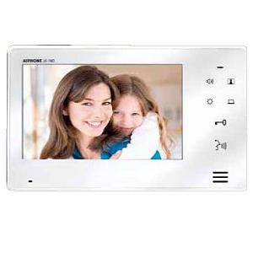
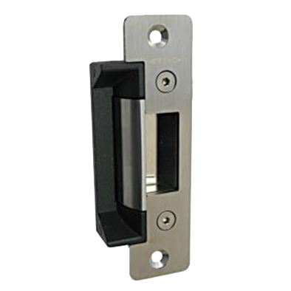
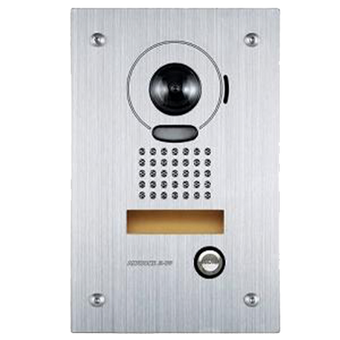
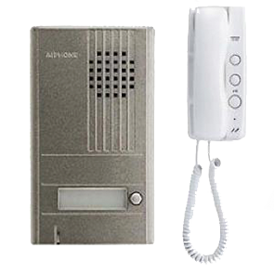
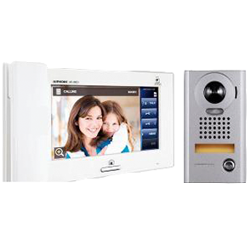
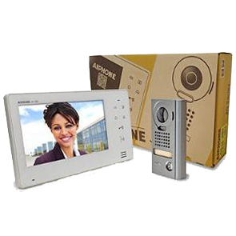
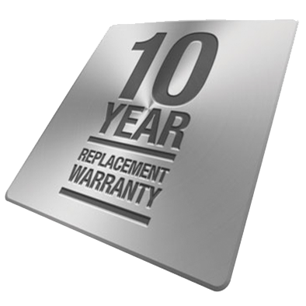
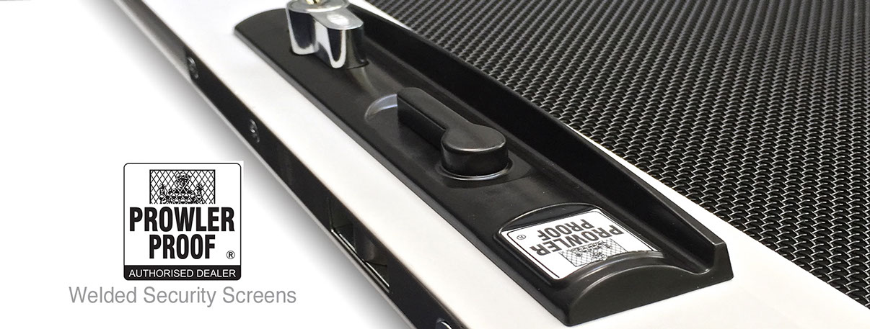
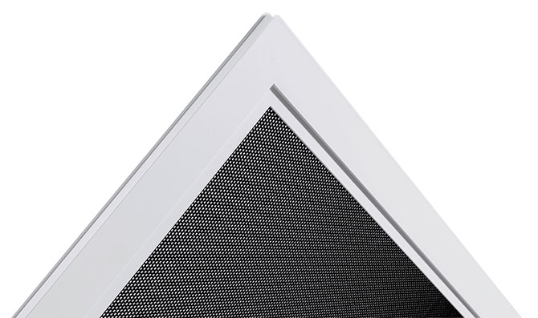
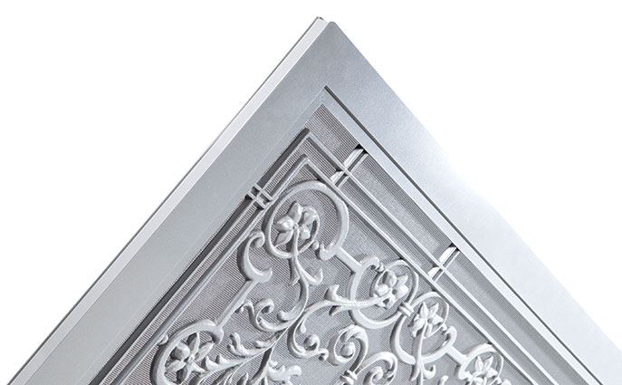
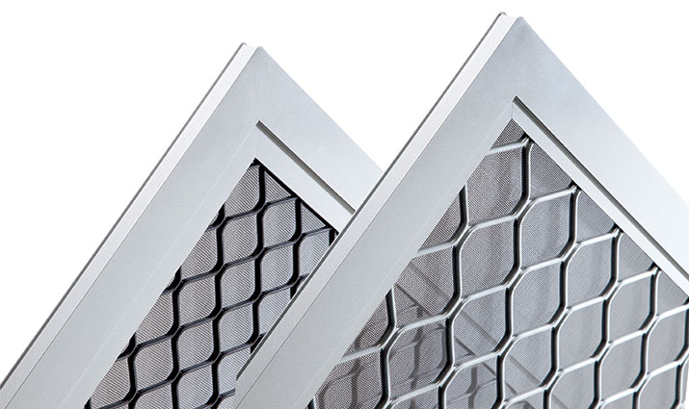
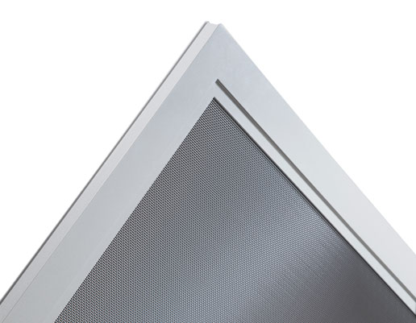

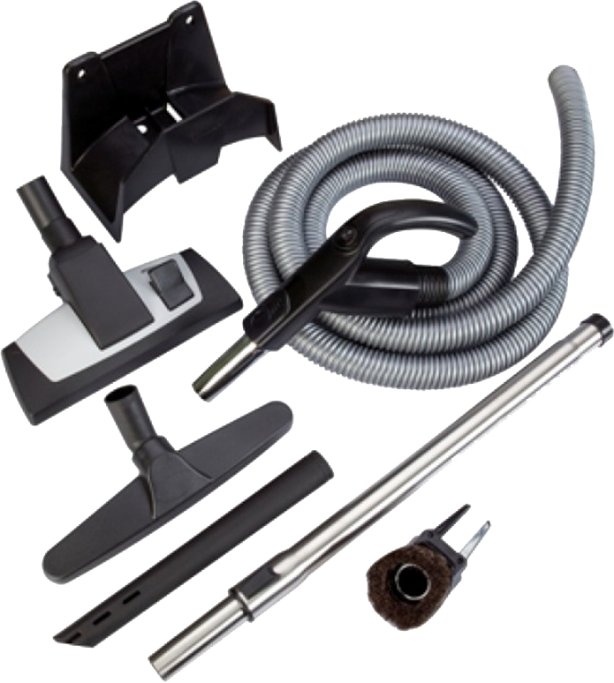
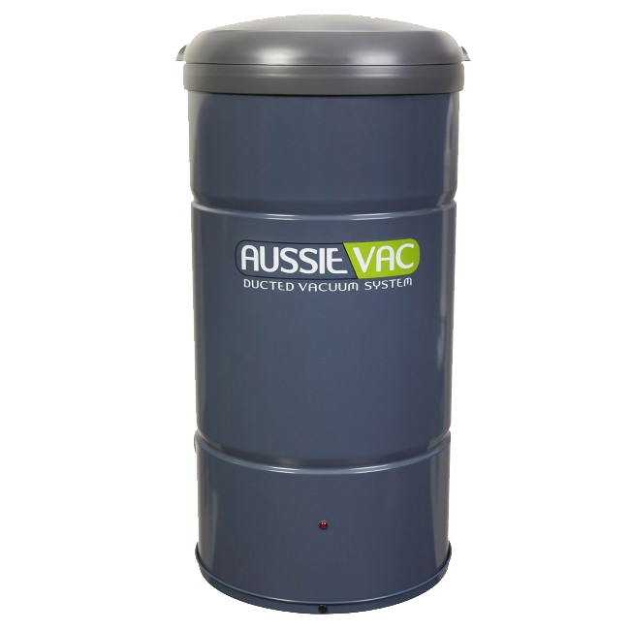
Intercom
Screens
Additional monitor installed . (Video Only)

Extend Intercom wiring to property font gate
Upgrade to flush mount stainless steel door station
Popular Upgrades
Audio Only Intercom
Whether it’s to help fit within the budget, and you just don’t have the requirement of having to see who is at the door, this no fuss, single purpose audio only intercom is that handy addition to the living area.
JP Colour Video Intercom
All the smarts built into a compact, modern designed glass face monitor, This unit has touch screen control, inter home communication between monitors and a build in handset for minimal disturbance when required. With maximums of 4 door stations and 8 Monitors, this system is perfect for the homes with multiple entry points and when multiple room monitors are required..
JO Colour Video Intercom
Superior quality, touch button control and door release. This sleek glass face 7’ screen intercom is just what you need to visually see and communicate with who is at the front gate or door. With the add on addition of a extra monitor makes it perfect for two story homes with the extra station up stairs.
A Bespoke Security Intercom system is a great addition to any home. Giving you the ability to communicate with visitors to your home at your front door or even at your front gate. In conjunction with the use of an electric strike you can hit the door release button on the intercom and let them in from where you stand in the home. Maybe even better still, decide to not let them in.
With the video intercom option your visitor will be displayed automatically and you can view who it is without them even knowing you are there.

Why Prowler Proof?
Prowler Proof is Australia's only welded security screen…and the only security screen made in a world class fully automated factory. These two facts combine to make Prowler Proof a superior product at a competitive price. We are the only security screen manufacturer in Australia to offer a 10 year replacement warranty. You will quite simply get a new product if your Prowler Proof product shows defects in workmanship or materials within 10 years from the date of manufacture. No ifs, no buts…no paperwork. Prowler Proof is a 100% Australian owned and operated family business. We have manufactured high quality security doors and window screens since 1984.

Heritage Design
Like all other Prowler Proof products Heritage doors are not held together by screws or rivets, but welded. You’ll appreciate the seamless corners and the added strength. Our Heritage doors are made with rust-free cast aluminium panels which are welded on all contact points to a heavy duty aluminium frame. Coupled with Prowler Proof’s 7-stage powder coating finish, the Heritage designs are virtually immune to corrosion and will give you many years of trouble-free use. There is a wide range of designs to choose from...all designs are available in 50 standard colours and more than 250 other colour options. There is sure to be a Heritage design to suit your home.

Diamond Grille
You’ll soon notice that there are no visible joints – it looks and feels like the security screen is made in one piece. Which is not far from the truth. Prowler Proof’s security screens are not held together by screws or rivets, they are welded. This adds strength…and good looks. You can choose between the Small Diamond and the Large Diamond designs. Both are secure and economical – Small Diamond marginally more secure, Large Diamond marginally more economical. Both options are available as SnapLock – a unique production process that makes it possible to choose any colour frame to match a black mesh. Looks fantastic!

Protec
It’s built in our hi-tech factory as an all-aluminium design with Prowler Proof’s famous welded, seamless corners. The mesh is a single aluminium sheet, perforated and powder coated to the high standards you’d expect from Prowler Proof. The perforations are exactly the right size – small enough to keep insects out, big enough to allow excellent airflow and transparency. The mesh is joined to the heavy duty aluminium frame in a process unique to Prowler Proof. Protec is one of Australia’s strongest and best looking security screens. The frame comes in over 300 colours to suit the black mesh. If you’re looking for smart security, you can’t go past Protec...

ForceField
ForceField security doors and window screens are welded instead of being held together by screws or rivets. A weld is stronger than any screw or rivet…and it looks better too. With its seamless corners, ForceField is the best looking security screen on the market. The heavy duty aluminium frame and the marine grade stainless steel mesh are joined together in a mechanical and chemical bond. It is virtually unbreakable and provides complete insulation of the two metals…eliminating a major cause of corrosion. ForceField has passed every imaginable test – and a few you would never imagine.

Ducted Vacuum

Ducted vacuums with Bespoke Security are the perfect accessory for keeping you home as good as new. With various units ranging from the smaller 2Hp - 2 to 4 outlet unit for the smaller home up to the 4Hp – 5 to 8 outlet unit for larger two story homes and everything in between.
Don’t get caught up wrestling with and dragging around a corded vacuum. Use a ducted system and all you’ll need to carry is the wand.

The Cost Effective Cleaning Solution
Did you know that most ducted vacuum systems cost roughly the same as a high quality portable vacuum cleaner? The differences are that ducted vacuum systems last considerably longer (up to four times in fact), are more robust and require less maintenance. It all adds up to a more cost effective investment.
Aussie Vac ducted vacuum systems are a semi-permanent feature and an excellent selling point for your home. Why? They not only make cleaning a breeze, they are built to last. That combination will increase the value of your home – well in excess of the original purchase price! As a ducted vacuum system is a semi-permanent structure in your house, it is covered under building insurance.

Faster Easier Cleaning
Ducted vacuum systems are versatile enough to be used just about anywhere. Carpets, hard floors, curtains, skirtings, staircases, cars and verandas can all be cleaned with a ducted vacuum system – even the family pet (yes, we have actually tested this – results differ from pet to pet!).
The longer hose and convenient inlet valves of a ducted vacuum help you to reach all parts of your house effortlessly. An Aussie Vac ducted vacuum will speed up and simplify how you clean your home, giving you more time for the important things in life – you and your family.

An Aussie Vac ducted vacuum improves your health
Every day we breathe in billions of polluting particles around the home. In fact, the average house collects 18kg of dust a year! Along with other allergens this can have a major impact on health, especially for asthma and allergy sufferers.
While portable vacuum cleaners appear to clean a room, they in fact release dust, bacteria and allergens back into the air. Aussie Vac ducted vacuum systems remove all vacuumed dust particles, allergens and noxious odours, creating a healthier living environment for you and your family.

More Powerful Suction
An Aussie Vac ducted vacuum system has up to five times more power than most conventional portable vacuum cleaners.
The heavy duty long-life motors used in all Aussie Vac systems ensure hard to shift dust and dirt will be removed from your valuable carpets, soft furnishings and other floor coverings, both protecting them and prolonging their lives. The ducted vacuum system also works well on curtains.

