Objective
To produce a logo to brand our develop software company.
Our Business
We are based in Vietnam. DIP Vietnam was established in 2005 to provide quality software developing services.
What we offer:
- Software for support business activities (CRM, ERP, Pos,…)
- Software for support operation activities,… (travel, moto agencies, …)
- Support Apps for consumers (include sales, managers, investor, customers,…).
Target Audiences
- Customers are mainly buyer, owner.
- Owners or manager
- Entrepreneurs who looking for a consultant…
- The other users (example: sales, managers, investor, customers,…).
Perception / Tone / Guidelines
- The design should be timeless.
- Different - a step above your typical technology logo.
- We need something that will look good on our website, collaterals and apps . We want to communicate to everyone we are the best/top in this industry.
- The tone of the logo should be looks powerful, modern but different with our competitor.
Logo Text (one Alternatives)
DIP Việt Nam
Color: we offer
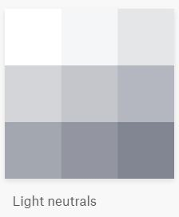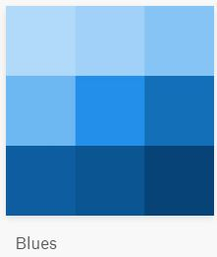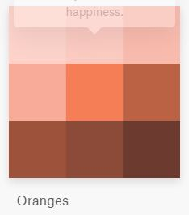

LOGOs that We like
