One of the top priorities I had coming into office in 2015 was to conduct a full scale branding and marketing study for Richmond The goal of this study is to make sure that the way we represent ourselves as a City is reflective of our community and that we establish an image and improved reputation with our residents, neighbors, businesses and visitors. I have wanted to do this ever since the aborted Branding and Marketing initiative of 2009. See http://www.tombutt.com/forum/2015/15-03-11.htm for history.

The Mayor’s Office raised over $100,000 in donations, primarily from the business community, and contracted with North Star Destination Strategies to undertake the effort. The first phase, which included a massive and exhaustive market research effort both in and outside Richmond, was completed at the end of 2015 and presented to the City Council on January 26, 2016,. Click on Richmond Research Report, which includes fascinating detail about people’s perceptions of Richmond.

In 2016, a small focus group (Creative Committee) of representatives from the Richmond Main Street Initiative, the Richmond Convention and Visitors Bureau the Chamber of Commerce, and other organizations worked with the mayor’s Office and Northstar to develop a strapline(a short, easily remembered phrase used by an organization so that people will recognize it or its products). The one they chose is:

Richmond, California. Bay Front. Home Front. Out Front.

The first two statements of the strapline are self-evident. The third refers to Richmond’s growing reputation as a leader and innovator in sustainability, environmental, education and health initiatives.

The Logo development proved to be challenging, and many months were spent reviewing proposals. We asked Northstar to focus on graphics that highlighted Richmond’s image as a waterfront city. This message seems to be most compelling to people who know little about Richmond and are surprised to find out that it is the home of Rosie the Riveter WWII Home Front National Historical Park (now nearing 100,000 visitors a year), has 32 miles of shoreline and more miles of Bay Trail than any other city.

Today, Northstar presented the PowerPoint Richmond Logos, that describes the development of the graphics shown below. The hyperlink Richmond Logos for the PowerPoint has full size versions of each proposal. I am asking E-FORUM readers to circulate this E-FORUM widely and to share both your preferences and the reasons for your preferences with me. If you want to refer to a specific graphic, use the number to the left of the image.

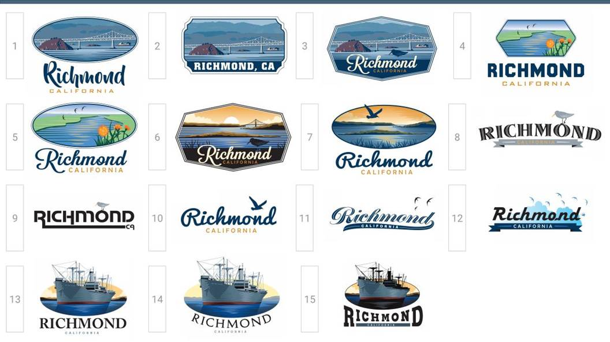
The final phase will include an applications plan with recommendations how to use the strapline and logo in a comprehensive marketing strategy that can be used by the City, by the business community and by community organizations.

Want to receive TOM BUTT E-FORUM and other action alerts on Richmond political and community issues delivered to your email address? Email your name and email address and/or the names and email addresses of others who would like to be placed on the mailing list and the message "subscribe" to tom.butt@intres.com. Comments, arguments and corrections are welcome. Tom Butt is Mayor as well as a member of the Richmond City Council. When opinions and views are expressed, without other attribution, in TOM BUTT E-FORUM, they are those of Tom Butt and do not reflect official views or positions of the City of Richmond or the Richmond City Council unless otherwise noted. Visit the Tom Butt website for additional information about Tom Butt's activities as mayor: http://www.tombutt.com. Phone 510-620-6503. Subscription to this service is at the personal discretion of the recipient and may be terminated by responding with “unsubscribe.” It may take a few days to remove addresses from the distribution list.

This site may contain copyrighted material the use of which has not always been specifically authorized by the copyright owner. We are making such material available in our efforts to advance understanding of environmental, political, human rights, economic, democracy, scientific, and social justice issues, etc. We believe this constitutes a 'fair use' of any such copyrighted material as provided for in section 107 of the US Copyright Law. In accordance with Title 17 U.S.C. Section 107, the material on this site is distributed without profit to those who have expressed a prior interest in receiving the included information for research and educational purposes. For more information go to: http://www.law.cornell.edu/uscode/17/107.shtml. If you wish to use copyrighted material from this site for purposes of your own that go beyond 'fair use, you must obtain permission from the copyright owner.

To the extent that content is excerpted under the fair use doctrine from other media, I urge readers to subscribe to the print versions of these media with print versions to help support professional journalism and the businesses that publish news, and I urge readers to log in to the online versions to access additional content, related content and unrelated news as well as the advertisements that support the media. I especially appreciate local sources of news that include the East Bay Times , the San Francisco Chronicle, Richmond Confidential and the East Bay Express.

