Click here for Richmond Logo Presentation 8.16.16 for logos that were presented by North Star in August 2016. I rejected all of them because, in my opinion, none “said” anything to me that was uniquely Richmond. For those of you who like black and white and simplicity, you may find something you like here. For comparison I have included the latest presentation (Richmond Logo Presentation No. 2)

Richmond Logo Presentation No. 1

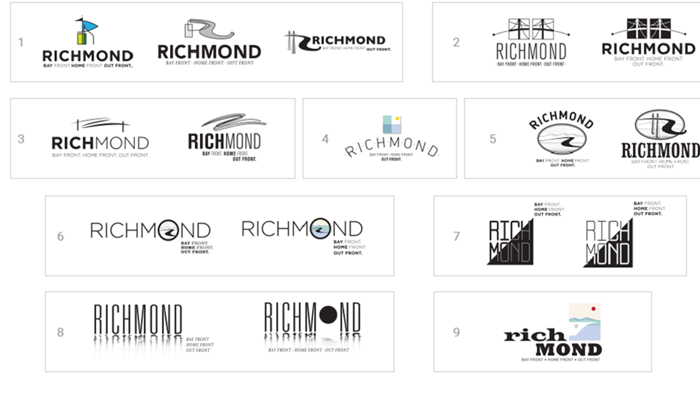

Richmond Logo Presentation No. 2
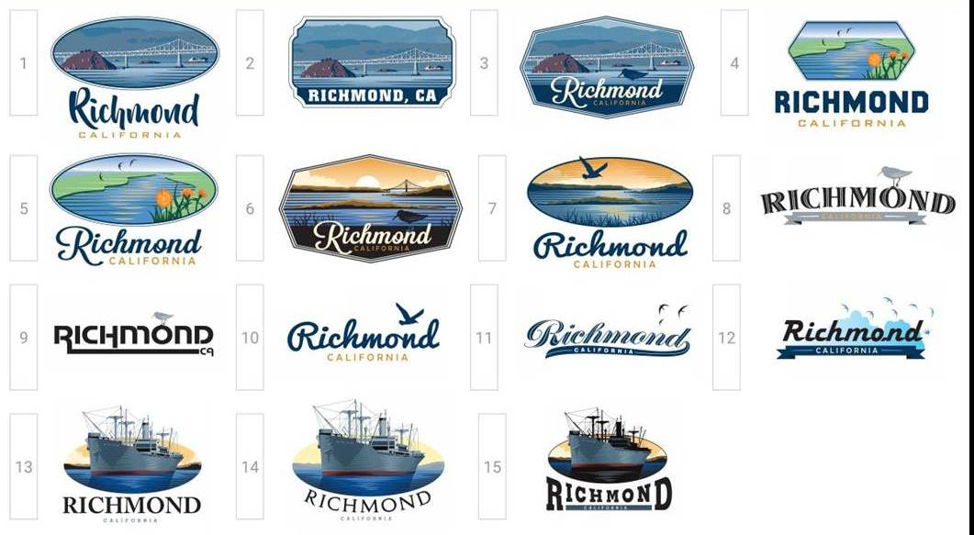

Want to receive TOM BUTT E-FORUM and other action alerts on Richmond political and community issues delivered to your email address? Email your name and email address and/or the names and email addresses of others who would like to be placed on the mailing list and the message "subscribe" to tom.butt@intres.com. Comments, arguments and corrections are welcome. Tom Butt is Mayor as well as a member of the Richmond City Council. When opinions and views are expressed, without other attribution, in TOM BUTT E-FORUM, they are those of Tom Butt and do not reflect official views or positions of the City of Richmond or the Richmond City Council unless otherwise noted. Visit the Tom Butt website for additional information about Tom Butt's activities as mayor: http://www.tombutt.com. Phone 510-620-6503. Subscription to this service is at the personal discretion of the recipient and may be terminated by responding with “unsubscribe.” It may take a few days to remove addresses from the distribution list.

This site may contain copyrighted material the use of which has not always been specifically authorized by the copyright owner. We are making such material available in our efforts to advance understanding of environmental, political, human rights, economic, democracy, scientific, and social justice issues, etc. We believe this constitutes a 'fair use' of any such copyrighted material as provided for in section 107 of the US Copyright Law. In accordance with Title 17 U.S.C. Section 107, the material on this site is distributed without profit to those who have expressed a prior interest in receiving the included information for research and educational purposes. For more information go to: http://www.law.cornell.edu/uscode/17/107.shtml. If you wish to use copyrighted material from this site for purposes of your own that go beyond 'fair use, you must obtain permission from the copyright owner.

To the extent that content is excerpted under the fair use doctrine from other media, I urge readers to subscribe to the print versions of these media with print versions to help support professional journalism and the businesses that publish news, and I urge readers to log in to the online versions to access additional content, related content and unrelated news as well as the advertisements that support the media. I especially appreciate local sources of news that include the East Bay Times , the San Francisco Chronicle, Richmond Confidential and the East Bay Express.

