JLM XM EBrochure
V1 Copy Deck
January 17th, 2017

Target: Agencies/3rd Parties



EXPERIENTIAL MARKETING & EVENT MANAGEMENT SERVICES: Need to fill a gap in a hurry with no time to hire? We can help! We offer agencies white label services.
(Copy above to be in grey box over black in image above)

Our team plugs in, ramps up to quickly deliver critical solutions that make a big impact on your business! Our services include (would like these as icons):

- Ideation & Concept Development
- Strategic Planning
- Research & Feasbility
- Event creation & logistics
- Venue, permit and supplier negotiations
- Registration management
- Hospitality
- Food & beverage
- Design & décor
- AV production, lighting and sound
- Full production services
- Creative services
- Technology management
- Travel logistics
- Speaker management
- Delegate management
- On-site management

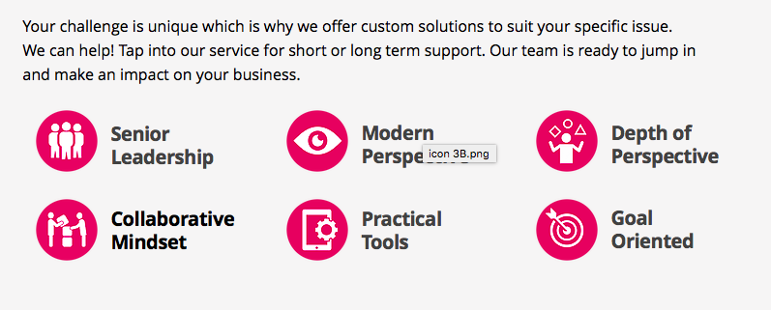

The JLM team is composed of highly motivated experts who are 100% focused on flawless and impactful results for our clients! We are only happy when you are!

Call me personally to discuss your challenge:

Jennifer Mason, President
Mobile: (416) 400-5633
Email: Jennifer@jlmstrategicmarketing.com
Website: jlmstrategicmarketing.com

