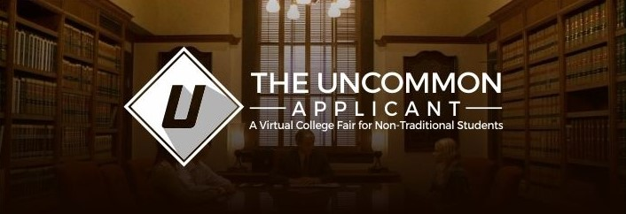

The Uncommon Applicant is a new web site designed to provide a meeting place for college and university admissions officers and non-traditional applicants like homeschoolers, unschoolers, students who attend democratic or independent schools, adults who are returning to school, and others pursuing alternative alternative approaches to education. Our services will include:
- For Students… free membership for any student or parent who wants to learn more about the colleges and universities that are actively recruiting non-traditional students, all in one location! You will have access to admissions officers, independent admissions advisors, regular articles on higher education topics, and resource reviews and links. We will also offer regular events, like webinars and admissions panels, where you can interact directly with admissions officers, college advisors, and college students from non-traditional educational backgrounds as you prepare to apply to college.
- For Colleges and Universities… an audience of thousands of non-traditional students who want to hear about your school and programs. You will have a dedicated page to set up a virtual “booth”, or school profile, where you can describe your institution, highlight aspects of your programs that may appeal to non-traditional students, offer details of their admissions process and requirements, and provide contact information for designated admissions representatives.
- For Independent College Advisors… a platform for sharing your services and connecting with thousands of students who need your guidance. Through forums, articles, ads, and online events, there will be multiple opportunities to share your knowledge and expertise, and to work closely with individual students.

Site Overview
This is a wordpress site using the “Collective” theme (already installed). I need help customizing the site to look and run like the theme’s demo. The main difference between my site and the demo will be that the “Our Team” sections, including portfolios, will be information on colleges/universities rather than people.

User Groups and Requirements for Phase I
- Administrator: Will create and maintain all site content, including virtual booths for each school. (Later phases will allow schools to input and manage their own information)
- General Visitors: Free access to all areas of the site except the “Member Resources” pages (which will include downloadable reports, presentations/videos, and detailed school information within the “booths”)
- Members (Students and Parents): Free access to all areas of the site, including the “Member Resources” section with a general password. (Later phases may include individual passwords).
- Schools (College Admissions Officers): In this first phase, schools will not need separate passwords or membership registration through the site. The administrator will recruit schools separately, gather their information to be included on the site, and then input this information, including photos, on the site. (Later phases will allow schools to manage their own information directly through a password-protected entry to the site). This group will have viewing access of all areas of the site, including the “Member Resources” area via a password provided by the administrator.
- College Advisors/Counselors: As with college admissions officers, counselors will have viewing access to all areas of the site with a password provided by the administrator. Counselors who wish to have a profile/advertise their services on the site will provide the information to the administrator, who will then add it to the site. (Later phases will allow counselors to manage their own information via a password-protected entry to the site).

Site Functionality
- Gather and store registration information for members, including:
  - First and last name
  - Email address
  - State
  - High school graduation year
  - Category: (e.g. homeschooler, unschooler, transfer student)
- Password protected area (“Member Resources”)
- SEO optimization

