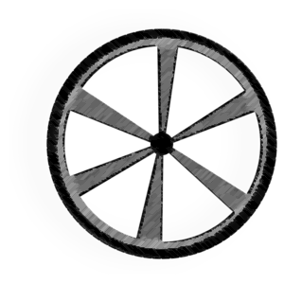
RPjr. Reggie Puckett Jr. Foundation
Foundation 235 Flowood Drive Flowood, MS 39232 Ph. 601-939-2948 Fax 601-939-2948
~Est. 2016~

