The Identity People
Keeping your people and your business secure

Security is a major concern for many organisations, businesses and government. Identifying persons using services, accessing buildings or campuses as well as presenting themselves to customers or patients, is a critical component in risk mitigation.

Organisations are implementing comprehensive networks of cost recovery, cashless POS, and work efficiency tools, which provides the user experience expected in a modern day professional environment. Identifying who is accessing and using these tools is an essential part of any businesses security posture.

Our aim is to offer expert professional advice, an amazing customer experience, at the most competitive pricing in the industry.

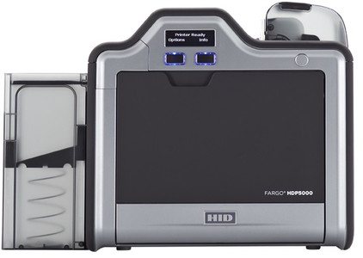
Products Sold
ID Card Printers and Consumables
- Photo ID/ Badge Printing hardware
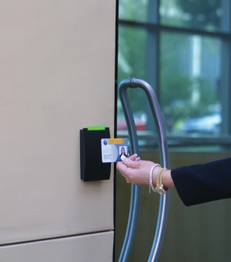
- Ongoing supplies of consumables / toner


Access Control Cards
- Smart chip cards/badges
- Magnetic stripe cards/badges
- Proximity RFID cards/badge

ID Accessories
- Card/Badge holders
- Lanyards and wristbands
- Card reels, clips and pins

Target Customers
- Healthcare - Hospitals and Aged Care Facilities
- Government Agencies and Departments
- Membership Clubs and Associations
- Corporate / Enterprise - HR and Security departments
- Education and Training - Secondary and Tertiary Education providers + RTO

