Edits: Round 1
Location Quad-fold Brochure
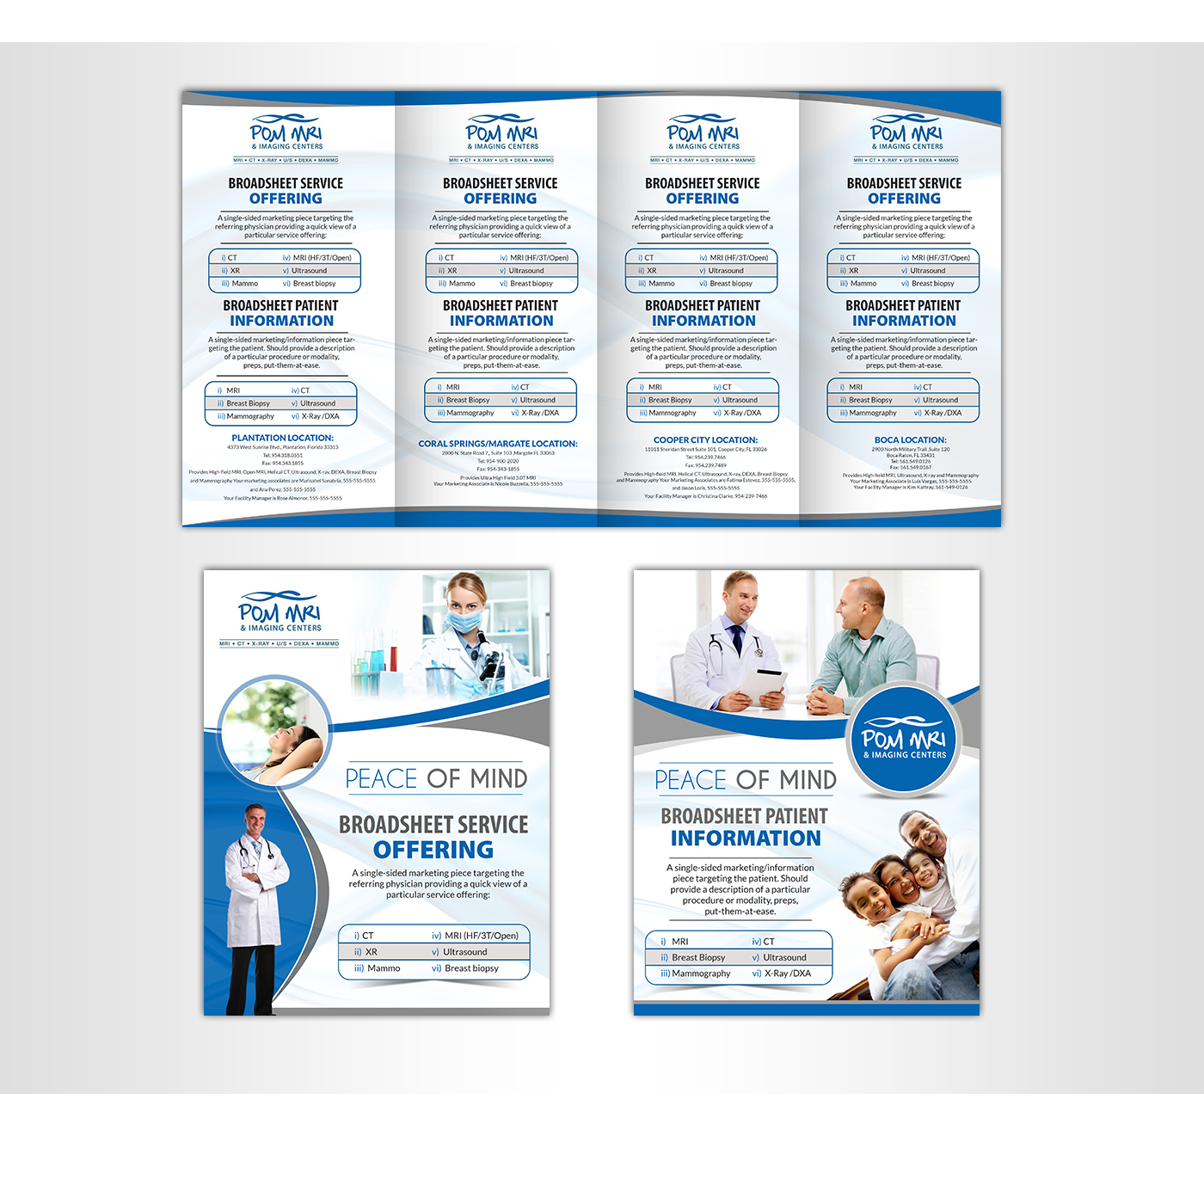
Contents In order top to bottom:

Logo
Plantation
Service Offering
- Open MRI/MRA
High Field MRI/MRA
- Helical CT/CTA
- Digital X-ray
- Mammography
- Ultrasound
- DXA Bone Density

24-hour routine turnaround. 4-hour STATS.
All Radiologists licensed with subspecialty. All technologists licensed & certified.
Most insurance plans accepted. Extremely competitive rates.

Convenient locations and hours.

Our Plantation facility is located at
4373 West Sunrise Blvd
Plantation, Florida 33313
Hours are M-F 7am-7pm, Saturday 8am-4pm

Your facility manager can be reached at 555-555-5555
Your marketing liaison can be reached at 666-666-6666

POM is Peace Of Mind!
Repeat changing service offerings and address for each location
Service offerings at
- Cooper City
  - High-field MRI/MRA
  - Helical CT/CTA
  - Digital X-ray
  - DXA/Bone Density
  - Mammography
  - Color, 3D-4D Ultrasound
  - Breast Biopsy
- Boca Raton
  - High-field MRI/MRA
  - CR X-ray
  - Mammography
  - Color 3D Ultrasound
Hours for Boca are M-F 8am-5pm
For the 2 Broadsheets:
1) Doctor-facing

Create a lot more room for content.
Maybe Eliminate the images in the top right. Move up the Peace of Mind circle and text. Look for some images representative of digital x-ray and use them.
Instead of the content in the main section (Lower right)
Use the following:

DIGITAL X-RAY

POM MRI & Imaging Centers proudly offers the latest Digital X-ray.
Place Image here
Why not provide your patients with state-of-the-art diagnostics?
Benefits of digital X-ray include
- Faster exam, less wait time
- Decreased radiation
- Clearer image quality for diagnosis
A digital revolution has taken place with the advent of digital radiography (DR) systems — active matrix flat panels consisting of a detection layer deposited over an active matrix array (AMA) of thin film transistors. These flat panel devices can instantly display a higher image quality than conventional systems, and have notably improved workflow as more images can be taken and processed in the same amount of time.
Most significant, however, is that DR has at least twice (2X) the dose efficiency of CR or traditional film.
What does that mean for your patients? Less wait times, lower dose, higher quality, better diagnoses.
Choose POM. Choose Peace of Mind. For your Patients, and for you.
Ask about or new DR systems today.
X-ray services offered at our Boca Raton, Plantation and Cooper City locations.
Include locations/addresses/phone numbers on content-footer
These have to be in the form of a shell so I can swap out images and text for each modality.

2) Patient-facing
Again, make some room for content in lower left content area. Keep “Peace of Mind” but move up.
Remove remaining content. Replace with:

So, you’re having an
X-RAY
Having an x-ray is fast, painless and safe. Your doctor has requested that you have this test done to screen for common problems, or to help diagnose a symptom that you have.

Congratulations! POM MRI & Imaging Centers has the latest Digital X-Ray systems.

There is rarely any preparation required for a conventional X-ray, and in fact we accept walk-ins for this exam. You may need to change into a gown or scrubs that we will provide, depending on the exam and what you are wearing. We recommend that you wear loose-fitting clothing without metal zippers, snaps or jewelry.

Most X-rays take less than 10 minutes to perform. To minimize any wait time, please give us a call to schedule an appointment.

We look forward to getting your X-ray done quickly and results back to your doctor the same or next day.

We take most health insurance plans, have expert Radiologists & Technologists, state-of-the-art equipment, convenient locations and hours.

Choose POM. Choose Peace-of-Mind.
Place locations that offer X-ray in the footer.

These have to be in the form of a shell so I can swap out images and text for each modality.

