HIGHIGHT YELLOW = MAIN FEATURES
HIGHLIGHT BLUE = MOVE THESE FEATURES TO A NEW SECTION “SOLUTIONS” (VERTICAL SOLUTIONS)

ORDERING
Attractive menus, show-off your goods to their best.
Specify Opening Times, Delivery, Dine-in and Take-away options and prices.
One-touch re-ordering for customer convenience.
Automatic in-shop order printing (printer hardware also available on request).
Online Payment options for Paypal, Apple Pay and Android Pay.
Popular uses: Take-aways and Restaurants
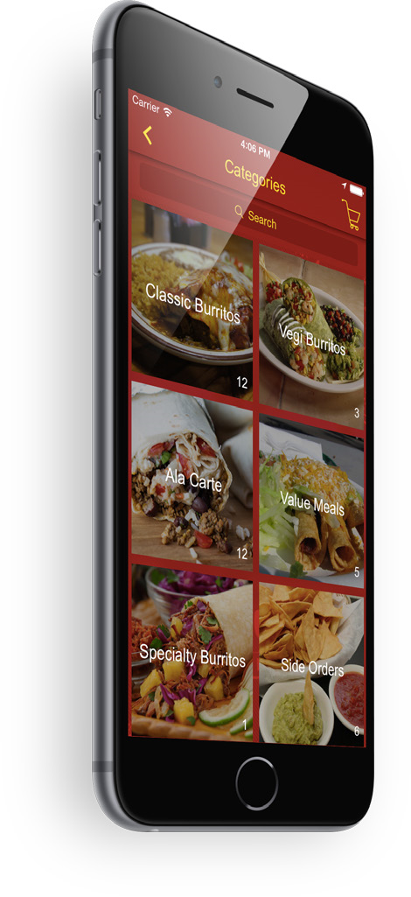
(Tim, could you place the image below into an iPAD?
There are some others later in the document that I’d like placed in an iphone too if you can?)

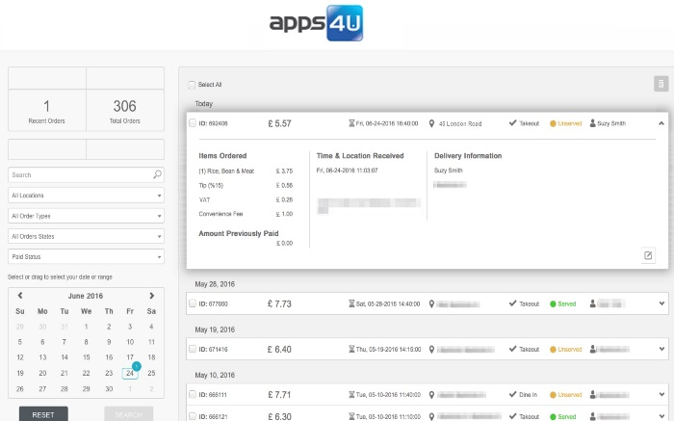

BOOKING AND RESERVATIONS
The booking system allows users to reserve time-slots for various services. Businesses can fill-up their appointment calendars without having to take phone calls or emails, and the service is available 24/7.
The advanced booking features also allows you to;
(tim this is two screen shots – should be split up and placed in two iphone screens if you can).
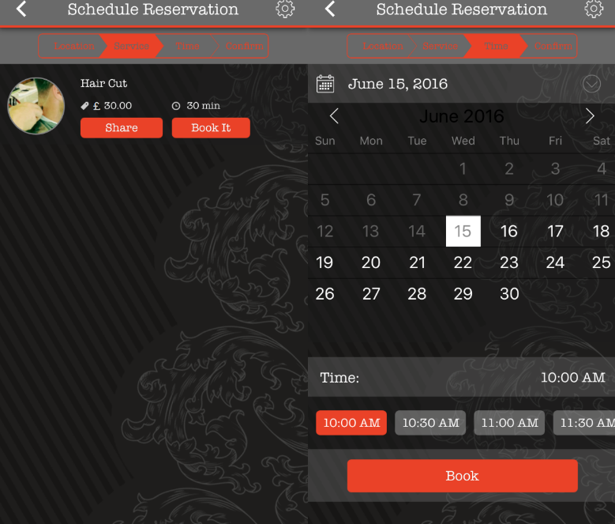
Define optional up-front booking fee for the appointment.
Manage your appointments with a beautiful built-in calendar.
Receive notifications via email when appointments are scheduled.
Provide users with easy appointment management via their app.
Book more clients and increase repeat appointments.
Use the built-in booking platform or integrate into Groupon, MindBody, Frontdesk or BookStream.

Popular uses: Restaurants, Beauty Salons, Hairdressers, Opticians, Spas and Health Clubs, Church and Community Halls, Leisure Facilities.

LOYALTY PROGRAM
Allow Customers’ to earn loyalty points in-order to unlock promotions.
Simple “coffee-shop” style loyalty cards and sophisticated solutions for all business requirements.
Popular uses: Retail, Food Outlets, Take-aways and Restaurants.
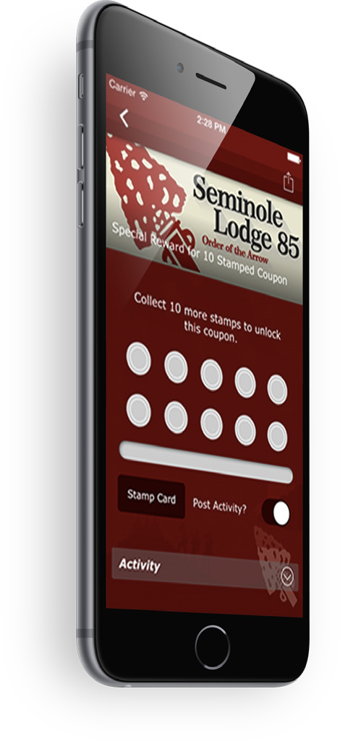

Advanced loyalty options allow customers’ to save-up for even better offers!
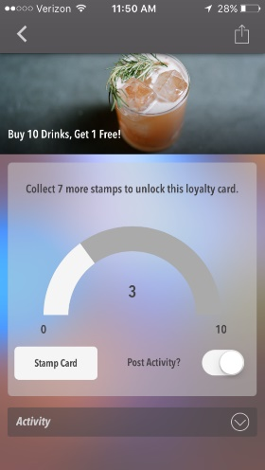

These go after the Loyalty MAIN Feature..

GPSCOUPONS in DROPBOX\\APPS4U\GRAPHIC\WEBSITE

GPS COUPONS
Increase foot-fall by including GPS check-ins to your events or business locations.
Post activity onto Social Media directly from app.
Popular uses: Retail, Event Management

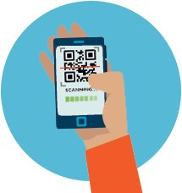
QR Coupons & Scanner(QRSCAN.PNG)
Quick Response (QR) codes allows users to capture information quickly by scanning the code from their phone.
This feature can be used to unlock a promotional offer, link to a web site, dial a telephone number or even store a business card!

Popular uses: Fundraising, Conferences, Nightclubs, Retail, Event Management, Restaurants & Takeaways
OTHER GRAPHICS:
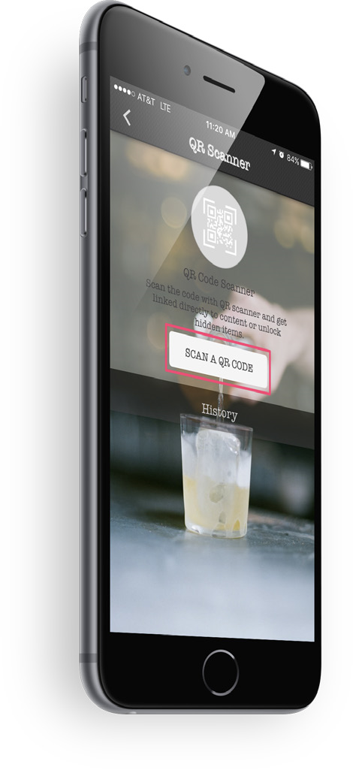

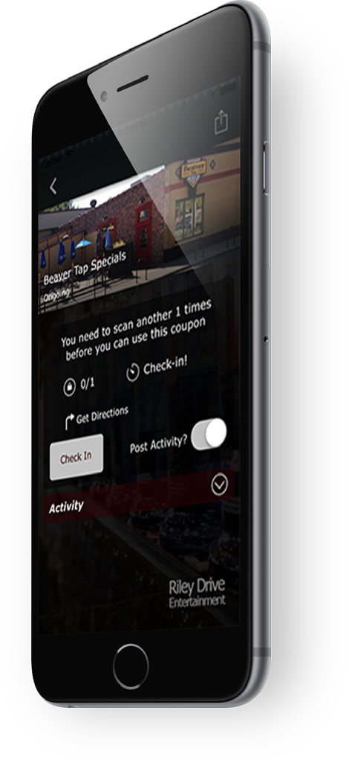

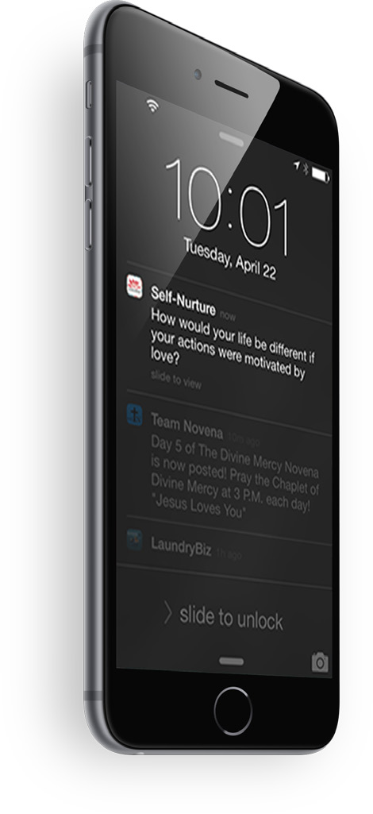
PUSH NOTIFICATIONS

The most feature-rich push notification system in the market.
Send unlimited free messages to your customers.
Target specific user groups, Android, Apple, Facebook or Twitter users or just send it to everyone.
Set-up messages for future dates and timed delivery.
Send web links, feature pages or promotions.
Optional Geofence targeting feature, message your customers as they enter a specific geographic location radius.

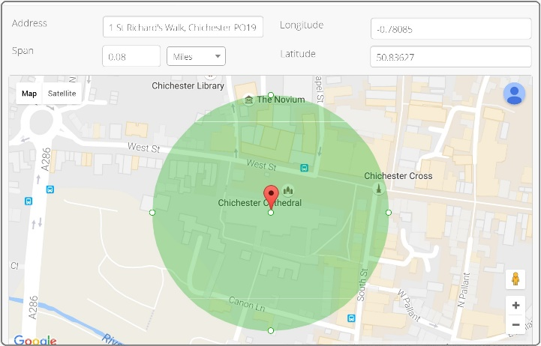 (ADD TO IPAD 3D SCREEN)
SMART SURVEYS

Interactive Smart Surveys that have both beauty and intelligence a rare thing indeed!
Collect Customer feedback and service information.
Questions adapt to the user’s responses and asks further relevant questions or provide summaries based on the information collated.

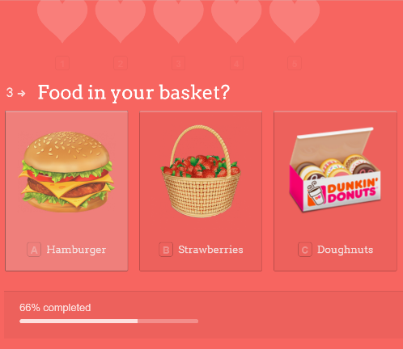
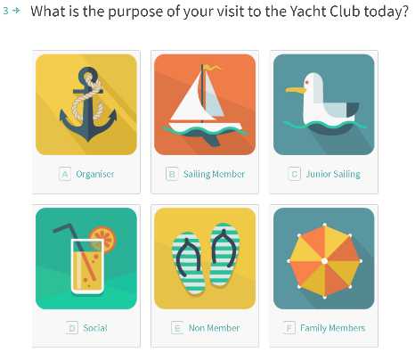

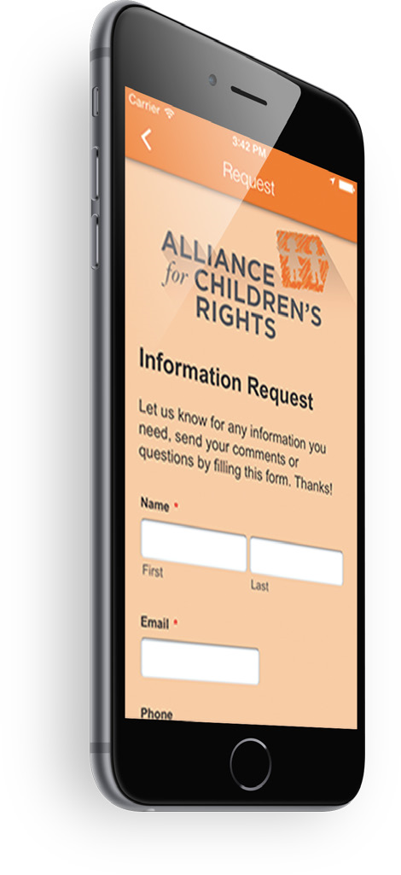
SMART FORMS

Smart Forms can be designed to fit your exact data collection requirements. Collect information and customer data. These forms are suitable for a wide range of services including:
Applications
Orders
Enquiries
Calculators
Incident, issue logging and tracking.

FIND US

This is simply one place for all your contact details.
Provides turn-by-turn, directions.
Business Contact Details
Business Opening Hours
Easy One-Touch Dialling
Contact Email
Link to business Website
OTHER GRPAHICS

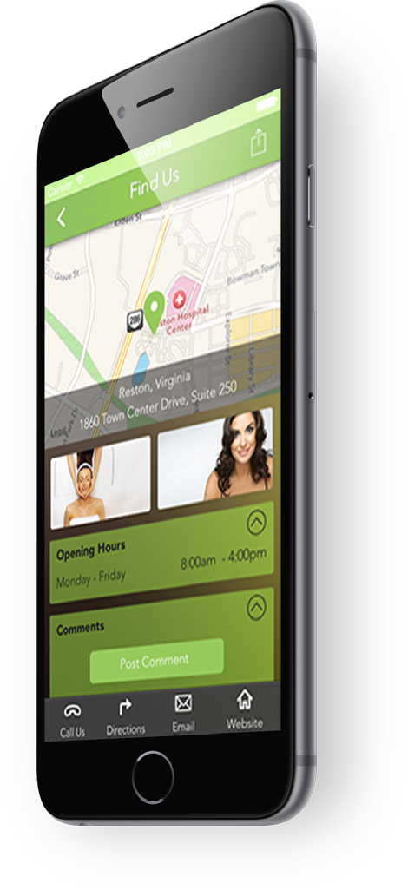

AROUND US

Bring attention to Points of Interest, events, additional business addresses or hotspots in your area.
Useful where businesses have multiple destinations as it aids cross pollination.
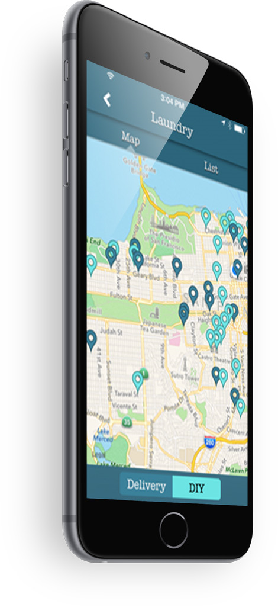

EMAIL PHOTO

Customers’ can use their mobile phones to take photos and then email these into your business.
Insurance companies and assessors can use this feature to capture claims information.
Nightclubs and Restaurants often use this feature to engage with their customers and encourage then to take photos of themselves enjoying themselves at their venues.
Popular uses: Insurance, Restaurants & Takeaways
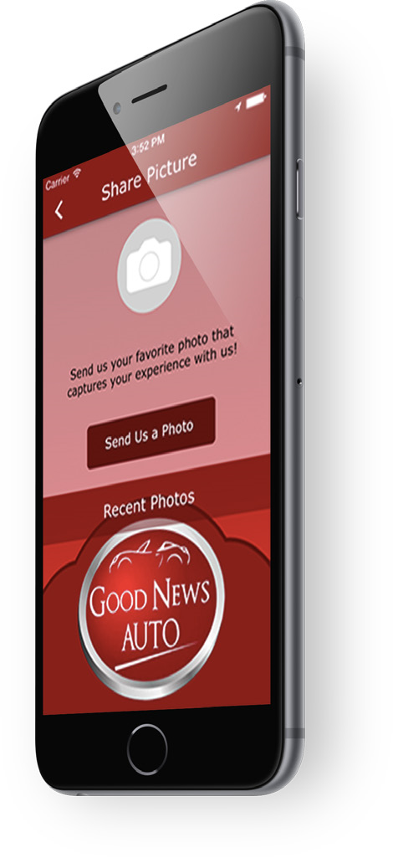
OTHER GRAPHICS:

FAN WALL


Customers can post and share comments and feedback on your in-app Fan Wall. Create a venue, a place for people to share and provide feedback!

Popular uses: Music Artists, Clubs and Associations.

OTHER GRAPHICS
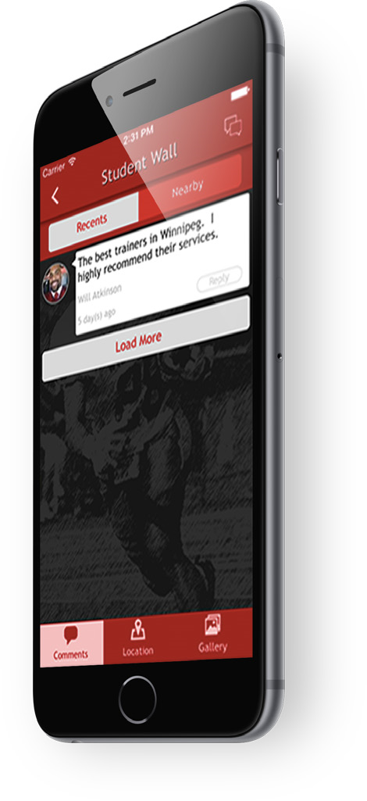

PHOTO GALLERY

Upload photos, posters, and event information. Great for pubs, nightclubs or any organisation that engages with their customers and wants to post event photos
Popular uses: Bars, Nightclubs, Bands, Music Artists, DJ’s.

OTHER GRAPHICS
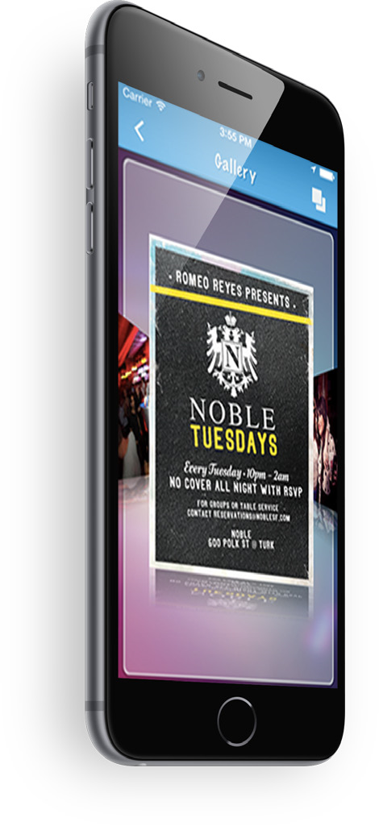

INFORMATION

Share any information in a variety of multi layered screens that engage with your customers’ and work intuitively.

OTHER GRAPHICS
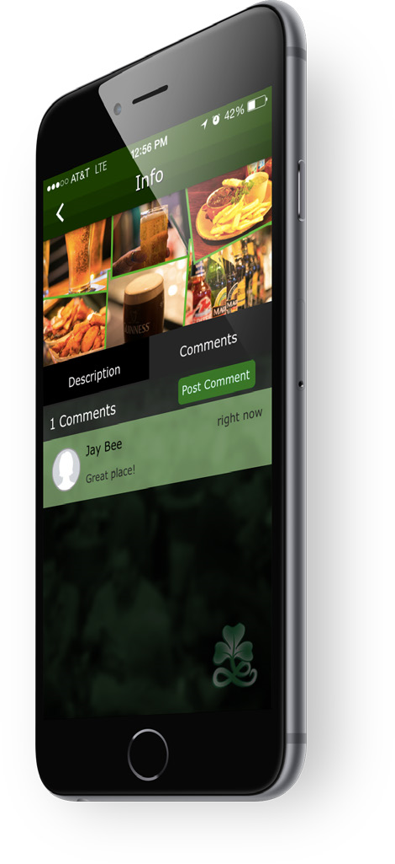
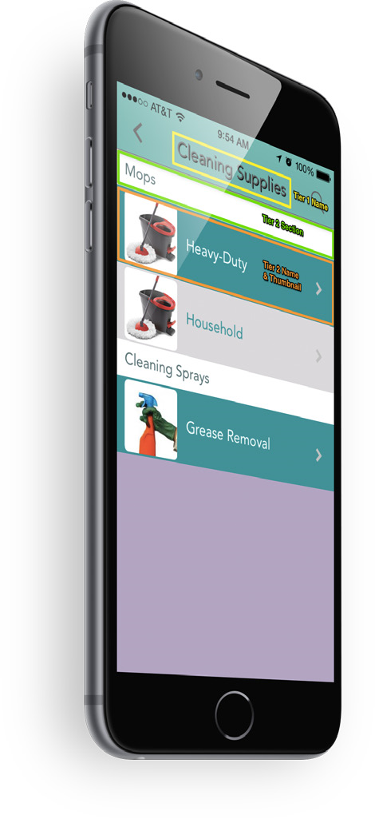

MAILING LIST

Capture customer information and build-up your customer base for managing future campaigns, events and promotions.
Customers are promoted to opt-in to the mailing list.
We also provide contact integration with: MailChimp,
iContact,
Constant Contact
& Campaign Monitor.

OTHER:
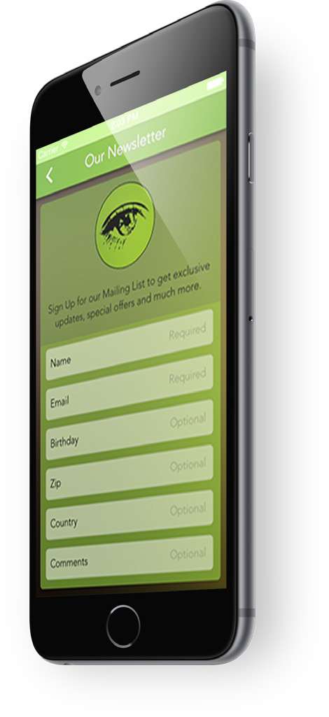
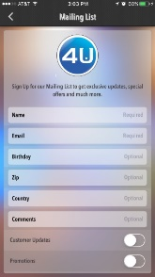

NEWS

Integrate live feeds from Google News, Facebook and Twitter into your news feed page.
Popular uses: News, Politics.

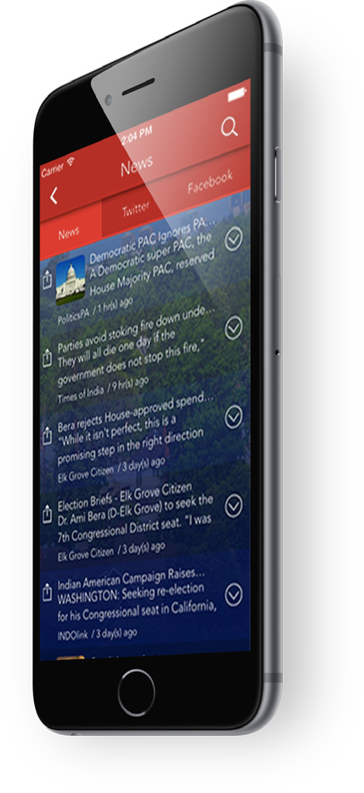
OTHER GRAPHICS
RSS FEEDS

Integrate any RSS feeds directly into your apps.
RSS feeds constantly update within the app without any manual changes on your behalf.
Updated with current news, links to articles, special offers, and endless array of useful info, your RSS feed can prove incredibly useful for users, who will check multiple times a day for new content.
Popular uses: News, Politics, Education.
OTHER GRAPHICS

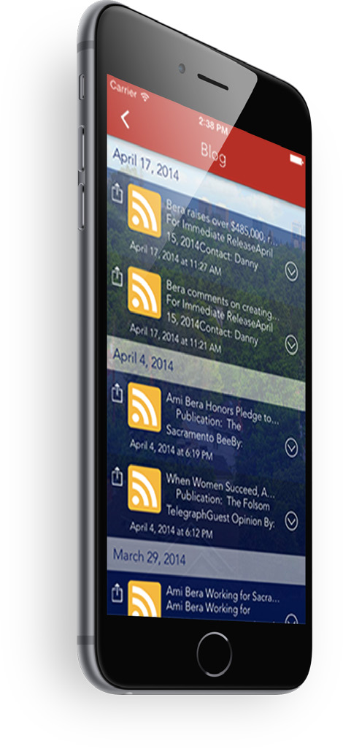

MUSIC
Allow your customers to download or purchase your music or audio.
Integration includes iTunes and SHOUTcast
Stream audio books, radio and music.
Popular uses: Bands, Recording Artists, Hypnotherapists and DJ’s.
OTHER GRAPHICS
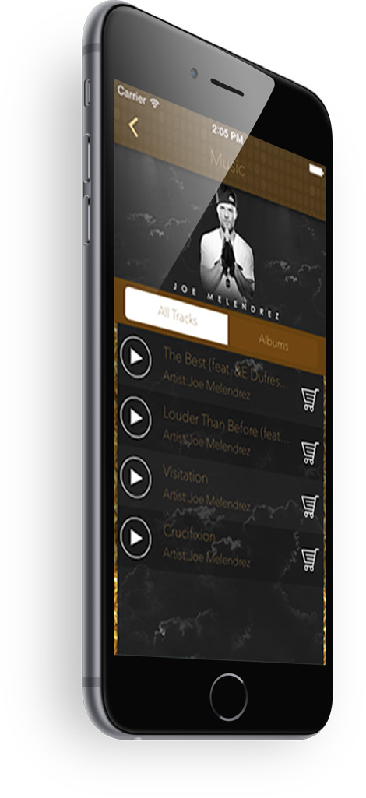

ONLINE SHOP (SHOPPING GRAPHIC)
Sell your goods within your app and via your website. You can even embed the shop back into your existing website!
Upload your products and services to your store and manage your orders from our customer web portal (or we can do it all for you!).
Popular uses: Hairdressers, Beauty Salons, Hotels and Spas.

OTHER GRAPHICS

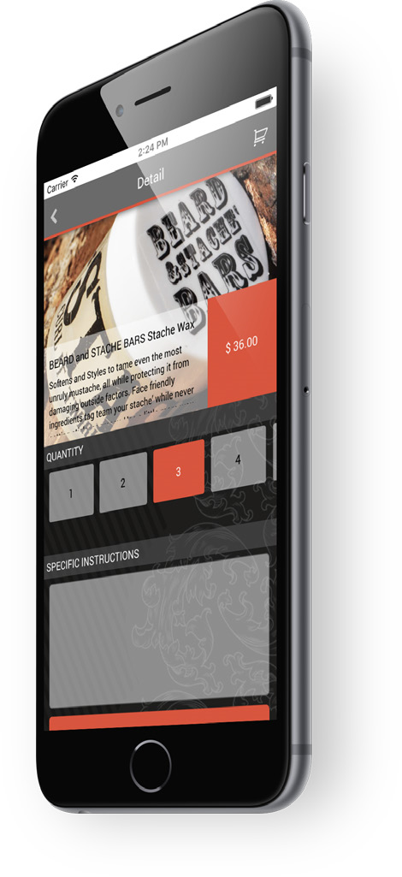
PODCAST

Stream audio and video podcasts directly from within your app. Content is dynamically updated from your live feed.
Popular uses:
Churches, Councils, Public Figures and Radio.

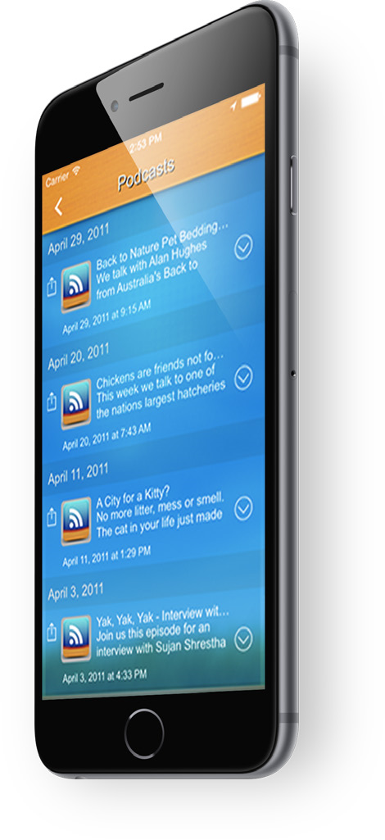
OTHER GRAPHICS
PDF FILES

Portable Documents Format (PDF) files retain their design and are the ultimate portable documents for sharing information.
Frequently used for presenting menus, white papers, product information, staff rotas, agendas, overviews and just about anything else.

Popular uses: Schools and Colleges, Education, Restaurants & Takeaways, Manufacturing.
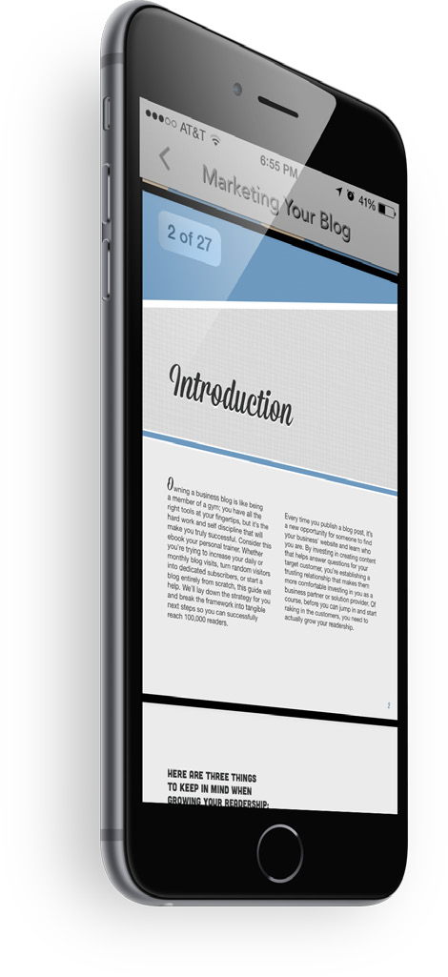

VOICE / AUDIO RECORDING


Record voice notes, conversations, messages and forward them to your business or back to your email account.
Popular uses: Legal, Solicitors, Schools & Colleges, Radio Stations.

OTHER GRAPHICS

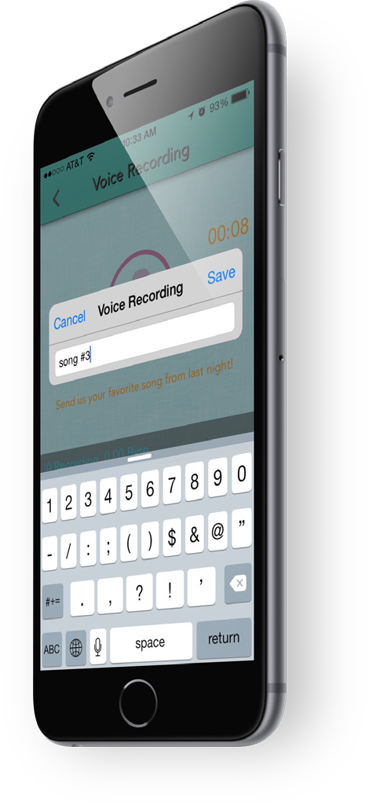


YOUTUBE CHANNEL
Display hundreds of videos from your YouTube channel directly from within your application.
Popular uses: Music, Education, Training Videos, Religion.

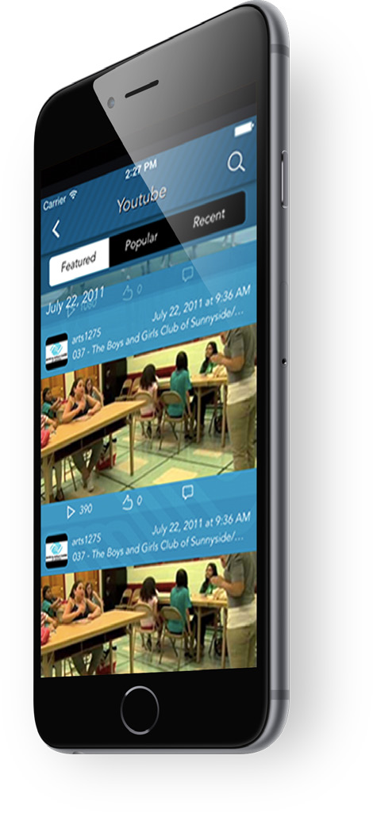
OTHER GRAPHICS
INTEGRATIONS PAGE

(Tim – can we get the logos for all please?)
- Facebook
- Twitter
- Google+
- YouTube
- WuFoo
- PayPal
- Google Maps
- Google News
- Flickr
- Picasa
- Instagram
- MailChimp
- iContact
- Constant Contact
- Campaign Monitor
- GetResponse
- Emma
- Volusion
- Magento
- Shopify
- TypeForm
- iTunes
- 7Digital

CUSTOM FEATURES PAGE
In addition to our extensive library of functions we can add any custom features to your apps too!
Please complete this form and let us know your exact requirements as we’d be delighted to work with you on your app.

Name*:
Email:*
Telephone:*
Best time to contact you:
Requirements:

NEW MENU ITEM – TOP LEVEL “SOLUTIONS”

“EVENTS MANAGEMENT”
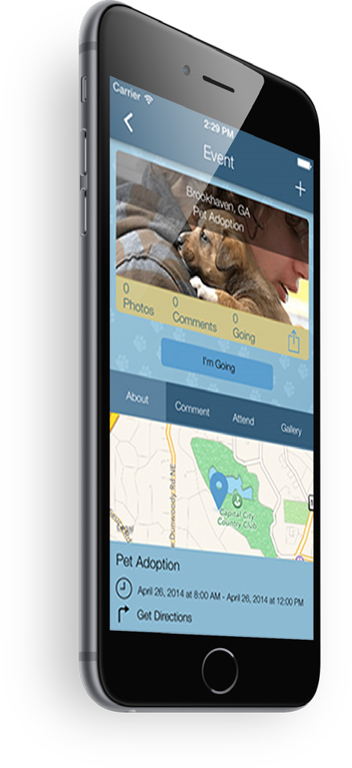

Show different event tracks, content, speakers, locations, directions and further details.
Allow customer feedback and engagement with comments and photos.
Popular uses: Event Management, Training.

VERTICAL SOLUTIONS
ESTATE AGENTS

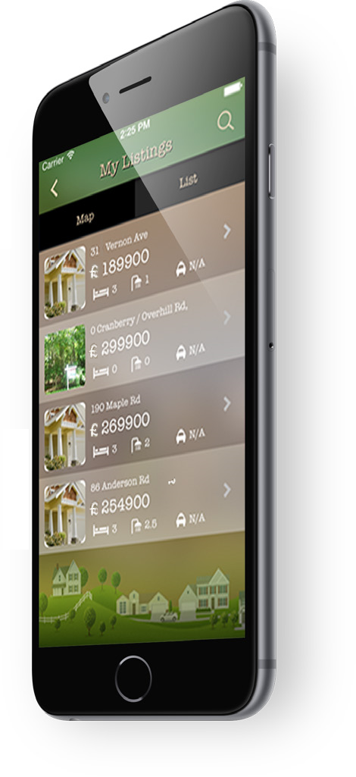
Upload your database of properties for rental or sale. Customers can download your app and view all your properties available.
Print your apps QR Code on your For Sale signs and allow passers-by to download your app and see all property details 24 hours a day, 7 days a week!
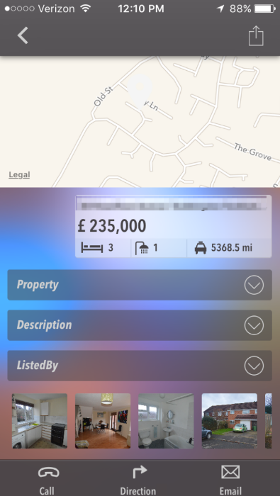
Provide directions and full details of each property.
Popular uses: Estate Agents, Property Management.

VERTICAL SOLUTIONS
GOLF COURSES
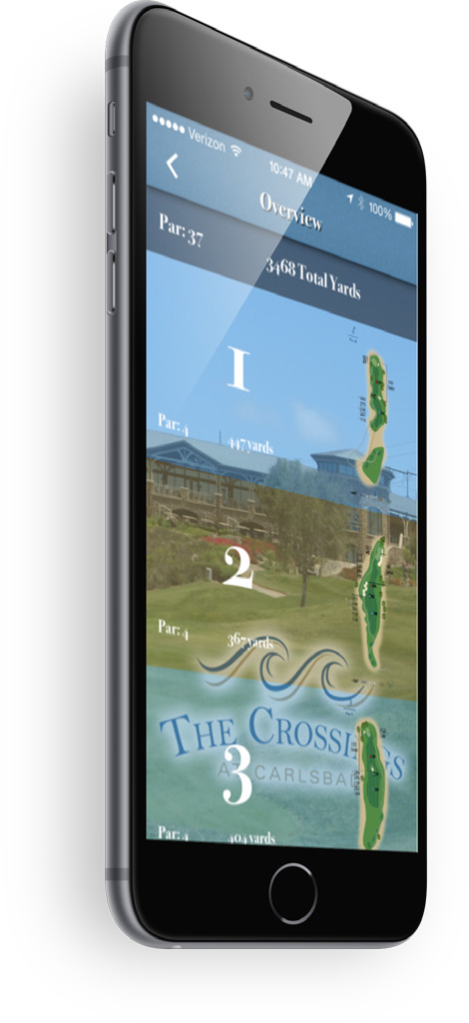
Ok, fair enough, not everyone has a golf course to show-off, but it you do, we have some very special features for you!
Golf Score Card
Distance from tee-to-green (front, middle back tee positions)
Pictures of course, hole and green.
Popular uses: Golf Courses

