
(Panel #1)
Qld Ultimate Schools and Youth Program
2017

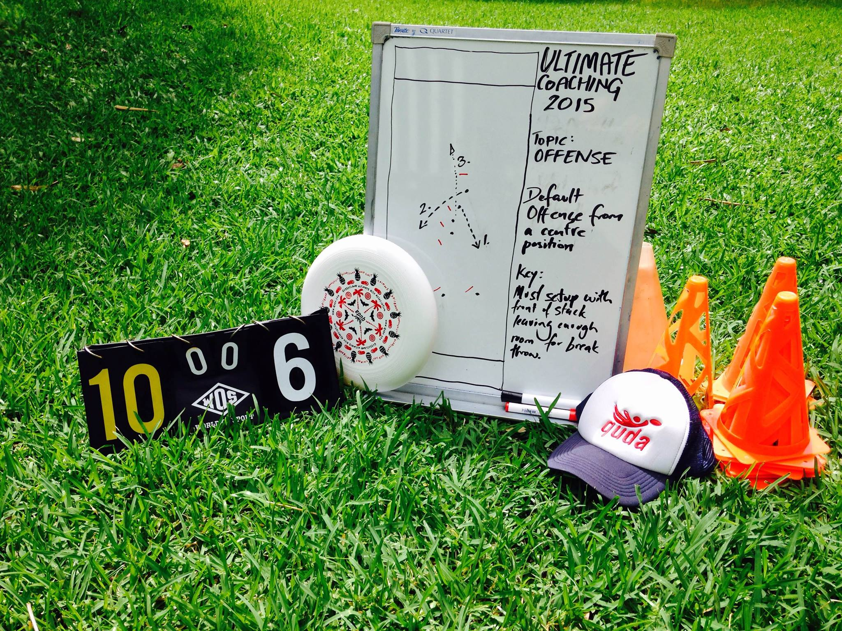
Insert Youth Ultimate image #2
(use one of the images of the teams playing in purple/maroon shirts).
(panel #3)
School Coaching Programs
Qld Ultimate provides Level 1 certified Coaches to conduct school coaching from Years 4-12.
Coaching rates are $45/hr per coach (max. 25 students per coach) plus travel subsidy where school is >50km.
We can also provide coaching services to school sports gala days and interschool competitions.
Full coaching terms and conditions at: <<get schools rate document added to website>>

Professional Development
Qld Ultimate runs regular teacher PD and Level 1 Coaching Courses for Ultimate.
Talk to us if you want to run a tailored PD program for teachers in your school
We also participate in the GAQAP conferences where Level 1 Certificate courses are run free of charge for teachers and community members.
Check web for GAQAP details:
www.qld.gov.au/recreation/sports/volunteers-coaches/courses/

Insert image #1
(This is the front page – use the “best” image.
Play Ultimate Frisbee in your school!!
Qld Ultimate is seeking the assistance of school PE and Sports staff to promote and encourage eligible players to nominate for selection.
Contact: officer@qldultimate.com.au
(Panel #2)
Australian Youth Ultimate Championships 2017
Melbourne, 7-9 July 2017
www.youthnationals.ultimatefrisbee.org.au/e/ayuc2017
Qld Ultimate will be selecting representative Boys and Girls (under 18) teams for this Youth National Championship event.
Players aged 15-18 years are encouraged to nominate for selection.
Selections and trainings will commence in early 2016.
Note: Qld Ultimate will pay for uniforms and training costs, and all players are eligible to apply for YATS funding (up to $400) to cover travel expenses.

Contact: Queensland Ultimate
www.qldultimate.com.au
FB: Queensland Ultimate
Development Officer: officer@qldultimate.com.au
Mb: 0434 275 661

