Concussion Management

Concussion is a complex and evolving functional injury to the brain. Prompt trained medical review is mandatory in all international guidelines, as well as before returning to sport. This is to ensure there is no evidence of structural or other major pathology, as well as to guide you back to normal life and sport safely. Careful monitoring by your specialist Sport and Exercise Physicians (ACSEP) at SPARC, trained in up to date concussion management will help guide this process to the same standard of care whether you had a fall at work, are a 12-year-old soccer player, or an elite AFL player. You only have one brain and we believe the same standard of care applies whoever you may be.
While concussion itself is a largely benign condition that typically fully resolves within 7-10 days (90% of people), there are important factors to be aware of:
- Concussion can occur with a sudden impact to the body, not just to the head
- Concussion often occurs without loss of consciousness
- After a concussion, you cannot return to sport or activity on the same day
- Symptoms evolve over time, and therefore you may experience different symptoms at different times
- Our brain has many different functions and concussion can affect any or all these areas but typically you may notice:
  - Headache
  - Lethargy as well as sleep disturbances
  - Balance difficulties and dizziness
  - Disorientation and concentration issues
  - Temporary loss of memory
  - Mood changes such as being more irritable or emotional than usual
  - Blurred vision
- Given these changes, it is important that you do not drive during this time, nor put yourself in risky situations as your judgement and reflexes are compromised
- No alcohol, sleeping tables, aspirin, or anti-inflammatory medications
While extremely rare, it is important to watch for the following signs that potentially can indicate more serious issues. If any of these signs are noticed, please contact your doctor or the nearest emergency department.
- Frequent vomiting and severe headaches
- Excessive drowsiness or falls unconscious
- Convulsions or spasms
- Weakness and slurred speech
- Or if you simply remain concerned about any further deterioration in symptoms
Early management
- Rest – the most important early treatment
  - Both physical rest, as well as mental (watching TV, reading, computer games can all worsen your symptoms and if so should be stopped)
- Non-urgent review with your sports physician at SPARC
  - Within 1-2 days after your concussion is best
- Panadol if you have a headache
- Your sports physician will then develop a plan to return to school, work, and / or sport safely
- Further testing such as advanced computer based reaction tests may also be undertaken to better asses your condition
- Clearance by your sports physician before returning to full training and competition
Caring for your brain is vital, and as Sports and Exercise Physicians we are dedicated to making sure that up to date guidelines and best medical management are followed to get you safely back to work, school, and sport, as well as preventing any long-term issues.
For more information or to book an appointment, please contact:
OPENING HOURS
- Monday – Wednesday 8:30 - 6
- Thursday 8:30 - 8
- Friday 8:30 - 3
- Saturday 9 - 12:30
CONTACT DETAILS

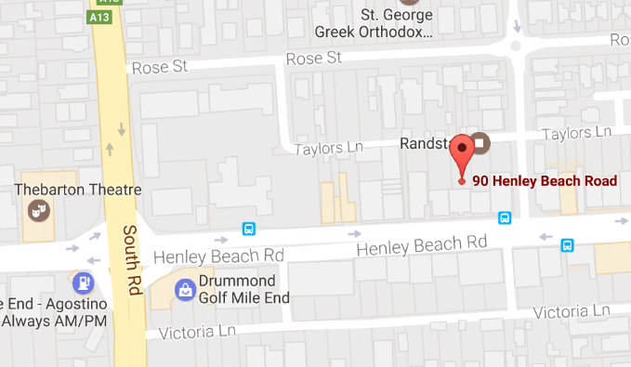
Sports and Arthritis Clinic
90 Henley Beach Rd, Mile End 5031
Telephone 08 8234 9707
info@sportclinic.com.au
www.sportsandarthritisclinic.com.au

