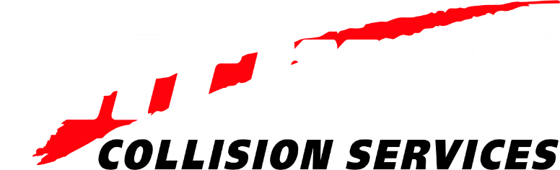

Invites You to Attend

“An Evening to Celebrate”
Our People
Our Community
Our Company

Saturday, May 13th, 2017, at the Fairmont Hotel Vancouver

