Footbridge poster brief

We are a design company specializing in bridge design and engineering. We have developed a footbridge design intended for use in local parks within New Zealand. With the help of our friends here at Design Crowd have created 3D render of our bridge that we need turned into striking posters that can be used to advertise the bridge to local councils, architects, and private developers.
We have attached a series of high resolution raw images that we would like used in our posters. Feel free to select and/or crop the images to fit with your poster style. We have also included all of the text that we need added (see below). We would like the posters to appear professional but artistic/fun. We have created a quick mock-up using MS Word to give you an idea of what we need. Please note we expect the designers to vastly improve or in many cases drastically change these quick mock-ups and we will be looking at composition, alignment/layout, and style. Once we have an entry that we feel provide a high quality visual poster we will guarantee the payment.
The competition will be based on producing 2 posters: page 1 and page 2 as per the attached poster content. After the winning designer is selected we will need two further posters which will appear similar to Poster #2 with a slightly different balustrade design (we will provide the additional graphics and text changes). The same poster layout and style of page 2 can be used. Final Payment to the competition winner will be based on us receiving the four posters. We have done this so that designers do not need to do as much work during the competitive phase which we think sounds fair. Let us know if this is not clear.
- Poster layout must be landscape.
- The posters must be high resolution PDF to size A0.
- The poster will also be printed at A3. Minimum font size when viewed in A3 should be size 8 and readable (size 9 is preferred). Images can go all the way to the outside of the page but A3 text margins must be set a minimum 0.4cm from top and bottom and 1cm left and right.
- Some examples of architecture board styles that we like have been put in a Pinterest folder here: https://uk.pinterest.com/DanCrockerCEng/architecture-display-board/
- We have also uploaded a PDF mock-up (see attached).
- If you think your style would be better achieved by splitting each page into two this will be considered if it lends significant style advantages. We will try to provide early feedback on this if we see good examples.
- Along the way we will be providing detailed feedback to our designers at day #5, day #7 and day #9 (and day #10 if required).
- If you need more text or info for a particular poster style let us know. Requesting more text is fine but further 3d renders are not possible. We will try to provide additional text as requested.
- We require the high resolution PDF of the posters and the raw production files (e.g. Indesign, Photoshop etc.) depending on what software you use.
- We have included a company logo that was created very quickly by our team. Feel free to modify or improve this logo if it improves your poster design. Merit will be given to posters that significantly improve our logo. Our company creates vibrant and interesting footbridges.
Please be as creative as you can. If we like your style there is the potential for future work doing similar poster work for alternative bridge designs.
Let us know if you have any questions.
PAGE 1 CONTENT:

Title: PEDESTRIAN & CYCLE FRIENDLY FOOTBRIDGE DESIGN SET

Are you a landscape architect, developer, or local council looking to create or improve a public space?
Do areas of your design require pedestrian or cycle friendly bridges?
Does your project budget make engaging bridge engineers difficult at this stage of your design process?

THE “DCSS PEDESTRIAN BRIDGE”
This bridge set is a simple and cost effective bridge solution for use in parks and urban landscapes. It is designed to New Zealand standards by experienced and qualified bridge engineers and bridge architects. The aim of this bridge design is to establish a baseline pedestrian bridge design for New Zealand that can be easily implemented into most New Zealand design situations.
The bridge design is a steel beam system supporting timber joist and decking. The bridge can carry pedestrians and cyclists and allows spans of up to 18m and usable widths up to 3m. Various balustrades designs are provided and the colour of the steelwork is fully customisable without further design inputs.
This bridge set is intended to help designers who need a simple cost effective bridge for their overall masterplan but who do not want to commission a bridge engineer or bridge architect in the early stages. In many cases the design can be successfully modified using variations of colour and balustrade type to fit the specific context without further design inputs being required.
The design is intended to help the following professionals:
- Landscape Architects
- Councils & Local Boards
- Developers
- Design and Build Contractors

Why do we need a baseline pedestrian bridge design in NZ?
These designs are intended to be used for concept and feasibility stages of urban and landscape design projects. Landscape designers and councils often ask us if there are any basic bridge designs they can use to begin setting their overall masterplan and capital budgets. Until now the answer has always been “no”. As of 2017 none of the local councils of NZ or the NZ Transport Agency have standard designs for pedestrian or cycle bridges that are readily available to designers.
In the early stages of a project; councils, developers, and landscape designers want simple and reliable bridge options that fit to, and help set, their overall budgets. Making this design set freely available to all professionals is aimed at encouraging and more easily enhancing public spaces in and around NZ. This set aims to enable landscape architects and urban designers to setup public space masterplans and overall capital budgets that their clients can readily understand and hopefully accept prior to engaging other professionals.
So you have set a masterplan and you have agreed a capital budget using this bridge design… what next?
The bridge beams, decking and balustrades of this design set are pre-designed ready for construction to New Zealand standards as outlined in the New Zealand Building Code (as of January 2017). This approach to the design is intended to save your project time and money. At building consent stage and in accordance with the New Zealand Building Code a Designer Producer Statement (PS1) for the bridge structure and PS1 for Geotechnical work will be required. Such services can be provided by your existing chartered professional engineering professionals (CPEng) once they have satisfied themselves that the design is compliant. Alternatively, you can contact us at DC Structures Studio Ltd to provide these services.
Prior to resource consenting a small geotechnical study will be necessary to confirm the ground conditions, geotechnical design parameters and provide bridge foundation recommendations. This is likely to consist of two borehole tests (one at each abutment location) followed by a small report summarising the ground conditions, geotechnical properties, and substructure recommendations. This study will then be used by your structural engineering design professional to design and detail a suitable abutment to support the bridge.

Version: Jan 2017. ©DC Structures Studio 2017. All copyright for content and images reserved

PAGE 2 CONTENT:

Title: NZ PEDESTRIAN FOOTBRIDGE WITH HORIZONTAL WIRE BALUSTRADE

This balustrade option features horizontal balustrade wires. Horizontal wires are a cost effective and low maintenance option for NZ bridges. The horizontal wire infill system is common place on New Zealand cycle bridges as they allow a lightweight aesthetic whilst proving a safe restraint to users*.
Because the infill wires are made from stainless steel they provide optimal long-term durability compared to contemporary painted steel rod or steel plate infill systems. Using this system reduces overall fabrication and whole of life maintenance costs for the bridge.
- Fully code compliant. Designed for New Zealand applications in accordance with New Zealand Design Standards.
- Spans up to 18m. Reduce by multiples of 1.8m for smaller spans e.g. can also work for 16.2m, 14.4m, etc.
- Designed for 3.0m wide footways. Can be easily reduced to other widths without further design.
- Balustrade heights of 1.1m. Posts are fabricated by cutting universal beams to reduce welding and fabrication costs.
- Architectural flexibility. Alternative balustrade designs can be incorporated to enable the implementation of customised – but cost effective – project specific architectural merit.
- Full colour versatility. The steelwork can be finished to a vast array of different colours including most of the Resene and/or Dulux colour palettes.
- Includes full superstructure design drawings. Enables fast and simple detailed design and fabrication stages.
- 3D models available. SKP files can be provided so that the design can be quickly added to landscape architect or urban developer masterplans.
- Good whole of life cost. The 100 year overall design life exceeds the NZ Building Code (NZBC) requirement of 50 years. Achieved with minimal additional cost thus providing good whole of life cost for clients. Time to first maintenance for steelwork paint systems is 40 years and timber replacement after 50 years.
- Environmentally friendly. Acrylic elastomeric paint systems can be used directly over the existing paint system during bridge maintenance and touch-ups which prevents the need for sand blasting over waterways.
- Thoughtful economic Vs. aesthetic balance. Only the visible elements of the steelwork are painted. All of the internal steelwork is galvanized or zinc sprayed. This provides an excellent balance of aesthetics to cost.
- Safe and quick construction. Time on site can be significantly reduced by fabricating the entire superstructure (including balustrades) off-site. Bridge is designed to be transportable in single piece (depending upon site access). It can be lifted into place once the abutments are complete.
- Cost effective solution. The estimate for this bridge is approximately $3,500 per metre square (+/-30% depending on site conditions, location, and project setup) ≈ $190,000 for the 18m long x 3m wide version. Since this estimate includes all structural design, geotechnical and fabrication/erection costs (a full “no surprises” estimate for pricing purposes) it therefore represents a very cost effective solution for most applications. Consenting fees, construction monitoring, and adjoining paths for the bridge are assumed provided elsewhere in your masterplan costs.
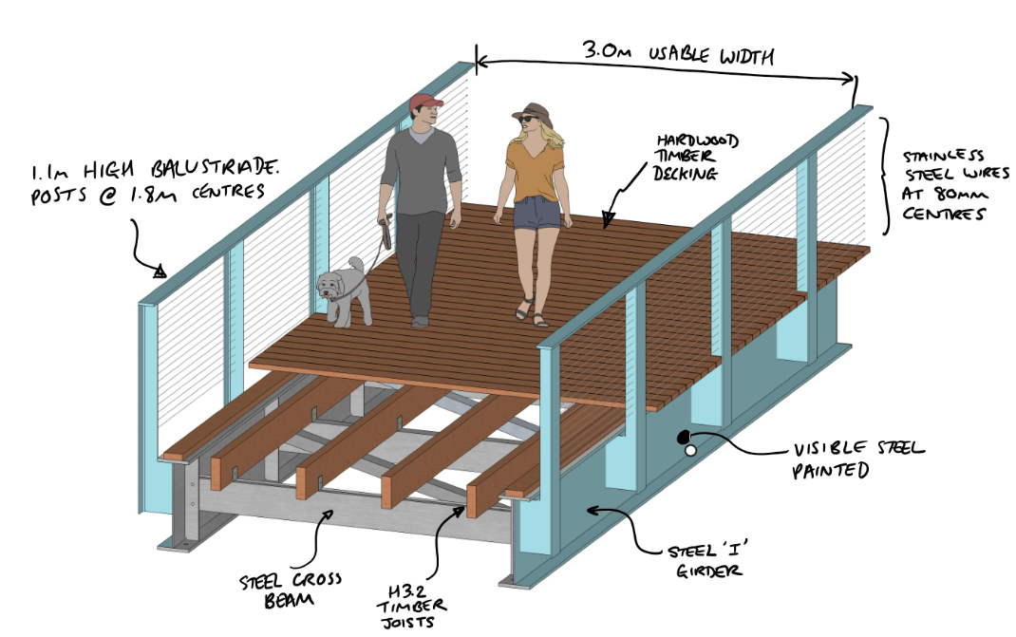
Following annotated isometric will need to be added. A version of the image without the text is added for designers who want to change the arrows, fonts etc. of the annotations:

Version: Jan 2017. ©DC Structures Studio 2017. All copyright for content and images reserved

PEDESTRIAN & CYCLE FRIENDLY FOOTBRIDGE DESIGN SET

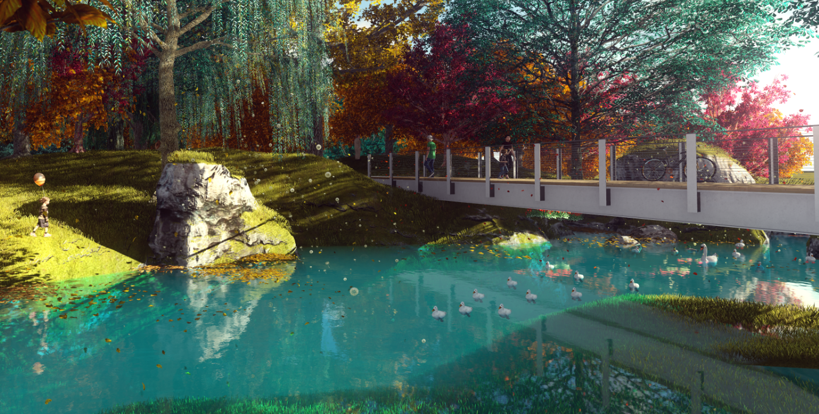
THE “DCSS PEDESTRIAN BRIDGE”
This bridge set is a simple and cost effective bridge solution for use in parks and urban landscapes. It is designed to New Zealand standards by experienced and qualified bridge engineers and bridge architects. The aim of this bridge design is to establish a baseline pedestrian bridge design for New Zealand that can be easily implemented into the majority of New Zealand design situations.
The bridge design is a steel beam system supporting timber joist and decking. The bridge can carry pedestrians and cyclists and allows spans of up to 18m and usable widths up to 3m. Various balustrades designs are provided and the colour of the steelwork is fully customisable without further design inputs.
This bridge set is intended to help designers who need a simple cost effective bridge for their overall masterplan but who do not want to commission a bridge engineer or bridge architect in the early stages. In many cases the design can be successfully modified using variations of colour and balustrade type to fit the specific context without further design inputs being required.
The design is intended to help the following professionals:
- Landscape Architects
- Councils & Local Boards
- Developers
- Design and Build Contractors

Are you a landscape architect, developer, or local council looking to create or improve a public space?
Do areas of your design require pedestrian or cycle friendly bridges?
Does your project budget make engaging bridge engineers difficult at this stage of your design process?

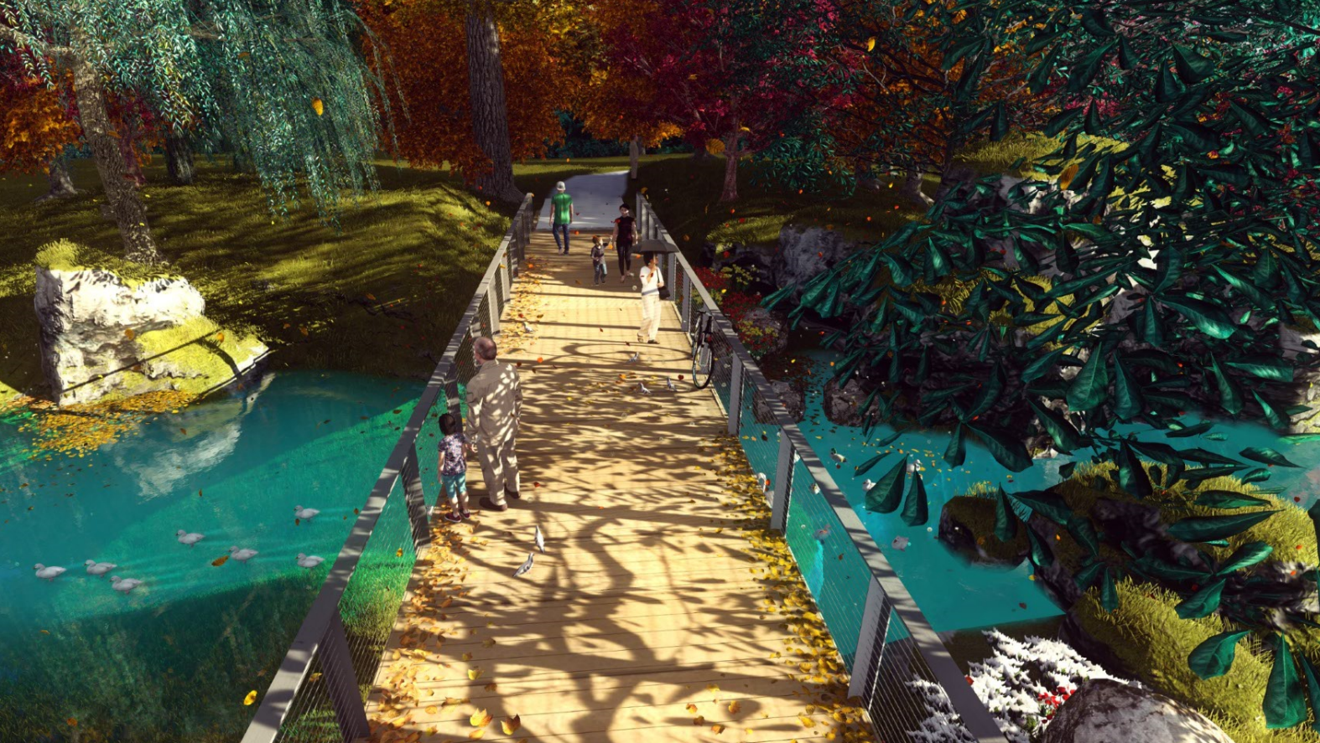
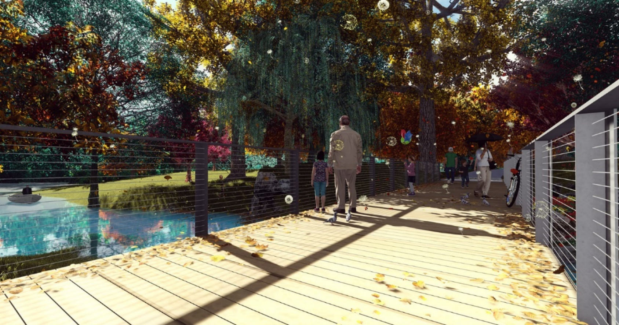
Why do we need a baseline pedestrian bridge design in NZ?
These designs are intended to be used for concept and feasibility stages of urban and landscape design projects. Landscape designers and councils often ask us if there are any basic bridge designs they can use to begin setting their overall masterplan and capital budgets. Until now the answer has always been “no”. As of 2017 none of the local councils of NZ or the NZ Transport Agency have standard designs for pedestrian or cycle bridges that are readily available to designers.
In the early stages of a project; councils, developers, and landscape designers want simple and reliable bridge options that fit to, and help set, their overall budgets. Making this design set freely available to all professionals is aimed at encouraging and more easily enhancing public spaces in and around NZ. This set aims to enable landscape architects and urban designers to setup public space masterplans and overall capital budgets that their clients can readily understand and hopefully accept prior to engaging other professionals.
So you have set a masterplan and you have agreed a capital budget using this bridge design… what next?
The bridge beams, decking and balustrades of this design set are pre-designed ready for construction to New Zealand standards as outlined in the New Zealand Building Code (as of January 2017). This approach to the design is intended to save your project time and money. At building consent stage and in accordance with the New Zealand Building Code a Designer Producer Statement (PS1) for the bridge structure and PS1 for Geotechnical work will be required. Such services can be provided by your existing chartered professional engineering professionals (CPEng) once they have satisfied themselves that the design is compliant. Alternatively, you can contact us at DC Structures Studio Ltd to provide these services.
Prior to resource consenting a small geotechnical study will be necessary to confirm the ground conditions, geotechnical design parameters and provide bridge foundation recommendations. This is likely to consist of two borehole tests (one at each abutment location) followed by a small report summarising the ground conditions, geotechnical properties, and substructure recommendations. This study will then be used by your structural engineering design professional to design and detail a suitable abutment to support the bridge.

Version: Jan 2017. ©DC Structures Studio 2017. All copyright for content and images reserved.
NZ Pedestrian Footbridge with Horizontal wire balustrade

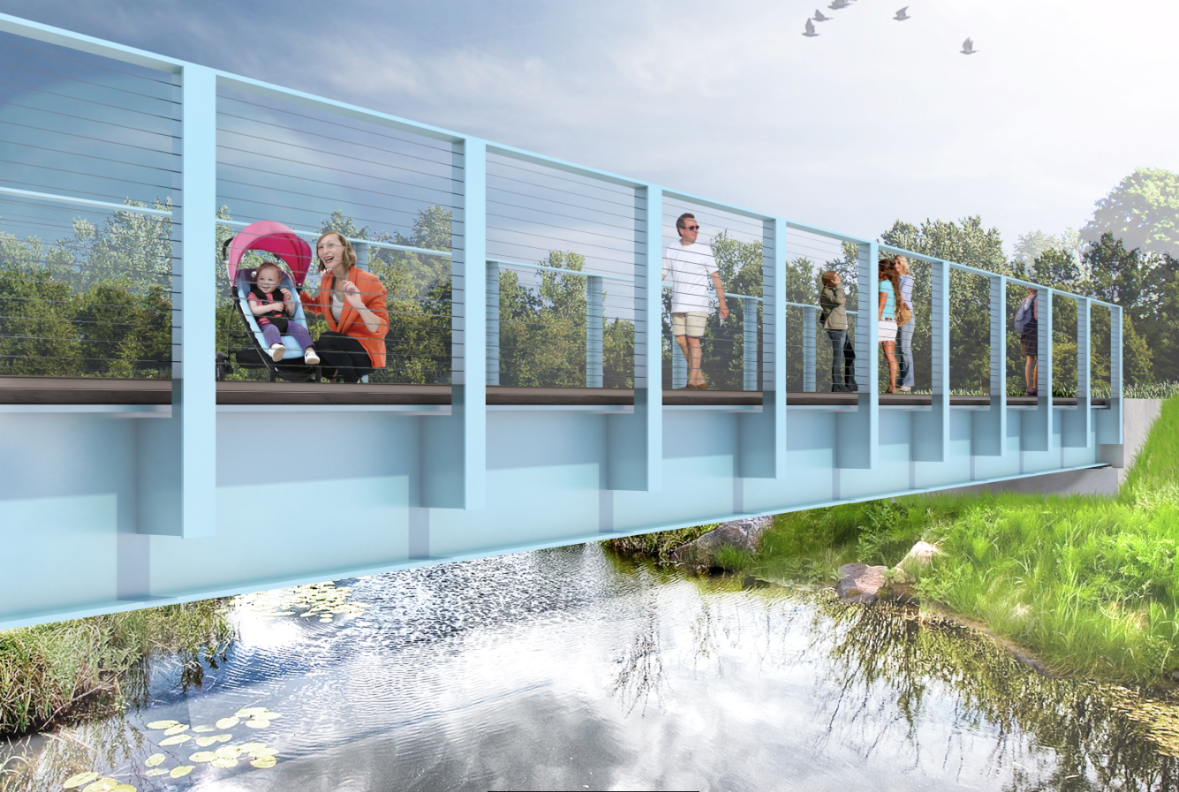
This balustrade option features horizontal balustrade wires. Horizontal wires are a cost effective and low maintenance option for NZ bridges. The horizontal wire infill system is common place on New Zealand cycle bridges as they allow a lightweight aesthetic whilst proving a safe restraint to users*.
Because the infill wires are made from stainless steel they provide optimal long-term durability compared to contemporary painted steel rod or steel plate infill systems. Using this system reduces overall fabrication and whole of life maintenance costs for the bridge.
- Fully code compliant. Designed for New Zealand applications in accordance with New Zealand Design Standards.
- Spans up to 18m. Reduce by multiples of 1.8m for smaller spans e.g. can also work for 16.2m, 14.4m, etc.
- Designed for 3.0m wide footways. Can be easily reduced to other widths without further design.
- Balustrade heights of 1.1m. Posts are fabricated by cutting universal beams to reduce welding and fabrication costs.
- Architectural flexibility. Alternative balustrade designs can be incorporated to enable the implementation of customised – but cost effective – project specific architectural merit.
- Full colour versatility. The steelwork can be finished to a vast array of different colours including most of the Resene and/or Dulux colour palettes.
- Includes full superstructure design drawings. Enables fast and simple detailed design and fabrication stages.
- 3D models available. SKP files can be provided so that the design can be quickly added to landscape architect or urban developer masterplans.
- Good whole of life cost. The 100 year overall design life exceeds the NZ Building Code (NZBC) requirement of 50 years. Achieved with minimal additional cost thus providing good whole of life cost for clients. Time to first maintenance for steelwork paint systems is 40 years and timber replacement after 50 years.
- Environmentally friendly. Acrylic elastomeric paint systems can be used directly over the existing paint system during bridge maintenance and touch-ups which prevents the need for sand blasting over waterways.
- Thoughtful economic Vs. aesthetic balance. Only the visible elements of the steelwork are painted. All of the internal steelwork is galvanized or zinc sprayed. This provides an excellent balance of aesthetics to cost.
- Safe and quick construction. Time on site can be significantly reduced by fabricating the entire superstructure (including balustrades) off-site. Bridge is designed to be transportable in single piece (depending upon site access). It can be lifted into place once the abutments are complete.
- Cost effective solution. The estimate for this bridge is approximately $3,500 per metre square (+/-30% depending on site conditions, location, and project setup) ≈ $190,000 for the 18m long x 3m wide version. Since this estimate includes all structural design, geotechnical and fabrication/erection costs (a full “no surprises” estimate for pricing purposes) it therefore represents a very cost effective solution for most applications. Consenting fees, construction monitoring, and adjoining paths for the bridge are assumed provided elsewhere in your masterplan costs.

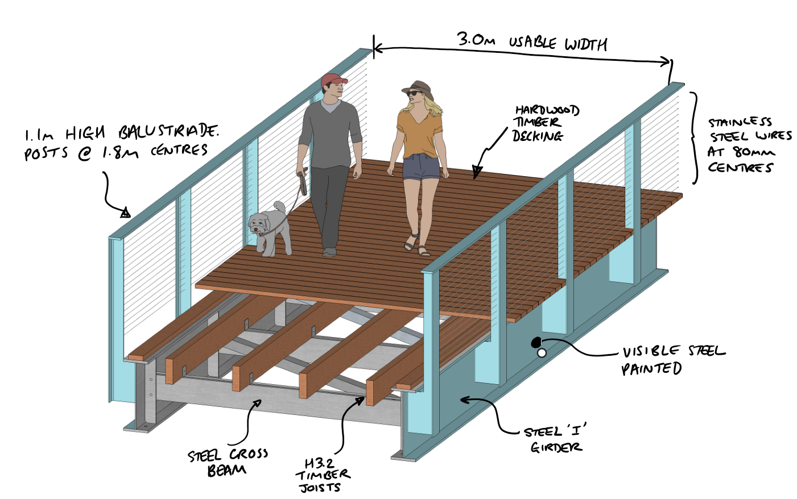
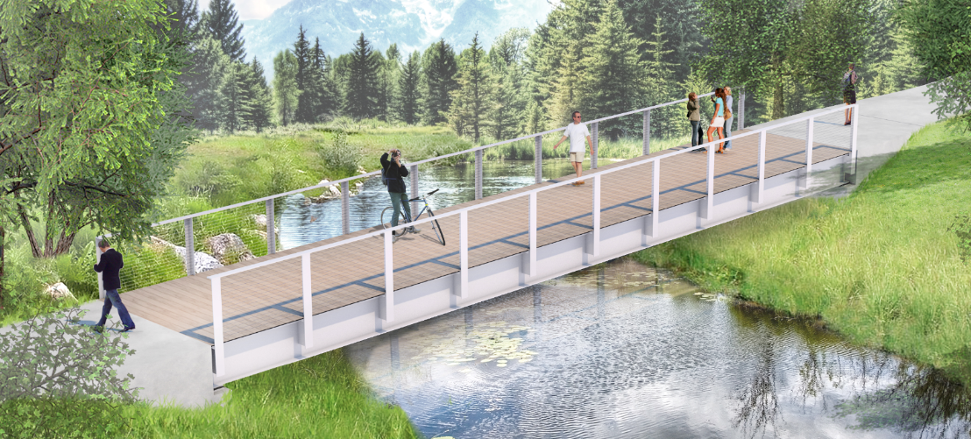
Version: Jan 2017. ©DC Structures Studio 2017. All copyright for content and images reserved.
* Please note that this system incorporates a horizontal infill system that is not strictly in accordance with NZBC F4. We strongly recommend that this system is pre-agreed with your consenting authority at the earliest opportunity. Since bridges are not strictly speaking buildings (as intended by the NZBC) and the presence of unaccompanied children under 6 years of age is less likely, councils often agree to the use of horizontal wires because of the improved durability and lower capital costs incurred.

(Above and below) Bridge colour as Resene Charlotte (B87-041-214)

