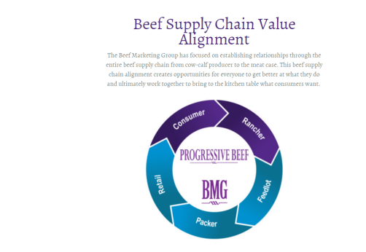

Rancher: Cowboy with cattle in the background
Feedyard: Cowboy sunrise picture
Packer: Meat inspector (person with white coat, white hard hat) and hanging carcasses
Retail: Butcher talking to the mom shopping in the meat case with a child in grocery cart
Consumer: Family around the table eating beef

