CHANNEL LETTERS
TYPES & STYLES
- Trimless Channel Letters
- Channel Lock Trimcap
- Fabricated Trimcap
- Fabricated Reverse
- Open Face
- Led Illumination
- Neon Illumination

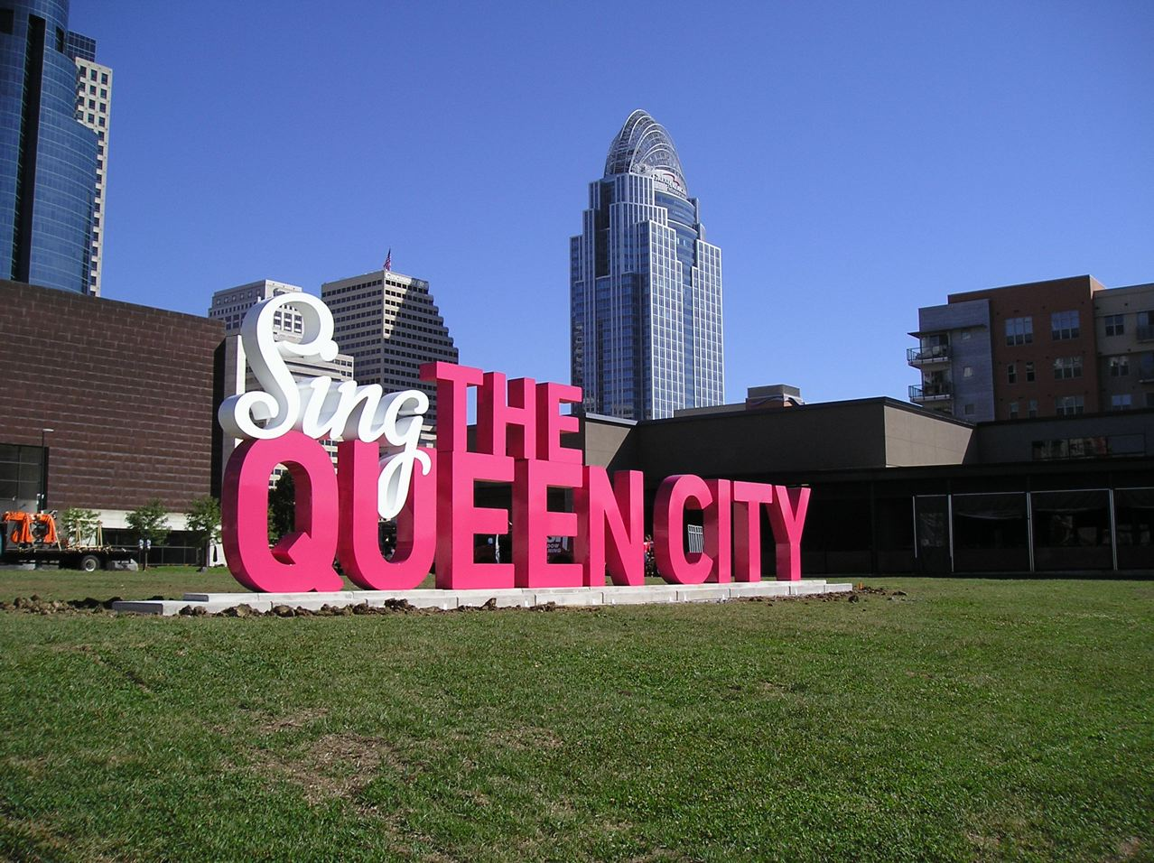
Channel letters and channel lettering are very popular for lighted business signs. These can be used indoor or out as they are very durable and weather resistant.

Introducing our new line of
Trimless Channel Letters with face, edge, and backlit illumination. These channel letters offer the distinctive and unique identity your customers have been searching for.
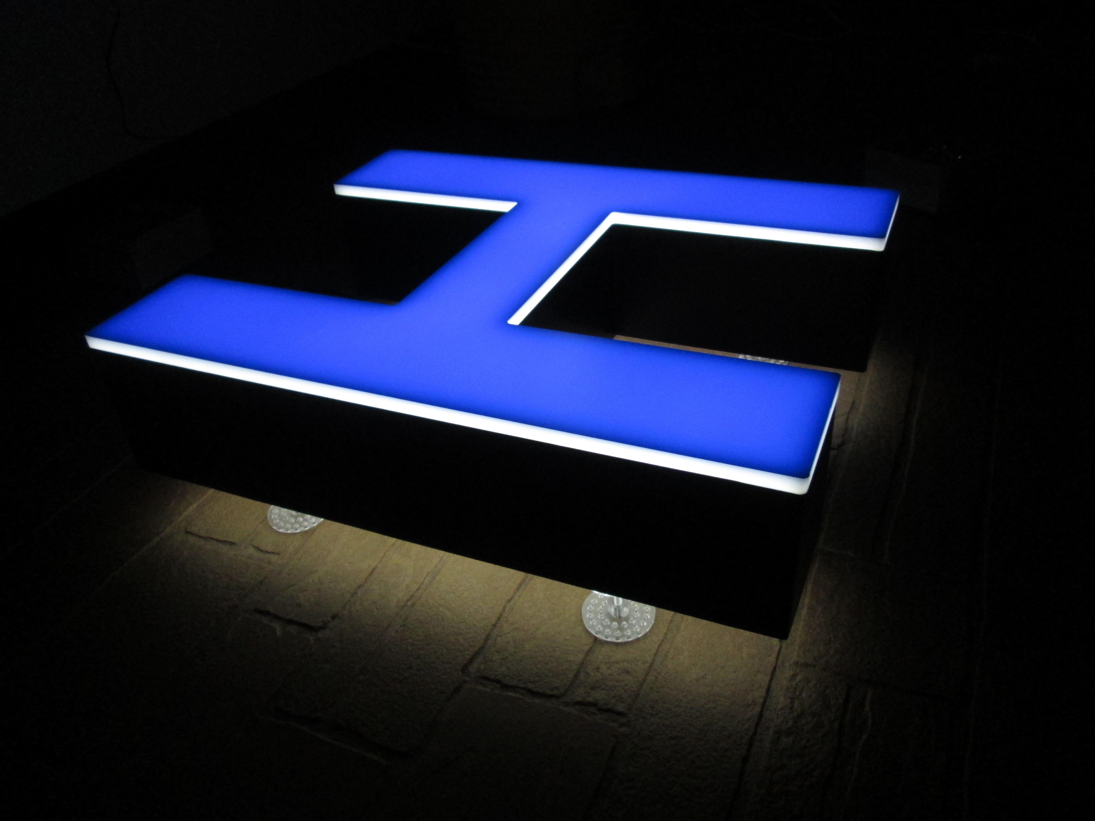
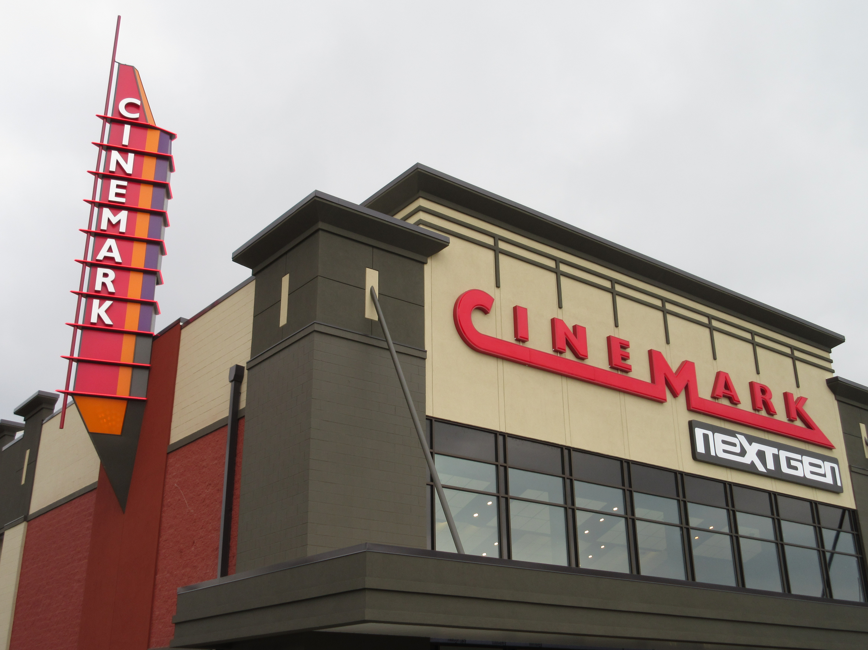
FEATURES & BENEFITS
- Sizes available from 6in – 15ft
- Channel Lock Letter Backs
- UL Approved
- LED or Neon Illumination
- Quantities of 1 or 100 sets
- Quick Production Time
The

Division of World Wide Sign Systems Inc.

