ARCHITECTURAL SIGNAGE
We manufacture custom architectural signs to provide unique identification for your customer. Whether your sign is round, square or a unique shape, our experience fabricators will design and make it per your instructions and needs.

Features and Benefits
- Fabricated odd-shaped cabinets and pole covers (round, round ends, cut corners, oval, radius corners)
- Computer driven robotic system precision cut routed aluminum faces (Push thru letters)
- Formed pan embossed, odd shape options
- UL approved illumination (Fluorescent. LEDs or Metal Halide)
- Post & Panel identification or directional signs (Custom or SignComp Series 2, 3, 7, or 12, extrusion systems)

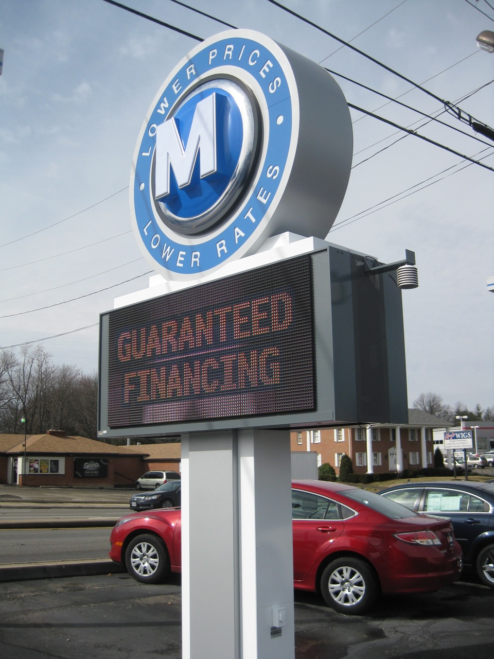
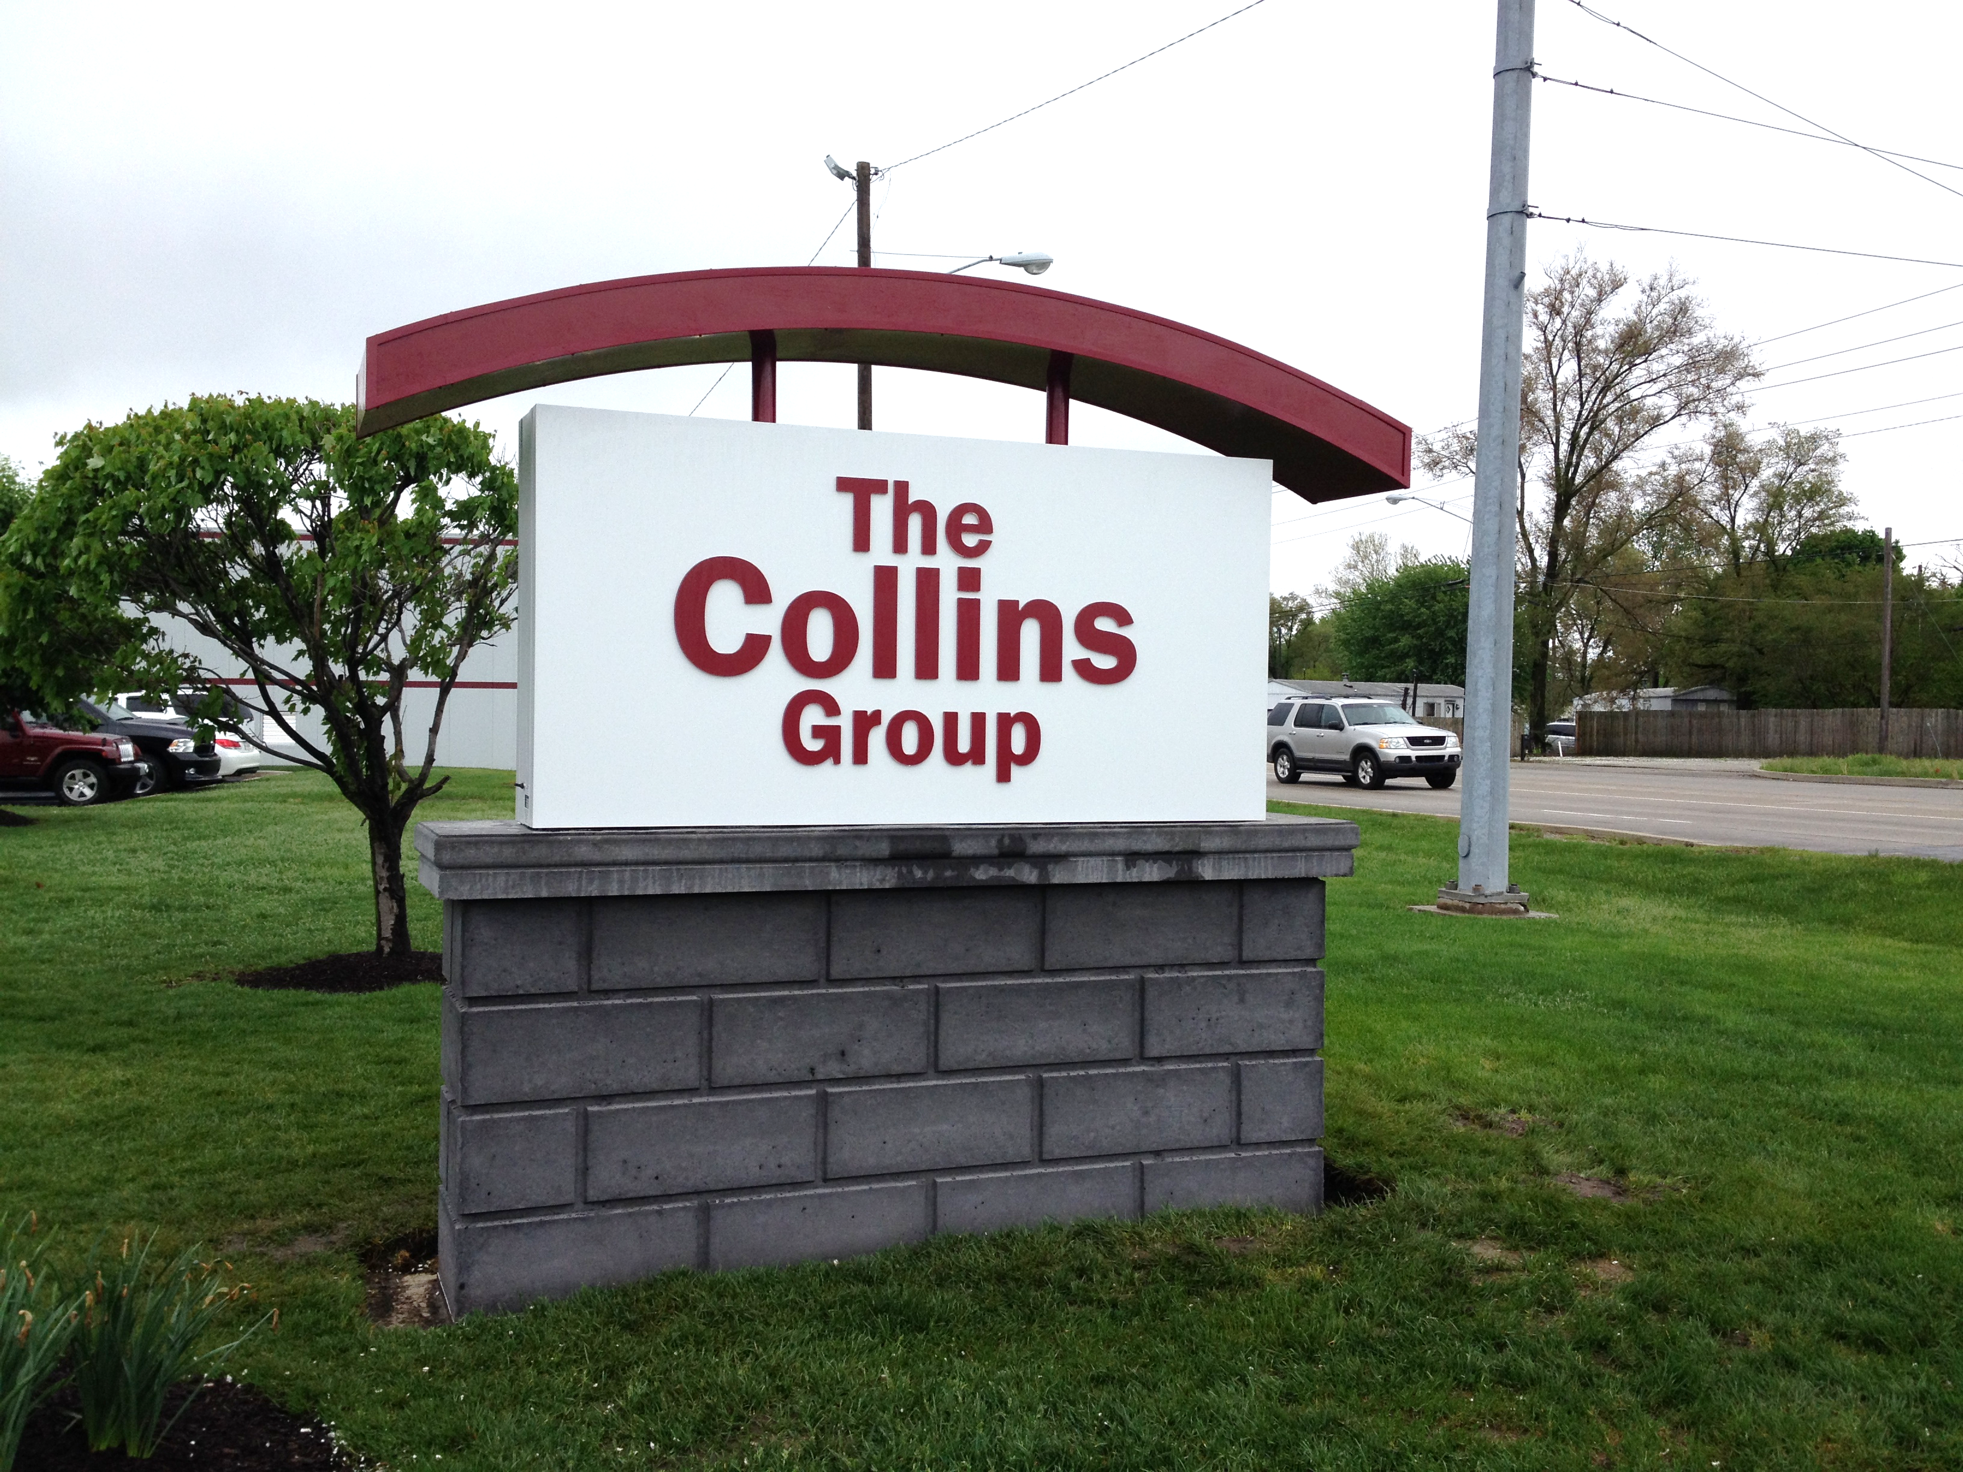

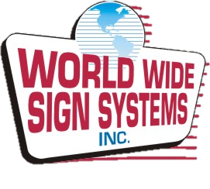
FABRICATED CABINETS
Each sign cabinet is manufactured to last; including the use of CNC manufacturing, strong frames, rust-proof metal, high-end automotive paint, and high-impact plastics or strong flexible-face materials.

Features and Benefits
- Custom fabricated signs manufactured in
3- 6 weeks
- UL approved illumination
- High Output Fluorescent , LED’S , or Metal Halide lamps
- Custom shapes and radius corners
- Custom fabrication sign cabinets designed for rigid or flexible faces (18", 24", 36", 48" depth available)

