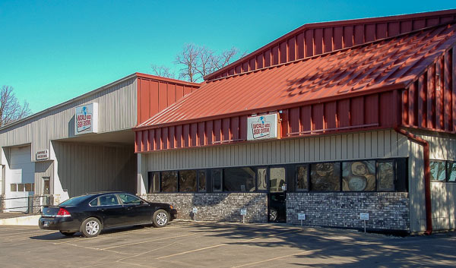
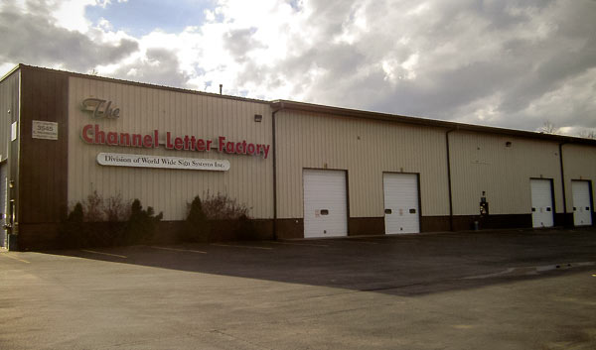
WEST COAST LOCATION
5071 SIGSTROM DR.
CARSON CITY, NV 89706
EAST COAST LOCATION
2765 BANKERS INDUSTRIAL DR. UNIT A
ATLANTA, GA 30360

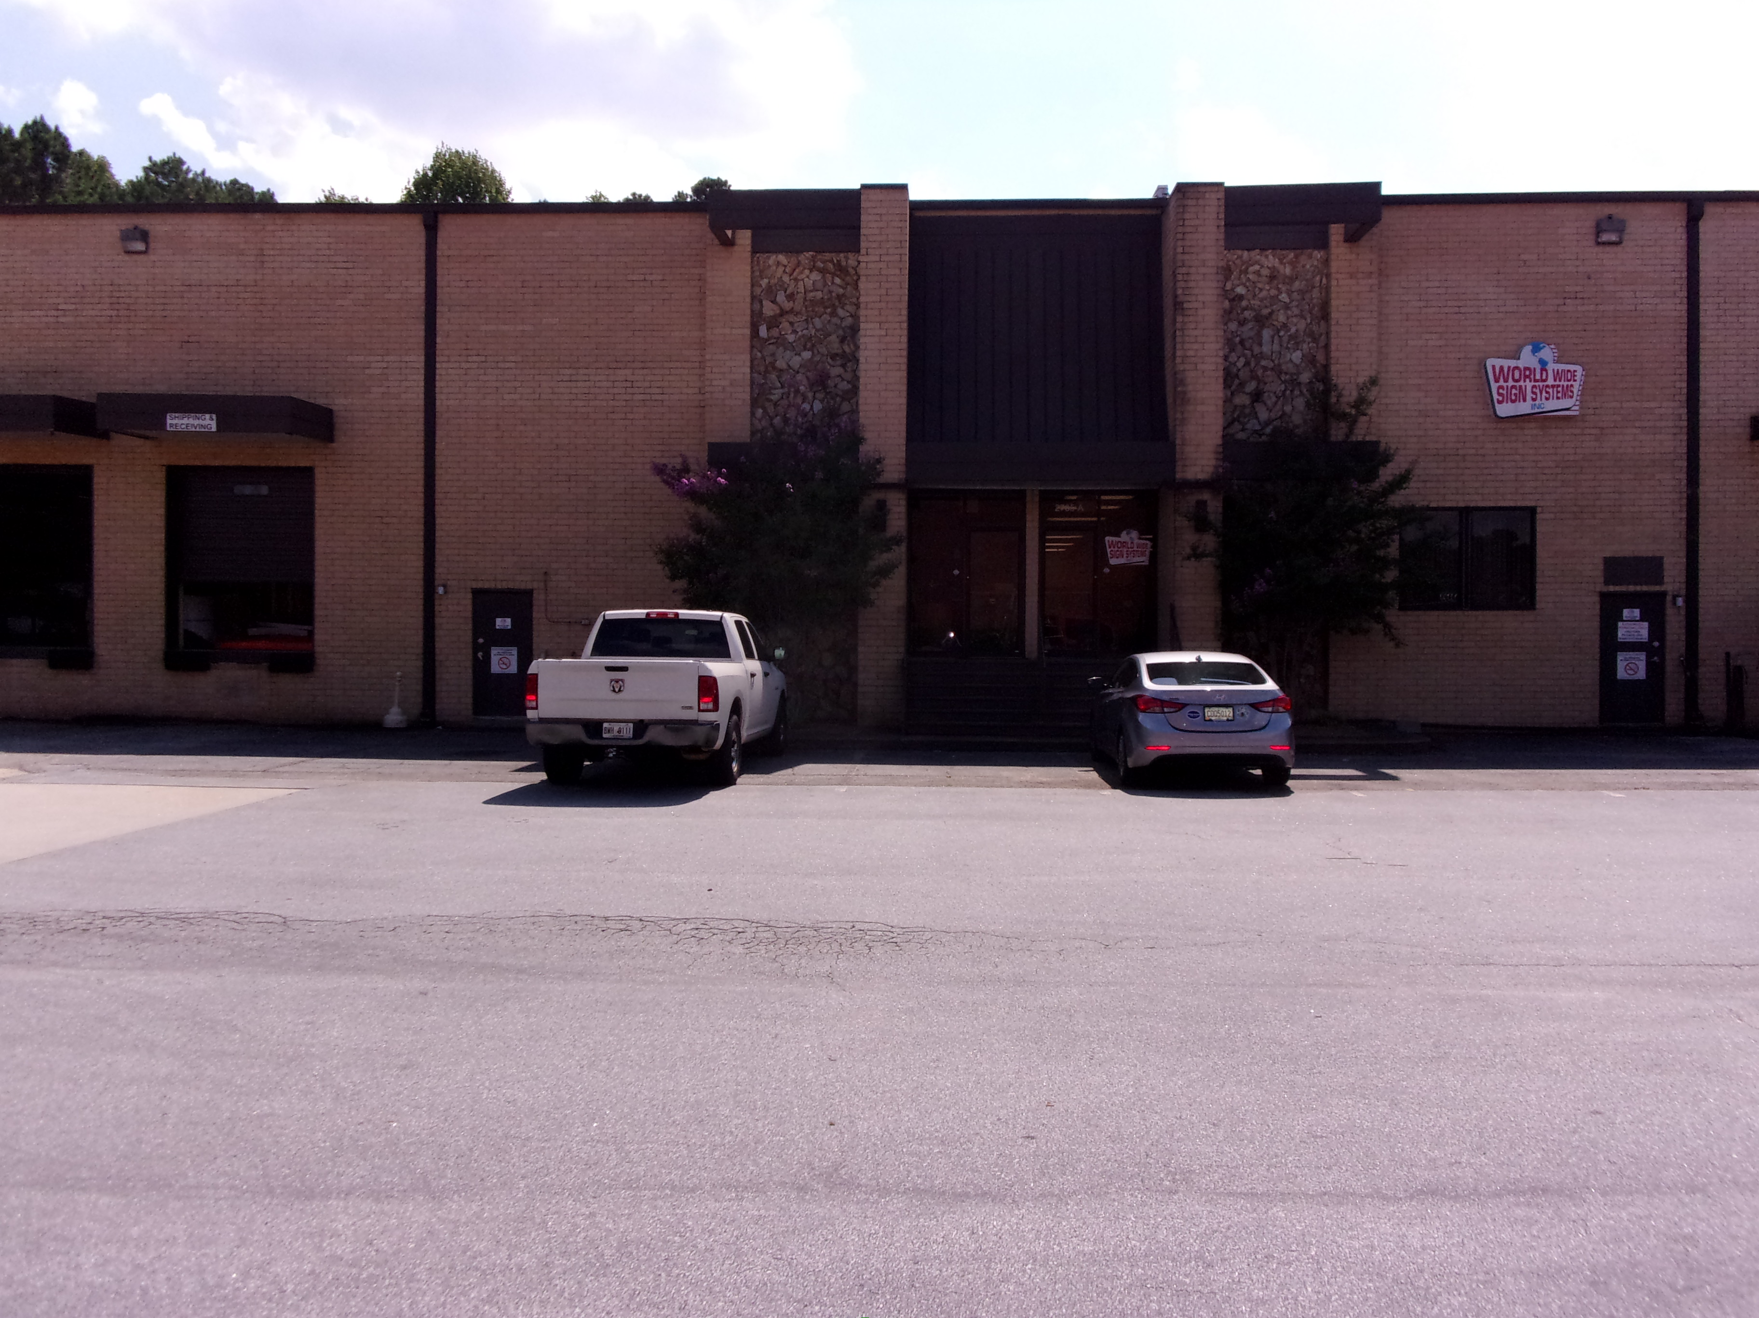

INSERT BUSINESS CARD
2 X 3.5
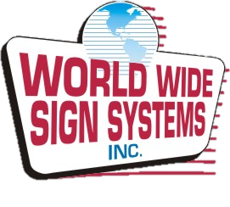
4 NATIONAL LOCATIONS
2 ADDITIONAL SALES
OFFICES IN FLORIDA &
NORTH CAROLINA
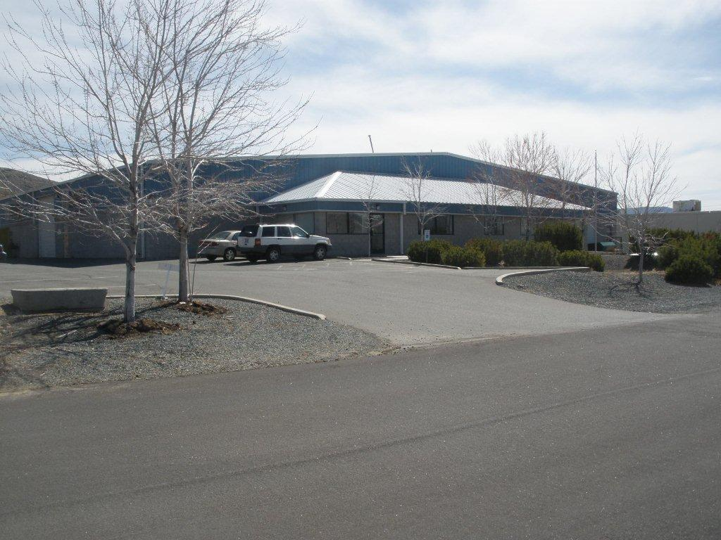

CORPORATE HEADQUARTERS
446 N. CECIL ST.
BONDUEL, WI 54107
THE CHANNEL LETTER FACTORY
3545 E. RICHMOND ST.
SHAWANO, WI 54166

