FORMED FACES
Our formed face signs are custom made to your specifications. Through our time tested process, we mold plastic over designs that you approve. We can then paint or cover your sign with vinyl or digitally printed graphics. With this process, we can create embossed letters and graphics to make them stand out more.
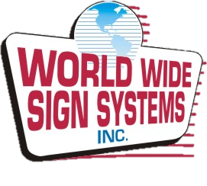
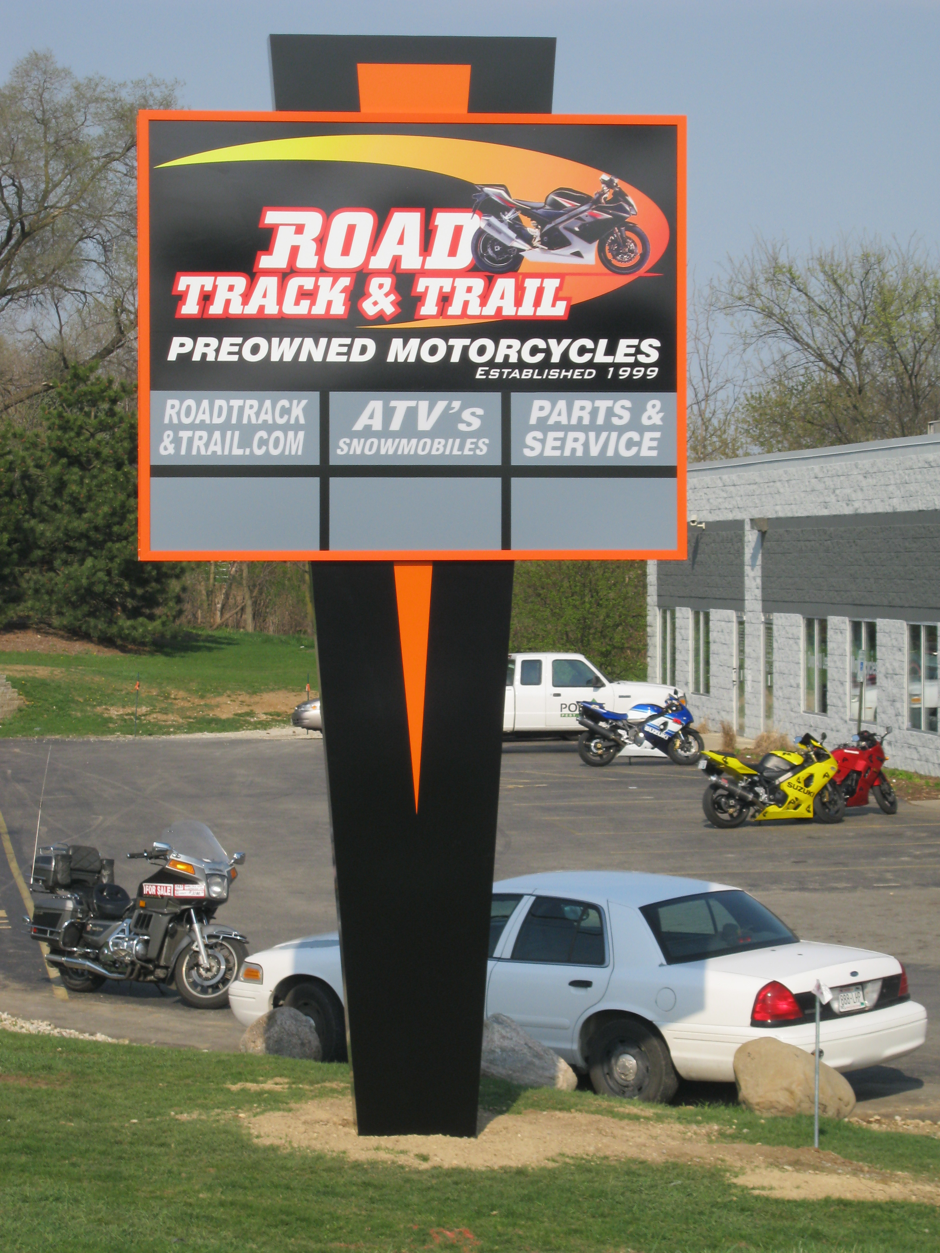
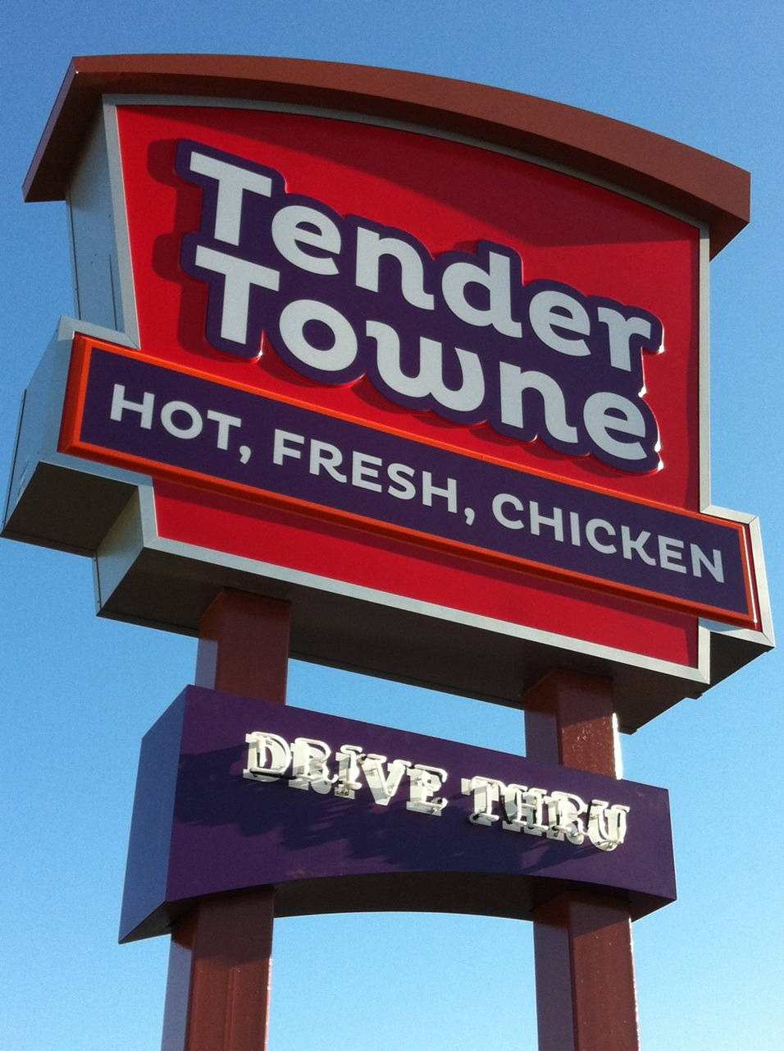

FLEXIBLE FACES
We offer Backlit Flex Face prints using translucent flexible vinyl, digital prints and direct printing to the substrate. We offer 3M Panagraphics III, Signtech FX and Sign Tech Wide Format substrates to meet all your needs. These Flex Faces are produced for installation into your existing "tension frame" sign cabinet, new replacement Retro frames and/or new construction.
Features and Benefits
- Digital printing for your custom logos
- Dedicated dust-free factory space for production
- Pressure sensitive quality vinyl film produced by our computerized cutting system and applied to premium substrate
- Factory trained technicians producing premium quality Flexible Faces

Decorated
- 2nd Surface Paint
- 1st or 2nd Surface Translucent Vinyl or Digitally Printed Graphics
- Pre-applied vinyl prior to forming
TYPES & STYLES
- Pan/Pan Embossed
- Flat Embossed
- White or Clear
- Up to 10ft x 20ft in one piece
- Odd Sizes and Shapes Available

