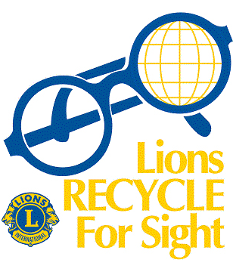
New for Old

Receive $5 off your new glasses for every pair of old glasses donated.

See reverse for details.

Do you have any unused glasses or sunglasses?
Why not donate them to someone in need.
The Eye Place is a collection spot for the Lions Recycle for Sight program.
Single vision, bifocal, multifocal, sunglasses …. it doesn’t matter, we’ll take them all. Even if they’re broken, bring them in and see if we can fix them ready for donation.
The Lions Recycle for Sight initiative is part of the larger eye care Program run by Lions International. The program helps to prevent blindness, restore eyesight and improve the eye health of millions of people worldwide.
The Eye Place is committed to supporting Lions Club Singleton and Lions Recycle for Sight. We will give $5 off your next purchase for every pair of glasses donated.
How it Works
1. Bring in any of your old/unused spectacles/prescription sunglasses to our store.
2. Choose a new pair of spectacles or sunglasses on the day of your donation.
3. Receive $5 off your purchase for each pair of glasses donated (max. 5 pairs per new purchase).


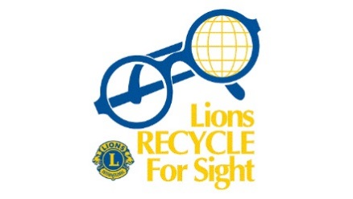
See you soon at The Eye Place.

