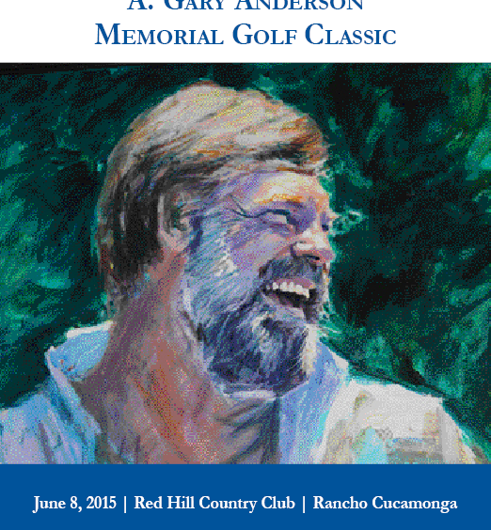
I visualize the logo going where the A. Gary Anderson Memorial Golf Classic text is listed above the photo, or placed in the dark green background of the photo.

