Slogans:
America is built on fearlessness, first as Veterans now as Ironworkers.
For Veterans, by Veterans
Building America: One Veteran Career at a Time
A Secure future in building America: Ironworking
Transforming Veterans into Skilled Tradesmen

Logo:
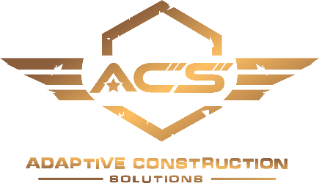
Gold Illustrator
Background Color:

“Gunmetal Blue” : 243e55 OR (R:36 G:62 B:85)

Publisher Illustrator Blue with no texture

Fonts:
The logo font is microgramma
TRI-FOLD BROCHURE:
Veteran Apprenticeship Program in Ironworking
Skills/Traits: Welding, bolting, rigging, connecting
Teamwork, camaraderie, GI Bill, Skilled Labor, Career, Community service
OJT, Apprenticeship, Career
Due to the large number of retirees from the baby boomer generation, ironworkers are in high demand. In Texas, the construction industry is on the rise and due to our training regiment, an average of 40 hrs/wk are worked. Our apprenticeship program follows the NCCER curriculum and at the end of the 3-year course involving classroom learning, OJT and practical application the apprentice achieves journeymen status in ironworking. Journeyman status opens the door to possible postions like foremen, crane operators and project managers. Ironworkers perform their duties on steel structures that provide a skeleton for commercial buildings like hospitals, schools and skyscrapers. Some of the key skilled trades of ironworking are welding, rigging, bolting and connecting.
All Things Veterans
Camaraderie and Culture
-Veteran owned and majority staffed organization who are committed to the mission of providing opportunitites to Veterans
-Graduation celebration after completion of initial training period, holiday parties and get togethers at VFWs
-Work with other Veterans and always have your teammate’s six
-We’re building America, one Veteran career at a time
Professional Support
ACS is committed to providing Veterans with supportive services designed to assist you and your families in the following areas:
Financial, family and work-related support.
Community Service
Disaster Response
Louisiana Flooding - Sept 2016
As the 15th anniversery of 9/11 approached ACS worked to find a volunteer opportunity. An ambitious plan was formed to respond to the devastating 1000-year flood event in Baton Rouge. With little time for planning, ACS organized all the tools and supplies necessary to take 24 Veterans to assist a community in extreme poverty. The team gutted the homes of nine residents which included: single mothers, handicapped elderaly and a Korean War Veterans
Hurricane Matthew - Oct 2016
In a period of 24 hours ACS mobilized 16 Veterans with the supplies neccessary to be 100% self-reliant. The team arrived in Holly Hill, SC 8 hours after Hurrican Matthew made landfall. During a period of 2 days, ACS provided over 5,000 meals, distributed 40,000 bottles of water and removed nearly 100 trees.

