THIS IS FORMULA 95 GREENS.
8 Miracle Ingredients. 20 Servings of Fruits & Veggies Daily.
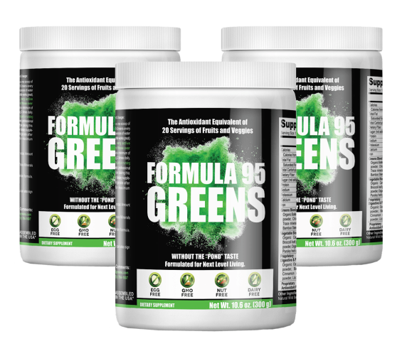
Energy-Boosting Greens SuperFood
for Highly Active Individuals
Stay Alert. Stay Focused. Stay Energized.
CLICK HERE TO ENERGIZE YOUR DAY.
100% NATURAL ENERGY FOOD FOR PEOPLE ON THE MOVE
From now on, you don't have to settle for just a few hours of energy.
You can also forget about taking separate supplements for overall health or dealing with the hassle of trying to get your daily fruits & veggies intake, especially when you're on the go.
ONE NEW SUPPLEMENT DOES ALL OF THIS AND KEEPS YOU ENERGIZED ALL DAY LONG...
KEEP READING TO DISCOVER THE SECRET!



Hi, my name is Mick Joyce and if you are suffering with low energy, I’m going to share something astounding with you.

I’m going to show you how people just like you are gaining energy.

And I’m not talking about a just a few hours of energy.

One new supplement does everything and keeps you energized all day long.

Plus, you can say “good bye” to dangerous side effects.

I see people with low energy levels every single day. Heck, I used to be that person!

Sometimes they try energy drinks.

Sometimes they try drinking dangerous levels of coffee and caffeine.

Other times they just give up, feeling they must live with a constant "drag" on their energy.
Do these symptoms sound familiar to you?

It’s difficult to stay focused.
In fact, many people can’t get a good night’s sleep because they are loaded up with harmful ingredients like caffeine.

You get tired regularly.
You just can't seem to keep your energy levels as high as you would like and get tired doing even the most mundane of tasks.

You suffer from work-fatigue.
You struggle to get work done during the day and you are always reaching for more coffee or an unhealthy energy drink.

You feel mental fatigue.
The demands on you are enormous, and you often find yourself extremely tired from pressures at work or school.

And here's the worst part...
No One Really Understands What You're Going Through.
...and they might even get annoyed with you because you never seem to have enough energy.
Now I see people with low energy every single day.
And over the years I've learned that traditional energy solutions like energy drinks and coffee don't have the answers.
Until now.
Many of the popular energy-boosting drinks have troublesome or addictive side effects.
Plus, there have been loads of individual supplements that only give you halfway-decent results for overall health and wellness.
Perhaps you’ve tried some and gotten “so-so” results
Sometimes, the results you got were so subtle and insignificant for a few moments you thought your energy had increased...
But, eventually... your low energy levels returned.
That's why what I'm going to share with you is so life changing.

I’m excited to tell you that there is finally a natural remedy for people with low energy that really works.
It’s called...
FORMULA 95 GREENS
Customers report that it works fast.
It's completely guaranteed.
And the price is completely reasonable.
This is a major breakthrough for people suffering from low energy levels.
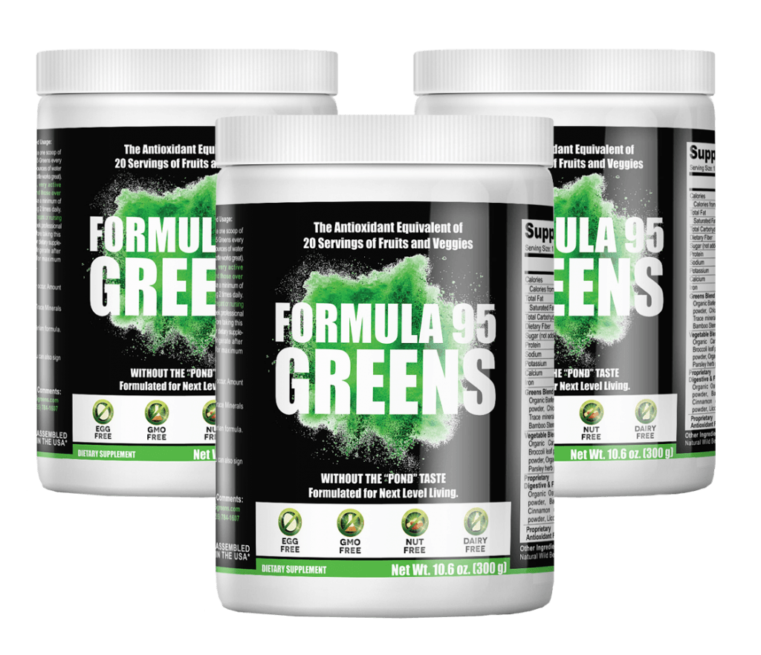
Chances are, you’ve never heard of it - Because that’s the way the big pharmaceutical companies want it.
They spend $30 billion a year to advertise their products to the public and medical community.
They have teams of sales people visiting doctors’ offices daily to make sure they keep pushing their pills and prescriptions.
So I understand most people haven’t heard of Formula 95 Greens.
Let me assure YOU... IT WORKS!

...The Feedback Has Been Incredible!
We hear from people saying "thank you" all the time.
You’ll hear their success stories in a few moments, the stories they share make me feel really good about Formula 95 Greens and its results.
We’re hearing from people who literally could not make it through their day without coffee and energy drinks.
People who were suffering and in pain are calling and emailing to tell us that they are feeling better than ever.

Working professionals are telling us they have less drag, less mental fatigue and are getting more done while throwing out harmful, non-natural, energy drinks.

Athletes and Runners are telling us they experience less down time post-workout and feel the extra energy boost gives them more endurance.

Parents are telling us they have more energy to focus on taking care of the house, get the kids to school, and spend more time organizing family activities.
And they are all wondering about one big question.
How did they manage without Formula 95 Greens until now?
Let me share something important with you.
The Key to Success Is CONSISTENCY, Taking a Scoop Every Single Day.
The Energy-Boosting Effects of Formula 95 Greens Increase with Daily Use.
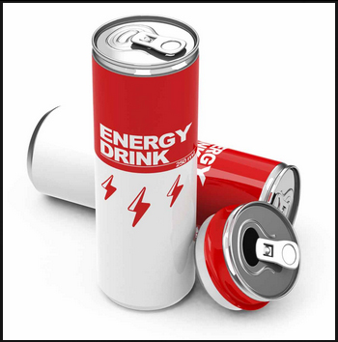
Energy Drinks Make You More Tired
Everybody knows how bad energy drinks can be for your health.
Especially when you feel like you need to drink them daily.
The problem is these drinks last only for a few minutes most of the time, leave you feeling worse than you did before.
Not to mention they are $3-$4 a piece.
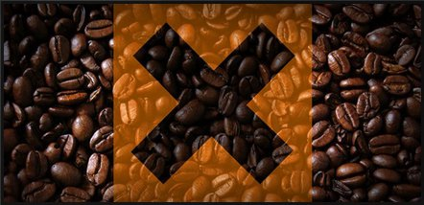
Too Much Coffee is Unhealthy
A cup of coffee never hurt anybody, but the problem lies when we absorb too much coffee.
The caffeine in coffee has been proven to cause changes in sleep patterns, hampers absorption of essential vitamins and minerals, can raise blood pressure.
Plus it stains your teeth!

Amazing Relief From Low Energy
Fatigue sometimes just leaps out at you.
You can be planning a well-deserved vacation and then...you just get tired.
All your plans go down the tubes and sometimes it doesn’t pass for days.
How can you make it go away?
I’m going to tell you about Formula 95 Greens, and then you’ll never have to suffer from fatigue again.
I know what it feels like... Sometimes even getting out of bed in the morning is agony.
Going to work becomes an impossibility. Heck, even getting dressed in the morning takes every bit of your energy.
And nothing works...
You just can’t seem to get enough energy. Working out makes you more fatigued. That pulls out even more energy, so you try to lie down on a sofa or bed.
But that is just as bad. The fatigue invades every aspect of your life. And the things you enjoyed most in life...
You can pretty much forget about them.
Playing golf with your buddies or working in the garden becomes an exercise in tiredness and suffering.
Now This is a Critical Point...
Formula 95 Greens is 100% Made in the USA
Most people aren’t aware of it, but the ingredients of most vitamins and supplements today come from China.
Even if the product says “Made in the USA”, the actual ingredients may come from China, or some other foreign country with lax food safety regulations.
The reason this is important is because these products are produced with little or no supervision.
You have no guarantee about the purity or quality of these ingredients.
It’s like a game of Russian Roulette.
Sooner or later, that gun is going to go off... And you don’t want it pointing at you when it happens.
Formula 95 Greens is different.
None of our ingredients come from China. They are 100% sourced in the USA.
Nearly all our ingredients are either organic or wildcrafted.
Wildcrafting means harvesting the plants from their natural state. This means taking only the parts of the plants that are needed and making sure we leave a healthy plant behind.
This means you are getting a completely natural product in a plant-based powder that is suitable for vegans.
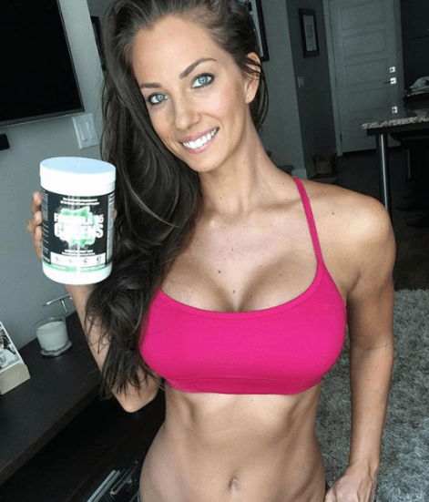
“I highly recommend Formula 95 Greens for a high quality non-GMO Superfood with vitamins, minerals, antioxidants, probiotics, and digestive enzymes. My body functions better in and out of the gym with added nutrition and it keeps my skin clear & youthful, eyes bright, and energy naturally high.”
- Janna Breslin (Certified Nutritional Therapist, NASM Certified Personal Trainer, Fitness Model and NPC Circuit Winner)
Nearly all of our ingredients are Organic or Wildcrafted.
Wildcrafting means harvesting the plants from their natural state.
This means taking only the parts of the plants that are needed and making sure we leave a healthy plant behind.
This means you are getting a completely natural product in a plant-based powder that is suitable for vegans.
Our 8 Natural, Miracle Ingredients Include:

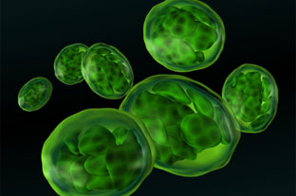

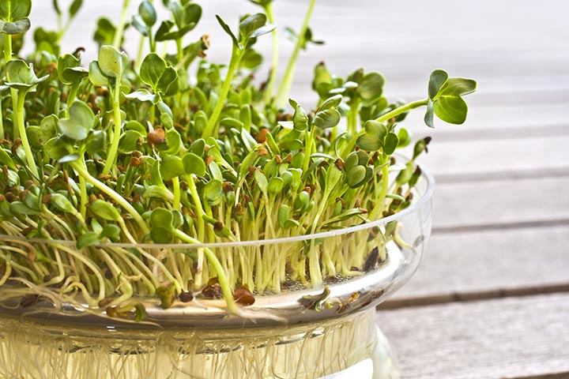
Spirulina
Spirulina has been called the "most superior plant protein in the world". It is high in iron, calcium and protein. It is probably best known for being extremely high in many nutrients and being used by astronauts. The Aztec Indians first discovered this food in Central America, and they consumed it daily for energy and strength.
Chlorella
A green algae super high in protein and healthy polyunsaturated fats. Popular in Australia, it's been proven to stop inflammation in it's tracks, and has been used around the world in treating cancer. It has also been shown to boost your energy, support fat loss and helps detox heavy metals like lead and mercury from your body.
Kelp
An excellent source of vitamins and minerals: Kelp has been shown to contain 46 minerals, 16 amino acids (the building blocks of protein) and 11 different vitamins. Prominent among the minerals are iodine, salt, iron, potassium, phosphorus and calcium. The lead vitamins in kelp are vitamin A and Niacin. It has been shown to help keep you hydrated, assist in weight loss, improve your body's pH levels and aid with cancer prevention.
Alfalfa Trace Mineral
Alfalfa has been used by the Chinese since the 6th century to treat several health conditions. It is considered the richest land source of trace minerals. Rich in vitamins, minerals and other nutrients that play a vital role in the strength and growth of our bones and in the maintenance of a healthy body. It contains protein and vitamin A, vitamin B1, vitamin B6, vitamin C, vitamin E and vitamin K. It also contains calcium, potassium, carotene, iron and zinc.
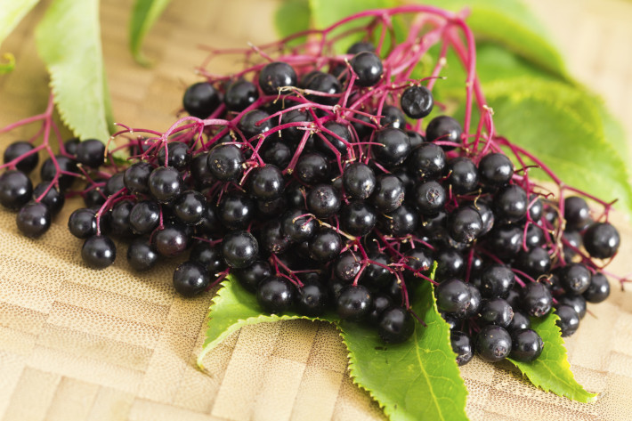
Elderberries
Elderberry is the fruit of the elder tree. Studies have found that elderberry eases flu symptoms like fever, headache, sore throat, fatigue, cough, and body aches. One study found that Elderberry could cut the duration of flu symptoms by more than 50%.
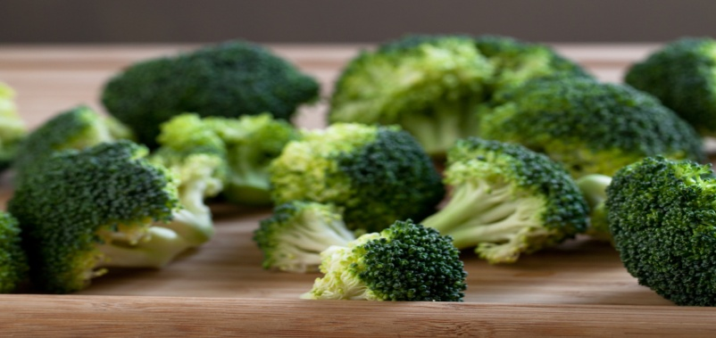
Broccoli Powder
Broccoli, a member of the cruciferous family of vegetables, contains high levels of healthy compounds called glucosino-lates. If you aren't able to consume enough broccoli in your diet (most of us aren't), broccoli powder is a convenient source of this nourishing vegetable, offering many of the same health benefits like energy, immunity and endurance, in a more concentrated form.
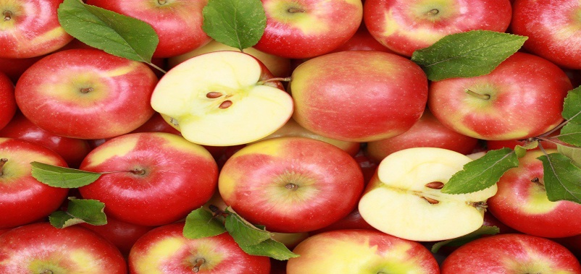
Apple Fiber Pectin
Rich sources of soluble fiber, like apple fiber pectin, plays an important role in the prevention and treatment of disease, reduces the risk of heart disease and reduces bad cholesterol levels more than following a low fat diet alone can. All types of soluble fibers slow digestion, so it takes longer for your body to absorb sugar (glucose) from the foods you eat. This helps prevent quick spikes in your blood sugar levels -- an important part of managing diabetes. Soluble fibers also bind with fatty acids, flushing them out of the body and helping to lower LDL (bad) cholesterol. The old saying is true: "An apple a day keeps the doctors away".

Bamboo Extract
Bamboo is one of the world’s best organic sources of silica. Silica deficiencies can lead to unfortunate health problems, including poor-quality skin and hair and an increased risk of wrinkles. Bamboo extract, on the other hand, contains 70% organic silica by weight. Bamboo extract works by raising the body’s natural levels of silica. When your body gets its recommended daily value of silica, you can experience the following benefits: healthier bones,teeth, and nails, reduced wrinkles and beautiful skin and thicker, more beautiful hair
PLUS...
Formula 95 Greens has another 53 whole food sourced ingredients to give you ALL DAY ENERGY
and 20 Servings of Fruits and Veggies Daily!

Check out the full arsenal of ingredients below...
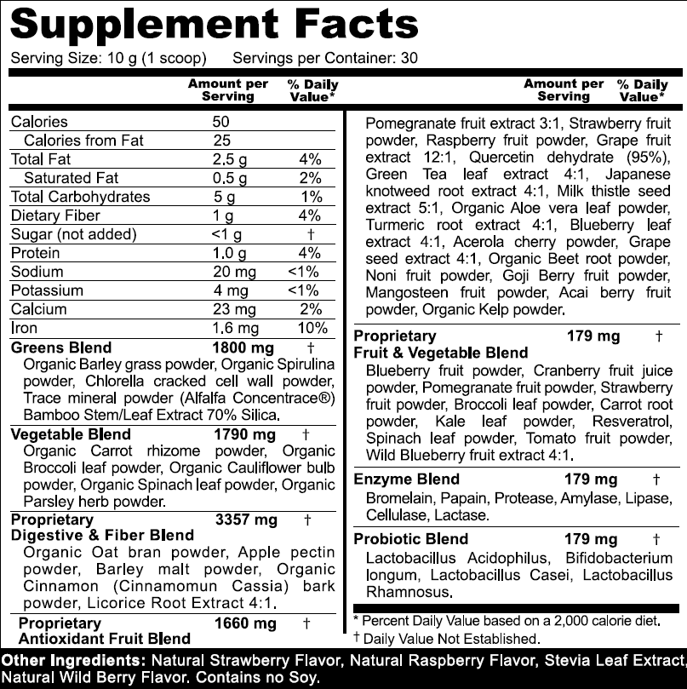
People Just Don't Understand...
When you have never had chronic low energy, you just don't know what's like.
When you can no longer do the things you enjoy or even function, life is frustrating.
Loss of energy is especially bad because it may never go away.
And usually it only gets worse and not better.
If you have any of the following problems, taking Formula 95 Greens may help you dramatically.
- Tiredness and Fatigue
- Lack of Energy
- Lack of Mental Focus
- Digestion Issues
- A Feeling Like You Are "Dragging" ALL Day Long
All of these issues can be traced back to not giving yourself the vital nutrients you need everyday, and your life can change when you turn to Formula 95 Greens.
Imagine Your New Life...
Imagine being able to go for long romantic walks on the beach.
How about a day in the park with your family?
How about hiking and camping with friends?
All of this is possible if you take Formula 95 Greens every day.
Don't be surprised if you become one of our raving fans.
We won't be surprised if...
You can resume all the activities that you love!

Get on your bicycle and
go riding with your kids?



Have the best workout

of your life?


Feel better and get

more done at work?
Fatigue and low energy don't have to be a life sentence anymore.
If you have low energy, why not take Formula 95 Greens FIRST?
It could save you from years of suffering, hurt and frustration.
How Formula 95 Greens is
Different
From Other Products
- Actually Tastes Like Something You Could Drink Daily
- 100% All-Natural and 100% Made in the USA
- Equals the Anti-Oxidant Equivalent of 20 Servings of Fruits and Vegetables Daily
- It's Completely Safe to Take Daily (Some Even Take 2X/Day)
- Contains 60 Ingredients Including Whole Food Sourced Fruits, Vegetables, Superfoods, Enzymes and Probiotics (Truly, a "One-Stop Shop")
- Contains Products Used For Centuries to Promote Health & Wellness
- Promotes Total Vibrant Health, Vitality, Mental Sharpness, Weight Management, Anti-Aging, Improved Digestion, Healthy Blood Sugar Levels, and Cellular Health
- No Capsules or Pills to Take, Just Mix One Scoop of Formula 95 Greens Powder with 8 Ounces of Water
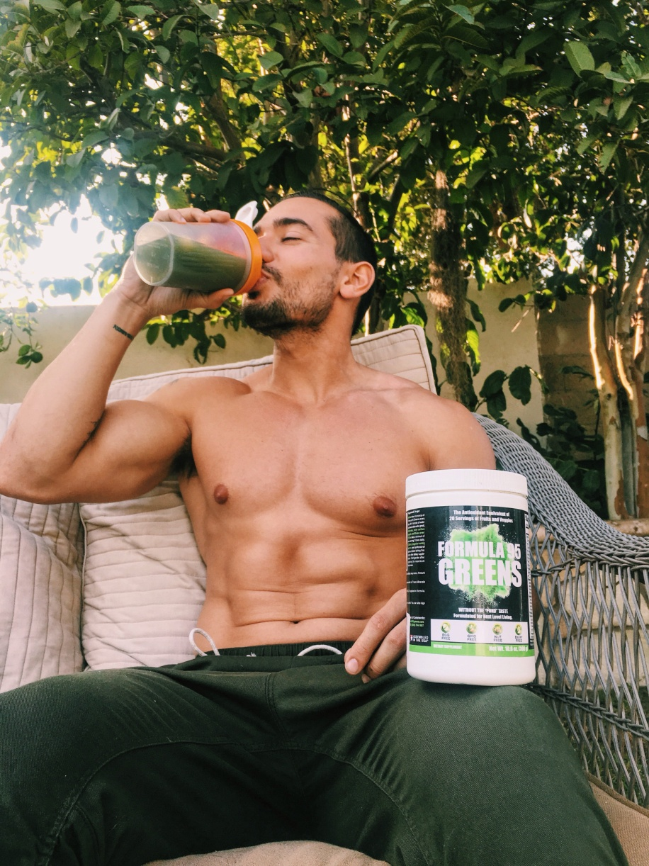
Here are a few real-world examples of how Formula 95 Greens is changing lives...

The Strength Coach
"Formula 95 helps me get in the vitamins, minerals, and probiotics my body needs to power through training and shorten recovery time...and it does it in a single, great tasting scoop. I'd recommend Formula 95 to anyone looking to push their performance to the next level..."
- Chris Hutcheson, National Qualifier for Strongman North America

The First Responder:
"Let's not kid ourselves, Lord knows we don't intake the recommended fruits and vegetables on a daily basis that we should. As a first responder, it's important that I stay on top of my game health-wise and since I've started taking Formula 95 Greens I've been able to do just that. I would definitely recommend this to anyone looking to become healthier".
- Matt Cathey, Fireman &First Responder, North Carolina

The CrossFitter:
"Obviously my body was missing the nutrients necessary to power through it's demands, despite my best put forth efforts to eat clean and for "fueling". After drinking Formula 95 Greens I feel more energized, more focused, and back to being able to keep up with the level of training I desirefor myself and my clients."
- Kasey Rising, Owner 524 Training and Head Female Coach at Hard Target Krav Maga, South Boston, VA

The Fitness Enthusiast
"So excited to take my training to the next level with this superfood blend and energy booster! You absolutely must have a healthy body while training hard and Formula 95 Greens will make sure your body is running at 100%. Taste's great by the way, very happy with it. Order yours!!
- Desiree Bramlette, Fit Chick Figure Competitor
When you order, you are getting a completely natural product in a plant-based powder suitable for vegans.
You won't find Formula 95 Greens, or anything like Formula 95 Greens, in your drug store or convenience store.
The only place you get Formula 95 Greens is right here.
And let me just share that Formula 95 Greens is a bargain compared to other choices.
In fact, it's only $1.69 per day.
60 Day Risk-Free Money Back Guarantee
Try Formula 95 Greens for 60 days and if you don't like it, you can send the empty bottle back to us for a 100% hassle-free refund.

How To Use:
Mix 1 scoop into 8 oz. of water, milk (we love it with almond milk!), your favorite smoothie or non-citrus juice.
Mix 1 Scoop of Formula 95 Greens
With 8 Ounces of Your Favorite Drink
To Boost Your Morning or Afternoon
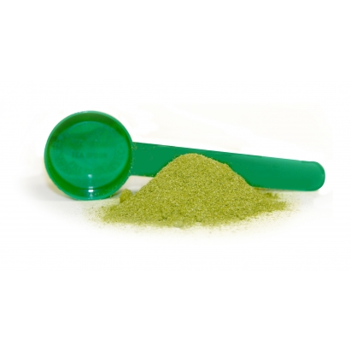

+


+

Try Formula 95 Greens Risk-Free Right Now.
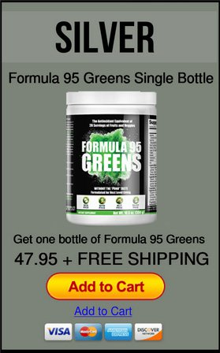
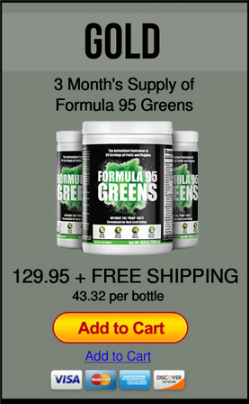
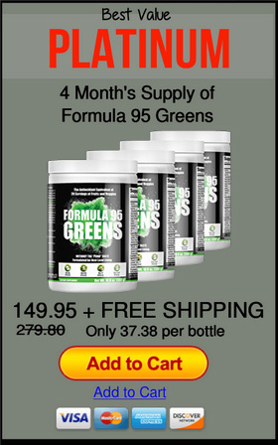
Questions? Email us at: support@formula95greens.com
This statement has not been evaluated by the FDA. This product is not intended to diagnose, treat, cure or prevent any disease. Information on this site is provided for informational purposes only. It is not meant to substitute for medical advice from your physician or other medical professional. You should not use the information contained herein for diagnosing or treating a health problem or disease, or prescribing any medication. Carefully read all product documentation. If you have or suspect that you have a medical problem, promptly contact your regular health care provider.

