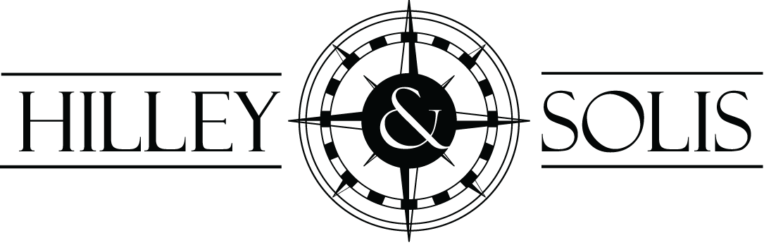

TO:

FROM: Carlos A. Solis
DATE: February 19, 2016
Re:

,
Regards,

Carlos A. Solis

