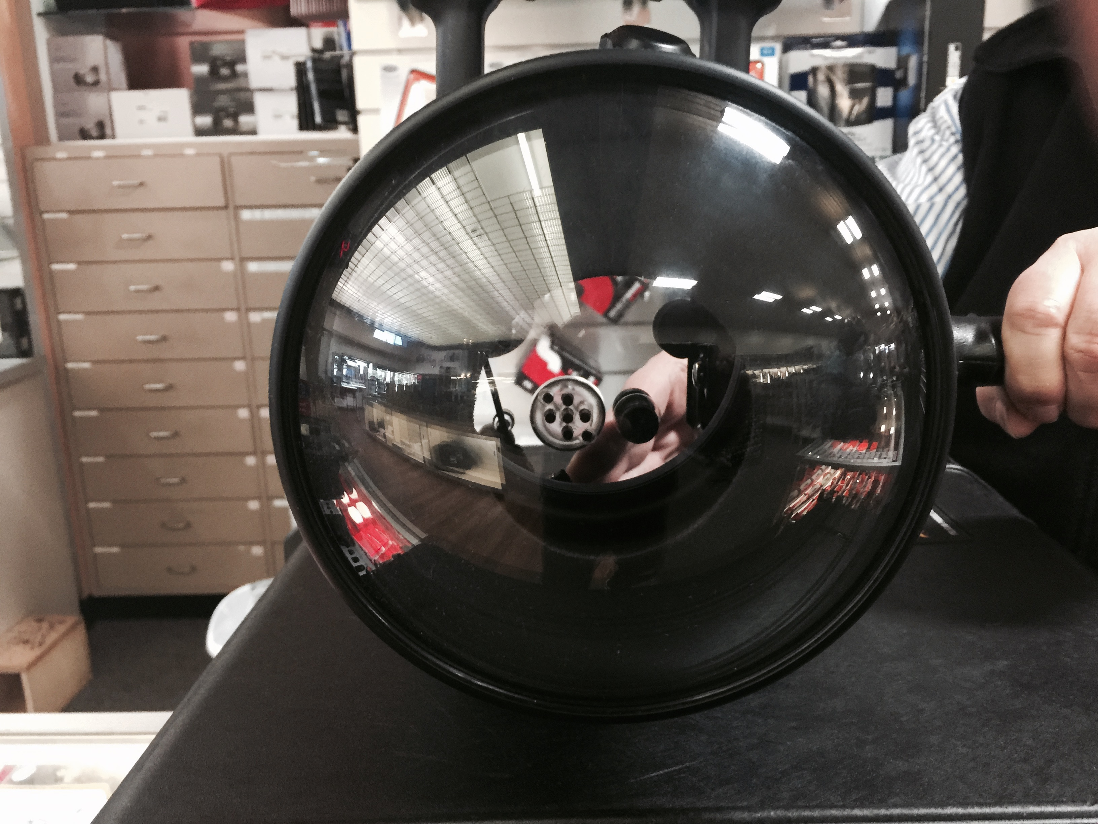
PUT LENSE IN THE MIDDLE SO IT READS LENSE – REDUCE THE THICKNESS OF BOTH OF THE GREY PORTAL AND CLOSING APETURE. PUT Dive HUB copy IN THE LENSE SO THE CURVETURE ADDS TO THE CURVETURE EFFECT.
DIVE FLAG IS THE DOT OF THE LOWER CASE I
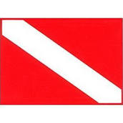

H
THE repeated FILM STRIP IS IN B/W THAT CONTINUES INTO THE H

Arial black lower case
Dive
ARIAL BLACK HUB
white lettering in light blue water

