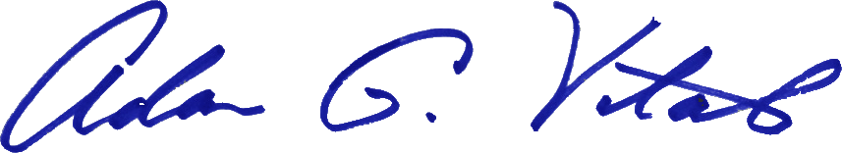

From the desk of
Adam G. Vitale

CONFIDENTIAL MEMO

To: Bob Boothe, Brandon McDonald, Chris Ashby, James Jones, Patrick Ruetz, Peggy Carr, Travis Stoneking
Cc:
Date: October 21, 2016

Re: Vision Statement of G & M Distributors, Inc.

To all,

Our vision statement provides the roadmap for the company. It defines us, and it gives us a macro-level view of who we are. The only thing that is constant is change, and our world is constantly changing all around us. We need a vision statement to continue to grow and thrive as a company.

Our vision:

At G&M, our vision is to be the best beverage distributor in central and northern Illinois. Our integrity and wining culture enables us to exceed the expectations of our customers, suppliers, and team members.

Team: Our team is inspired to be the best they can be. Our accountable actions speak louder than our words.
Partners: A winning network of customers and suppliers enable us to create value. We want to be the distributor of choice.
Winning: We are proud to win, and we are confident. Our drive pushes us to beat expectations, and we settle for more.
Portfolio: Our diverse and unique portfolio enables us to meet the needs of our customers.
Profit: Maximizing profitability and long-term returns helps us reinvest in our team, company, and community.
Community: We are active in the communities we serve. Giving back is part of our DNA.

