Inspiration logo’s
My zodiac sign is Leo. So it would be nice so incorporate this as a mark.
In general:
- Letters: minimalist, for example, only stripes.
Color: black, purple, mint / aqua green, as below:


Option 1:
- Letters filled with a picture (zodiac leo)

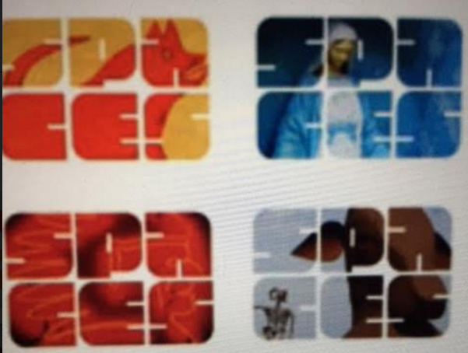
For example, this lion:


The letters under each other is also an option, so:
SE
EF

Option 2
Letters filled with this pattern


Option 3
for example: this logo before the letters SEEF. Only it needs to be made so different, otherwise it is plagiarism.


Logo ideas SEEF
https://www.google.nl/search?q=lion+security+shield&sa=X&biw=1536&bih=760&tbm=isch&tbo=u&source=univ&ved=0ahUKEwjC_d-Hie3QAhUBjCwKHaGwBj0QsAQIHg#imgrc=pwv4mV6_ivKK3M%3A

