STARTERS
PHILLY QUESADILLA
YOUR CHOICE OF PHILLY CHICKEN OR STEAK & ONIONS, CHEDDAR CHEESE, JALAPENOS, SIDE OF SALSA & SOUR CREAM – 10.95

PHILLY NACHOS
NACHO CHIPS COVERED WITH YOUR CHOICE OF PHILLY CHICKEN OR STEAK MEAT & ONIONS, JALAPENOS & QUESO CHEESE. – 10.95

PHILLY TATER TOTS
YOUR CHOICE OF PHILLY STEAK OR CHICKEN ON TATER TOTS COVERED WITH CHEESE WIZ. – 10.95

JALAPENO & CHEDDAR PIEROGIES (6)
THESE DELECTABLE LITTLE DUMPLINGS ARE STUFFED WITH CREAMY MASHED POTATOES, CHEDDAR & JALAPENOS THEN DEEP-FRIED TO PERFECTION & SEASONED. – 7.95

PROVOLONE CHEESE STICKS (6)
SERVED WITH MARINARA – 8.49

POTATO SKINS (6)
BACON, CHIVES, & CHEEZE WIZ OR CHEDDAR CHEESE (+$50) WITH A SIDE OF SOUR CREAM – 7.95
ADD CHICKEN PHILLY MEAT OR PHILLY STEAK – 4.50

SAMPLER PLATTER
PROVOLONE STICKS (4), BONELESS WINGS (6), PIEROGIES (3),
& CHIPS WITH QUESO. – 14.95

POPCORN SHRIMP W/FRIES – 8.49

CHIPS & QUESO – 6.49
QUESO REFILL – 2.00
CHIP REFILL – 1.00

MINI CORN DOGS (12) – 6.49

BASKET OF FRIES – 2.99 ONION RINGS – 6.49
ORIGINAL PHILLY
CHEESESTEAKS
MADE WITH SHAVED RIBEYE ON THE WORLD FAMOUS AMOROSO ROLL. COMES WITH FRIES OR CHIPS, ADD WHATEVER TOPPINGS YOU WANT: PEPPER RELISH, MUSHROOMS, BELL PEPPERS, PEPPERONCINIS, JALAPENOS, MARINARA, OR HOGIE STYLE (LETTUCE, TOMATO, & MAYO) – .75EA

FAMOUS PHILLY
SHAVED STEAK, GRILLED ONIONS & WHITE AMERICAN CHEESE, PROVOLONE, OR CHEEZE WIZ – 10.95

CHICKEN PHILLY
CHOPPED CHICKEN, GRILLED ONIONS & WHITE AMERICAN CHEESE, PROVOLONE, OR CHEESE WIZ – 10.95

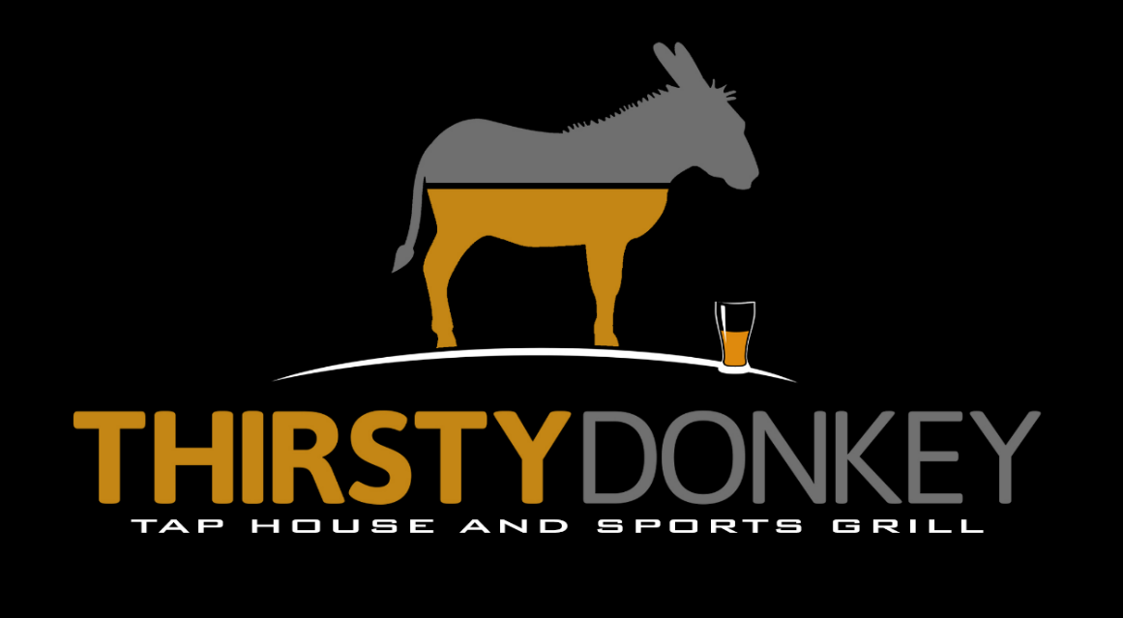
520-788-6390

WIFI PASSWORD:
ThirstyDonkey

ALL WEIGHTS ARE PRECOOKED WEIGHTS
SUB FRIES/CHIPS WITH TATER TOTS OR ONION RINGS +$1.50
GOURMET COLD
SUBS
ALL SUBS COME WITH APPROXIMATELY ½ POUND OF MEAT AND CHEESE PLUS TOPPINGS. THESE MEATS ARE HIGH END AND NOT PROCESSED.

“HOUSE WAY” IS WITH LETTUCE, TOMATO, RED ONION, OIL, RED WINE VINEGAR, MAYO, SALT, PEPPER, AND OREGANO. ROLLS COOKED FRESH!!!

INCLUDES FRIES OR FRESH COOKED CHIPS

ADD JALAPENO, PEPPERONCINI, PEPPER RELISH, BELL PEPPERS – .75EA

THE GRINDER DELUXE
PROVOLONE, HAM, PROSCUTTO, CAPICOLA, SALAMI – 10.95

TURKEY SUB
PROVOLONE, REAL TURKEY BREAST – 10.95

PASTRAMI (COLD OR HOT)
PROVOLONE, PASTRAMI – 10.95

CLUB SUB
PROVOLONE, HAM, TURKEY, BACON – 10.95

ROAST BEEF SUB
PROVOLONE, ROAST BEEF (MED RARE) – 11.95

BLT
HALF POUND OF BACON (6 SLICES) – 10.95
ONE POUND OF BACON (12 SLICES) – 15.95

JUMBO WINGS
ADD A SIDE OF FRIES OR CHIPS WITH WINGS – 2.00
FINALLY WINGS WITH SOME MEAT ON THEM!!!!
WINGS ARE JOINTED WINGS, A FLAT AND DRUMSTICK TOGETHER.

JUMBO TRADITIONAL WINGS
3 JOINTED WINGS (3 FLATS & 3 DRUMS) – 8.95
6 JOINTED WINGS (6 FLATS & 6 DRUMS) – 16.95

BONELESS WINGS
12 WINGS – 8.95 24 WINGS – 17.95

CHICKEN TENDER (4) BASKET W/FRIES OR CHIPS – 12.95

SAUCE CHOICES
BOURBON BBQ, MEDIUM, THAI ZING, MANGO HABANERO,
HOT (WITH JALAPENO), SCORCHIN’ (WITH HABANERO PEPPERS), DONKEY PUNCH (WITH GHOST PEPPERS)

DONKEY STYLE
(THE FRIES COME ON THE SUB, NOT ON THE SIDE!!)

THESE SUBS COME ON A HOGIE ROLL THAT IS NOT TOASTED. THE MEAT IS THROWN ON THE GRILL FOR A MINUTE TO HEAT IT UP A LITTLE AND THEN THEY ARE COVERED WITH FRENCH FRIES, PROVOLONE CHEESE, AND OUR SOON TO BE FAMOUS PEPPER RELISH COLESLAW. IT’S A ONE OF A KIND TASTE WITH A LITTLE KICK!

PASTRAMI
OUR PREMIUM PASTRAMI IS SHIPPED IN FROM BACK EAST! YOU’RE GOING TO LOVE IT!!!. – 11.95

PRIME RIB
SHAVED PRIME RIB THAT WILL MELT IN YOUR MOUTH. – 13.95

ROAST BEEF
A VERY HIGH QUALITY ROAST BEEF. – 11.95
SANDWICHES
ALL SANDWICHES COME ON A SUB ROLL & SERVED WITH FRIES OR CHIPS

ITALIAN SAUSAGE
½ POUND OF SAUSAGE COVERED WITH ONIONS AND BELL PEPPERS ON A HOAGIE ROLL. YOU CAN’T RESIST MY ITALIAN SAUSAGE!!! – 10.95

BACON & JALAPENO GRILLED CHEESE
HALF POUND OF BACON (6 SLICES) – 10.95

BUFFALO RANCH CHICKEN SANDWICH
RANCH AND MEDIUM SAUCE ON A BREADED CHICKEN BREAST – 10.95

GRILLED CHICKEN SANDWICH (8 OZ) – 10.95

GYRO
GYRO MEAT ON THE BEST PITA BREAD YOU’LL EVER HAVE. THE MEAT IS SMOTHERED IN OUR SOON TO BE FAMOUS TZATZIKI SAUCE. – 10.95

DONKEY DOG
THIS IS OUR VERSION OF A CONEY DOG. A DEEP FRIED BEEF FRANK ON AN AMOROSO ROLL TOPPED WITH OUR GUY STEVE’S CONEY MEAT SAUCE, SHREDDED CHEDDAR, RAW ONIONS, PEPPERONCINIS, & JALAPENOS.
BURGERS
CHOICE OF AMERICAN, CHEDDAR, SWISS, PEPPER JACK, PROVOLONE
BRIOCHE BUN OR SUB ROLL BUN, COME WITH A SIDE OF FRIES OR CHIPS. (LETTUCE/TOMATOES/PICKLES ON REQUEST ONLY)

GROUND BACON BURGER W/CHEESE
ONE THIRD POUND BURGER IS 70% GROUND BACON & 30% BEEF. IT’S COVERED WITH YOUR CHOICE OF CHEESE AND 3 STRIPS OF BACON.
– 10.95

CHEESEBURGER
QUARTER POUND BURGER TOPPED WITH YOUR CHOICE OF CHEESE.
SINGLE – 7.95 DOUBLE – 9.95

ITALIAN CHEESEBURGER
QUARTER POUND BURGER TOPPED WITH CAPICOLA & YOUR CHOICE OF CHEESE. – 11.95

PASTRAMI CHEESEBURGER
QUARTER POUND BURGER TOPPED WITH PASTRAMI & YOUR CHOICE OF CHEESE. – 11.95

BAD A$$ PHILLY BURGER
TWO ¼ LB PATTIES TOPPED WITH AMERICAN CHEESE. ON TOP OF THE PATTIES YOU WILL FIND PHILLY MEAT, GRILLED ONIONS, & MORE AMERICAN CHEESE. YOU GET THE BEST OF BOTH WORLDS, A BURGER AND A PHILLY PUT TOGETHER ON A SUB ROLL, GET THE NAPKINS READY, YOU’RE IN FOR A TREAT!!!! – 15.95

SALADS
RANCH, GREEK FETA, BLUE CHEESE, ITALIAN, 1000 ISLAND

CHICKEN TENDER SALAD
SLICED CHICKEN TENDERS SERVED OVER SLICED LETTUCE, TOPPED WITH TOMATOES, SHREDDED CHEDDAR, CUCUMBERS, RED ONIONS, & CROUTONS. – 10.95

GRILLED CHICKEN SALAD
SEASONED AND GRILLED CHICKEN BREAST SERVED OVER SLICED LETTUCE, TOPPED WITH TOMATOES, SHREDDED CHEDDAR, CUCUMBERS, RED
ONIONS, & CROUTONS. – 10.95

CHEF SALAD
HAM AND TURKEY SERVED OVER SLICED LETTUCE, TOPPED WITH TOMATOES, SHREDDED CHEDDAR CHEESE, CUCUMBERS, RED ONIONS, HARDBOILED EGG, & CROUTONS – 10.95

GYRO SALAD
GYRO MEAT COVERED IN TZATZIKI SAUCE SERVED OVER SLICED LETTUCE, TOPPED WITH TOMATOES, SHREDDED CHEDDAR, CUCUMBERS, RED ONIONS, & CROUTONS. – 10.95

