LOGO DESIGN BRIEF for behealthynow.co.uk
ABOUT MY BLOG
I strongly believe in a holistic approach to health. It’s not only about healthy eating, exercise and nutrition. It’s also about natural living, avoiding everyday toxins, choosing organic where possible, avoiding pollution where possible. It’s about stress management and healthy mind as well. And this is what my blog is about. A holistic approach to health.
I’ve been blogging over 2 years now and now it’s time for my website to get a professional logo designed which will reflect what my blog is about:
- valuable health articles (using trustworthy sources)
- evidence based nutrition advice
- inspirational fitness posts and my cycling/hiking adventures
- health tips, healthy eating, healthy recipes
- personal healthy living journey
- natural living (natural skincare products, avoiding everyday toxins)

TARGET MARKET: 25-40yrs old, mostly females but also males, interested in how to be healthier and how to improve their lives to be healthier, seeking inspiration for a healthier lifestyle. Mostly UK based.
LOGO REQUIREMENTS:`
- Simple and clean logo
- Text easy to read (no handwriting )
- The following text in the logo: Be Healthy Now (the name may change in the future so this needs to be kept in mind. Part of deliverables will be the font used.)
- Tagline to use underneath the logo: “Natural living and healthy lifestyle” (this is also likely to change in the future so I need an editable file which I can easily change if needed)
- Original & unique – it shouldn’t look like anything that already exists
FEELINGS TO CONVEY
Feelings that are the most important which I want to convey: trustworthiness, authority, professional and approachable. It should also look friendly and not like a healthcare institution.
COLOURS
I like pastel colours of green, purple, teal, but other colour scheme may be considered. However, I think the best would be to use a shade of green as it represents healthy & natural living well.
I wouldn’t like to use red, yellow, orange, brown or pink colours.
The logo should work in black and white as well.
Colours used in the logo don’t have to match the current website’s colour scheme. Once I have a logo designed I can change the website’s colours to match it.
Colours which I like are on the following page (just to get an idea of what I like but purple colours don’t have to be used at all if they don’t fit well with the whole theme).
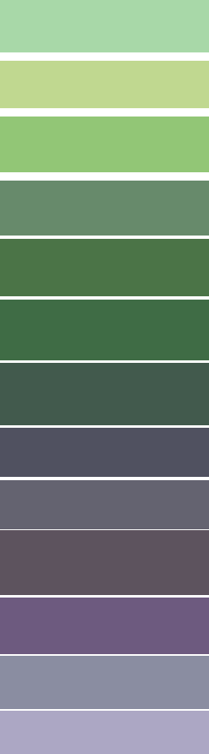
MY IDEAS
I like the idea of having a green tea leaf in the logo (as I drink lots of green tea) or blueberries (illustrated) as I eat blueberries every day. I love hiking which is a great way of staying healthy, so maybe mountains or tree in the logo could also be attempted? I want it to be professional but personal as well, showing part of me. To learn more about me please read this section of my blog: http://www.behealthynow.co.uk/about-me/
I am open to other creative ideas as well, whatever it will go well with the theme of health and what I try to potray.
COMPETITION - How do I see my blog distinct from competition?
Lots of bloggers are using just a pretty font for their logo which is black in colour. My blog has to stand out from this. The logo should have a distinguished look and not just join other similar looking logos which are just some nice font. It should contain some kind of graphics or symbol to look different.
WHAT I LIKE AND WHAT I DON’T LIKE
I don’t like the following:
http://annasnutrition.com/ - too busy, difficult to read, pictures on the sides of the logo are not flat while the rest of the website is
http://www.abalancedbelly.co.uk/recipe-easy-digest-gluten-free-pad-thai/ - looks amateur
This logo takes too much space: http://mumbalance.com/

I quite like the following:
I like this font:
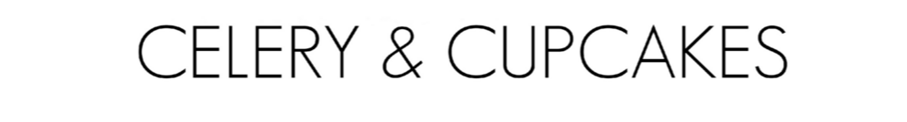
But not the logo as it takes too much of the screen and it doesn’t represent the authority: http://celeryandcupcakes.com/ - I don’t like round logos.
I quite like this logo, clean, simple and professional, although not a big fan of font: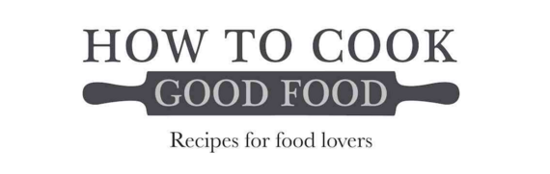http://www.howtocookgoodfood.co.uk 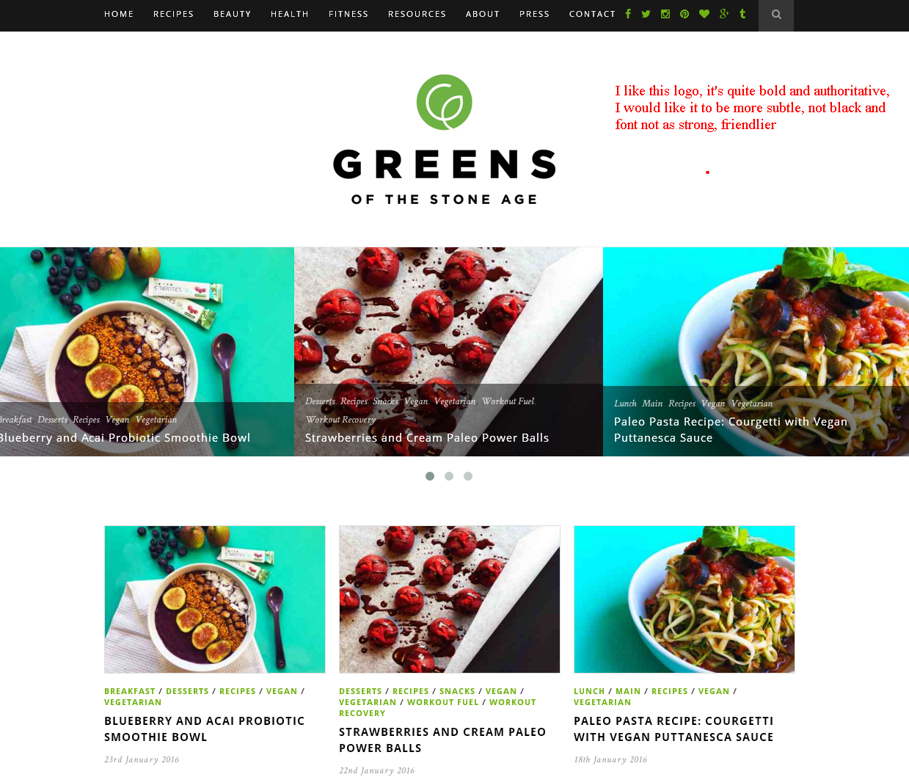
Nice font (it’s clean and professional but at the same time not too serious, friendly): 