THE BRAIN VALUE BOOK

Why did we write this book?

Every company has a vision, a set of values and a unique culture.
Every team should have its own vision, its own set of values and its own culture.
Both things aren’t necessarily exactly the same.
However they must be in alignment.

We believe that values are what makes the identity of a team.
Identity gives you a sense of pride, safety and belonging.
It also gives you a strong foundation from which to grow and become more.

Without an identity, a team is just a group of people trying to lay bricks individually.
With an identity, a team can build a cathedral.

By reflecting on what is the most important in a team, you establish a sense of clarity.
And only with clarity can you navigate in this chaotic working environment.

In ‘easy’ time, our values carry us in places we didn’t know we could go.
When the difficult times arise, we rely on our values to make key decisions.

Such decisions include how to behave and not behave.
Who to hire and who to let go of.
What to tolerate and to what extent.
In which activities to engage in and be focused on.
And which activities to let other teams handle.

This book was written by the BRAIN team members.
It describes our identity, who we are.

We hope this book will be a source of inspiration for you.

In any case, we highly recommend you to reflect upon it.

What’s your true identity?

Feel free to reach out to any of the BRAIN team members for further discussion.

How is this book organized?

We could have compiled a shortlist of what we value the most and give it to you.
But you wouldn’t read it, because it’d be so boring and meaningless.

Instead we took some time to reflect on our core values, and why.
This lead us to share a variety of stories.

You will find in this book a series of story from each team members.
Each story illustrates a core value.

To make it easier for you to navigate in this book, here are our 6 team values (in no particular order):

GROWTH
CONTRIBUTION
RESULT ORIENTED
UNDERSTANDING
INNOVATION
FLEXIBILITY

We wish you to enjoy this book.
If it inspires you, spread the word!
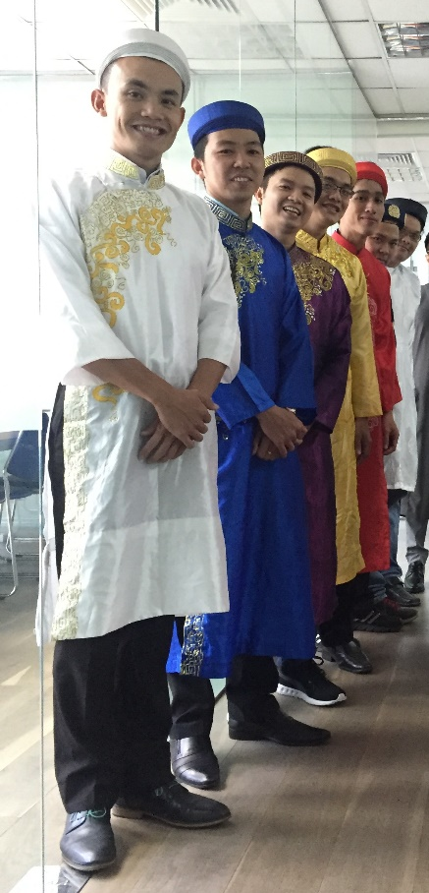

GROWTH
Son’s story
When we started this business, we had a simple CRM with only a few functional features, such as the lead module, the contract function and a few reports. We couldn’t do much with it, just run the “business as usual”.
Since we were planning to grow the business, we also had to plan for the growth of the CRM to go much beyond the existing scope.

That’s why in the end of 2014 we decided to develop The Brain. The end in mind was to implement key strategic processes that would streamline our business operation and prepare for scale. Such processes include the personalization of the students’ experience, more advanced booking functions to streamline the schedule efficiency, have more students report to follow up with our students, integrate with SDS on a daily basis instead of weekly basis, etc.

To do that, we had to change the way we worked together as a team. We started to work following the AGILE methodology using weekly Sprints. Later on we adopted tools like Trello to manage our daily tasks and Slack to communicate internally. We had to adapt to the new workflows while keeping the operation running. At the same time, we doubled the team size, which brought other management and communication challenges.

It felt like hell, but during that painful process we all learned and grew a lot. During the year of transition (2015) we kept growing the business by opening smoothly a new center in district 7. We managed to keep all the systems up and running most of the time, and started to slowly introduce some innovative features such as the MAP.

As of Aug 2016 the Brain now can accommodate any of our business needs, even needs that people aren’t aware they have yet. That kind of achievement makes us feel very proud.

Ninh’s story
Before joining WSE, I didn’t have real opportunities to apply my knowledge and technology expertise, although I knew it would be beneficial for my clients. In outsourcing companies, it generally takes many approval rounds from upper management to get anything done. Also, I had to rely on the existing infrastructure of my clients to develop. In such an environment, it’s almost impossible to express your full potential. You just do what the clients want you to do.

When joining WSE, I quickly realized that I had the autonomy and freedom to apply the new technology I had been researching for years, as well as express new ideas freely. I also have more chances to update my technical knowledge. Because we need to move at least as fast as the operation, we have to be technically on top of our game to deliver.

I’d say that WSE offers me an environment where I can try out new things, see if it works, learn from my mistakes and grow as a result. You won’t be blamed for making mistakes or proposing novel ideas. In fact, you are expected to do so. And I think that makes everybody grow as a result.

Tam’s story
I used to work in outsourcing companies, where the focus is solely on the delivery for the end clients. There was little time devoted to personal development, except for technical skills that could be applied for clients’ projects.

At WSE I had the chance to understand more about myself, my strengths and weaknesses. For example our team had to do the Strength Finder 2.0 test, which revealed 2 of our major strengths.

Discussing it openly with the team helped me focus on my strengths and minimize my weaknesses. We got a better understanding of each other, which gave us a better perspective on how to work effectively with others. Many people get in arguments and get fed up. In this team, we still argue, but instead of being fed up we take it as a learning experiment. We don’t really care who is right or wrong, we just care about finding the truth that will make the team and the business move forward.

Working in the BRAIN team also helps me understand more about Marketing, Center Operation, Telemarketing and other departments. I didn’t have such opportunities to learn in the previous companies. And nobody can teach you that at school. Direct experience is the greatest teacher.

I can say that my knowledge is broader now and closer to the reality of the business, because we are directly in charge of the product we develop, which is used directly by hundreds of users every day - from top management to the front line employees.

Khue’s story
In the previous companies I worked for, nobody really helped me to set my goals, let alone reach them.
I wanted to buy a house and lose weight for about 5 years. But I didn’t reach those goals before coming to WSE.

When joining WSE, one of the first thing I had to do was define my Highly Motivating Goals and decide on a few milestones to reach for in the next few months. I was actually quite surprised, I didn’t know how that idea would turn out.

Sometimes life gets in the way. The family, the house, the children, sports, friends, etc. It’s difficult to stay focused on the goals that take time to achieve. But the systematic monthly follow up process helped me keep in mind that I had to progress towards those goals every months.

After a year I lost more than 10 kg, and every time we had our monthly review, it helped me to keep myself disciplined in my habits. Within that same timeframe I also managed to buy my house. Now I am on track to get the ideal health I want.

Not only am I satisfied to have reached my goals, I also feel like I’m growing as an individual. What you can achieve in your personal life has a great impact on your professional life. You just feel better, and it shows everyday.

Every single achievement becomes the foundation for a new achievement. This helps me stay inspired every day.

Now I am confident that I know how to set goals effectively and achieving them. I can start thinking about how to teach that to others and change their lives too.

Tai’s story

The Brain team has evolved over the years along with this start-up company. At the beginning we were very small, nobody knew the brand, no one knew the team. As we grew, I developed the systems and the team to make it become what it is today. We literally did it from scratch.

Today the Brain team has become a very important function in the business. Although it was the vision since day 1, some days I had doubts. I didn’t believe that it could happen. But with persistence, it actually happened.

I started as a developer. In fact I was the first team member. From there, I learned and grew a lot. I had to build a brand new system myself, which helped me to improve my technical skills. We then had to organize its launch and growth, where I learned project management. Then we expanded the team, which helped me learned how to work with people and manage a team.

I really appreciate the management style of our leader (anh Bao). It wasn’t always easy and we had arguments. But overall I think we all became better as a result. Now that I manage the team myself, I use a similar approach. It’s maybe not the best way to manage a team, but I like that style because it creates opportunities for the team members to discover and develop themselves in the process.
Bao’s story
When I came to Vietnam to help set up the WSE business back in 2013, there was nothing but an old building being renovated and less than 10 people involved. We had to build everything from scratch.

This means that everybody had to do a bit of everything. In the first year, I was involved in almost all the functions of the business, from center activities to marketing, IT infrastructure, direct sales, telemarketing and training. It was a stressful but fruitful period, in the sense that I had the opportunity to learn a lot and eventually know exactly what I was good at and what I should stay away from.

In the following years, I narrowed my focus on training and technology innovations. Leading the Brain team, we grew it from a 2 people team to a 6 people team. My goal was to grow the best technology team in the WSE world so that as a company, we’d always stay ahead of the competition. I’m proud to say that we have achieved that in less than a year.

Besides growing myself, the biggest challenge I faced was to grow the team fast while making sure they didn’t burn out. You will read about some of the techniques and strategies used in this book. In the end, growing others is a never ending project and is the responsibility of the leader.

I’m confident to say that there is no school that could have taught me the things I’ve learned since 2013. Of course, there is a lot of self study involved: you absolutely have to read non-fiction books, you have to learn from other people in different fields and you have to always ask yourself at the end of each week (if not each day): what can I do better next time? Is this still something I feel passionate about?

Finally, you need to apply and practice the knowledge you learn. You can read twice as many books as you did last year if you want, but if you don’t use the knowledge in a practical manner to make something happen, you’re not tapping into your potential. That’s why I push people around a bit: sometimes it’s a bit scary to do something new, but every time you do you grow in the process.

WSE is a great playground to apply and practice. It’s a place where you can experiment, propose things without being seen as ‘weird’ and just try something new. And as a result of your iterations, you inevitably grow.

