Here are examples of existing industry logos and a few of my thoughts on each that hopefully will reflect my taste and what I am looking for.

Cool
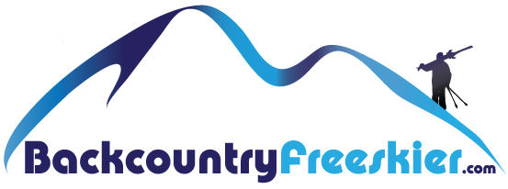
I like the text and pic concept but its not abstract enough, too much detail
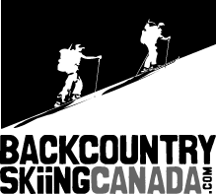

I like
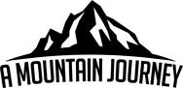

I like


I like the simplicity and humbleness but it’s confusing
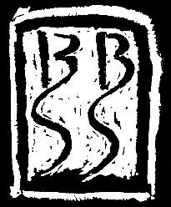

No!
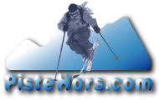

Clever but don’t like the arrows


If you want to know a little more about the activity
https://www.wildsnow.com/ The best blog in the industry
http://www.earnyourturns.com/ Great site
http://www.backcountryskiingcanada.com/?avad=54231_dd2bb7ef Good Canadian site
we enjoy going to places like this to skin up the mountain and ski powder down
http://www.solmountain.com/

Thanks for the thought and creativity it takes to complete this task, Much appreciated.
Lorne

