Front

Pinkera™
Natural Styling
Thermal Protectant Mist

Daily Styling Spray
Lightweight
Thermal Protection
For Straight, Virgin, Processed, Curly & Wavy Hair

8 FL OZ/ 237mL

Back

Pinkera™
Natural Styling
Thermal Protectant Mist

Daily Styling Spray
Oil Free, Lightweight
For all Hair Types

- Prevents Combing Damage to Cuticle
- Superior Slip and Wet/Dry combing
- Detangles
- Silky Smooth
- Reduce Static flyaway
- Thermal Protection
- Superb Conditioning

A cocktail of lightweight thickening elements pumps up th volume and boosts shine, while flexible styling agents grip skinn strands with a light, clean hold.

Directions: Spray onto clean, damp hair and comb through evenly. Do not rinse. Style as usual.

INGREDIENTS: WATER (AQUA, EAU), CETYL TRIETHYLMONIUM DIMETHICONE PEG-8 SUCCINATE, QUATERNIUM-91, CETRIMONIUM METHOSULFATE, CETEARYL ALCOHOL, BEHENTRIMONIUM METHOSULFATE, CETYL ALCOHOL, BUTYLENE GLYCOL, ETHYLHEXYLGLYCERIN, PHENOXYETHANOL, POLYSORBATE 20, FRAGRANCE

WARNING: KEEP AWAY FROM FLAME AND HIGH HEAT. DO NOT SMOKE DURING APPLICATION OR UNTIL HAIR IS FULLY DRY. AVOID CONTACT WITH EYES AND OPEN OR IRRITATED SKIN. IF EYE CONTACT OCCURS, RINSE THOROUGHLY WITH WATER. IF EYE IRRITATION PERSISTS, CONTACT A PHYSICIAN. FOR EXTERNAL USE ONLY. IF INGESTED, CONTACT A PHYSICIAN OR POISON CONTROL CENTER IMMEDIATELY. KEEP OUT OF REACH OF CHILDREN.

NOT TESTED ON ANIMALS.

Distributed by: Hairessence & Beauty, LLC. Capitol Heights, MD 20743
Made in the U.S.A.
www.PinkeraBeauty.com

Comments:
Please note that hundreds of identical items are being sold on each shelf. The design and color must stand out from crowd.
The product is for women, ages in between 25 and 60.
The product is for people of all color.
Please see the sample photos.

Bottle Measurement: Height 5 inch, Width 5-3/4 inch, 8oz.
Bottle Color: non-transparent white (see the attached)
Label film to be used: Clear PP

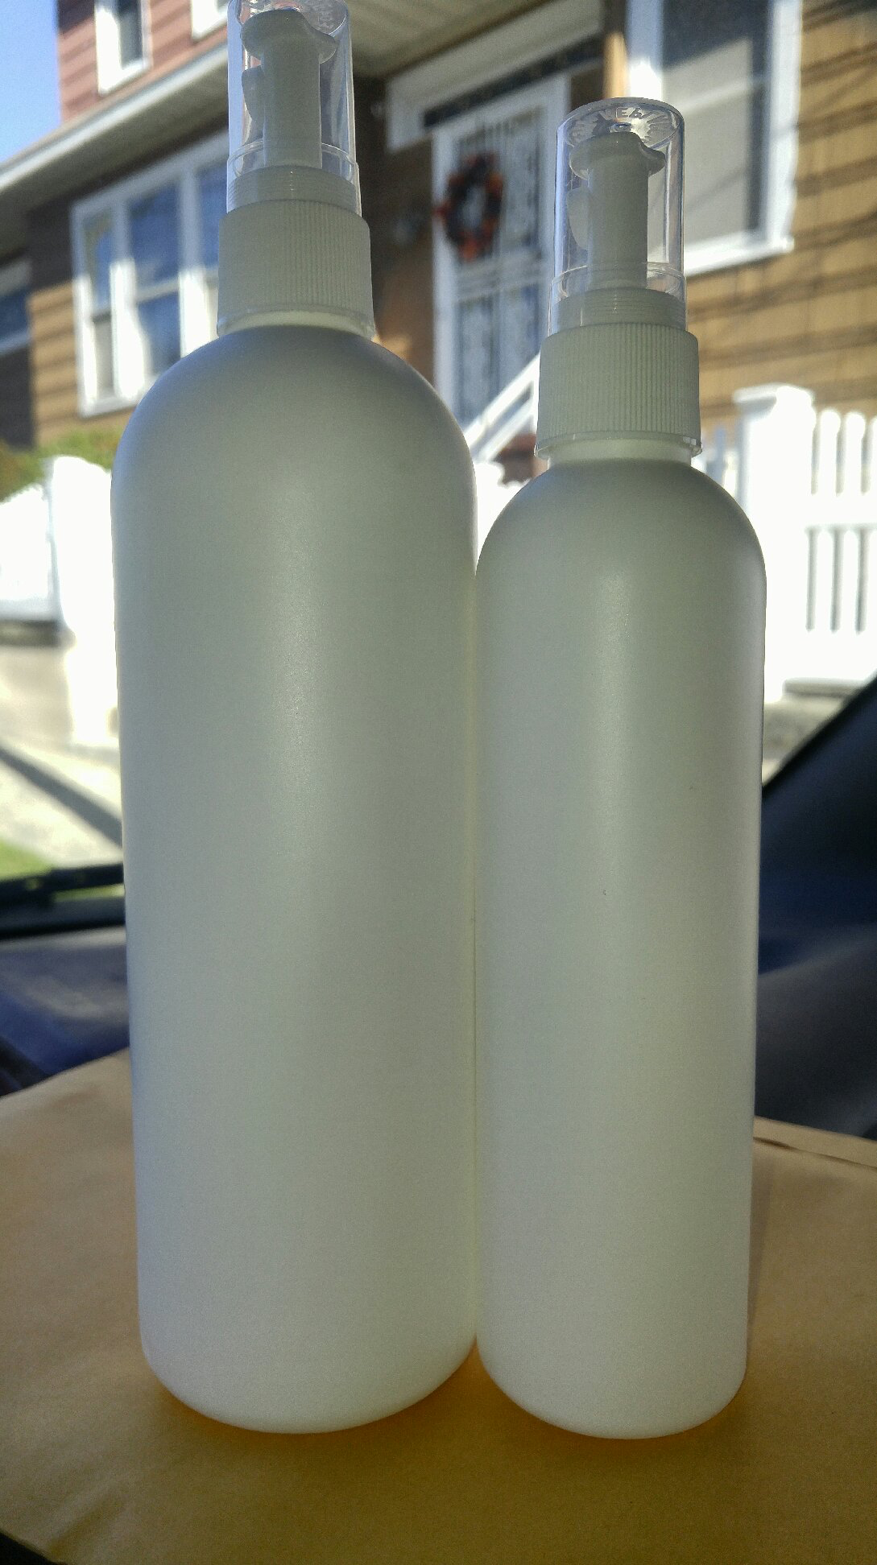
Actual Bottle
Height 5 inch, Width 5 3/4 inch, 8oz. (one on the right)

