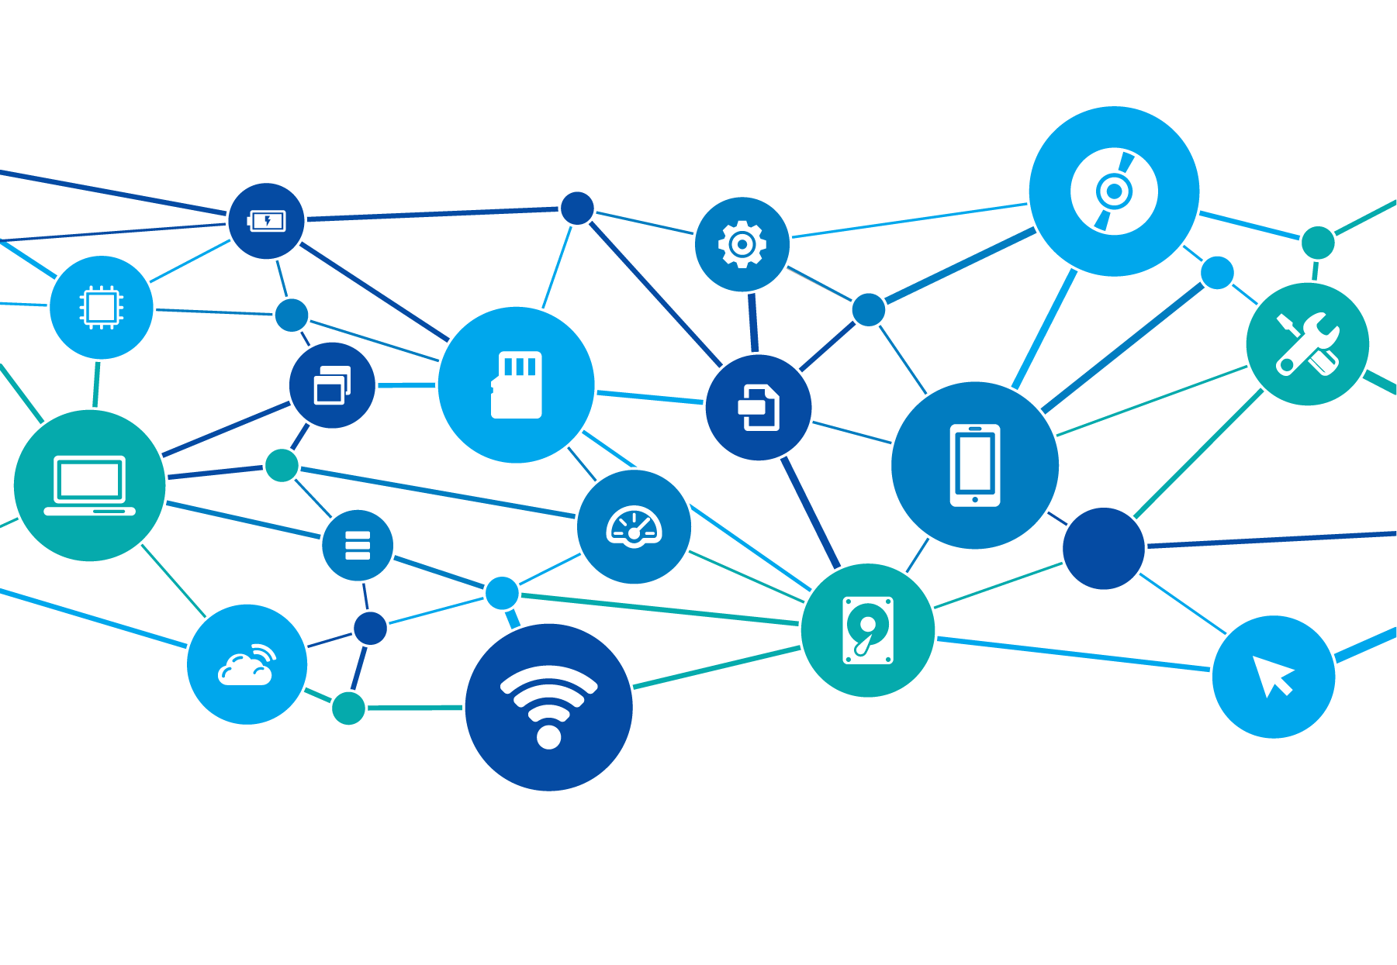


Helping you to stay safe in

A CONNECTED WORLD

Introduction

About us
Halma IT was formed in 1999 to implement a security standard across the group to protect the Head Office IT infrastructure.
Our remit has evolved over the years to improve Halma’s Cyber Security Response.
Our vision
[Have as a futuristic visual] Our vision is to move Halma subsidiaries from good managers of technology to great users of technology; to ensure technology adds value and increases the resilience of our businesses. What this means is working with subsidiaries to reduce the reliance on internally managed ICT hardware and move to agile, cloud based services.
Our goal
Subsidiaries are empowered to make risk-based decisions regarding their use of technology and its application.
Our objective is to work in partnership with subsidiaries to achieve business success through the best use of technology.
Our journey
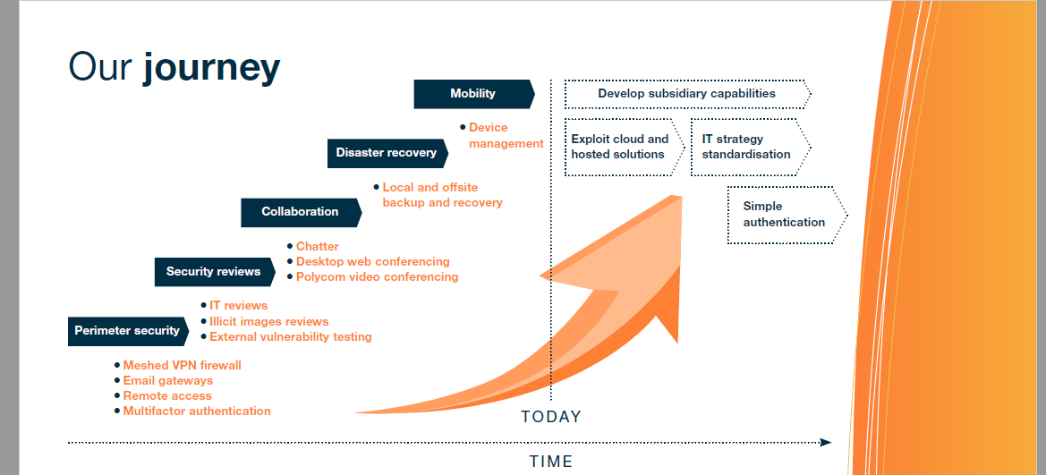
We would like this journey visual with the same text but an updated version to make the visual look more appealing. Add on ‘Identity and Access Management’ after mobility and then ‘Cloud Adoption’ after that on the left side, on the right side add ‘Facilitating subsidiaries more to digital platforms and products’ beneath ‘exploit cloud and hosted solutions’.

Our initiatives
We implemented a number of Cyber Security initiatives that would provide greater focus and insight to help identify and prioritise our vulnerabilities. From the data gathered we have learnt that we need to focus on attacks via the email and web channels that target our employees. It has become clear that employees are vulnerable to these attacks. Recently, we have also seen an increase in fraud attempts. Laptop, desktops, and mobile devices (Endpoints) are not properly managed and last year the Group experienced 6 cases of Cryptolocker. This Malware ransoms the company by encrypting their files making the data unreadable and then demands a fee to remove the malware. Compromised endpoints also provide the platform to attack other parts of the business, or potentially the wider Group. We have seen a considerable amount of Malware on endpoints and the associated outbound traffic to make contact with external command and control servers. Our initiatives are now are to focus on employee behaviour and education, reducing vulnerabilities on our endpoints, networks and business systems that provide the opportunity for attack.

Our pillars
Internet IoT of Things
Operating OT Technology
Raise standards of Cyber Security Protection
Information IT Technology
Improving Resilience
Protecting
our IT assets
with appropriate Security Controls
Developing Cyber Security Culture
---- VPN – Firewall Management
Resilience
Security
Controls
Cyber
Culture
Raise
Standards
OT
IT
IoT
---- Development of Cyber Standards
---- Cyber Policies
---- Risk Reviews
---- US IT Managers Meetings
---- EU IT Managers Meetings
---- Vulnerability Testing
---- Executive Reports
---- Secure Inter-Office Communications
---- Email Gateways
---- Malicious Web Protection
---- Vulnerability Assessment
---- Monitoring of Key Assets
---- Protection of Endpoints
---- Mobile Device Management
---- Incident Response
---- Cloud Due Diligence
---- Onsite Disaster Recovery
---- Cloud Migration Strategies
---- Resilience Planning & Guidance
---- Offsite Disaster Recovery
---- Measure Employee Behaviour
---- Computer Based Training
---- Cyber Workshops
---- Threat Reports
---- Awareness Training Material
---- Cyber Charter
---- Cyber ‘Ambassador’ Scheme
---- Disaster Recovery System
---- Identity & Access Controls
How we help

